ADHD: Through the transitional years from teenagers to Young adulthood
Natasha Hickling, CALC, UK

Abstract (300 word limit)
For years ADHD has been a well-discussed condition regarding its presence in children, and in more recent years among adults. However, the years in between – teenagers and young adults, often get sadly overlooked despite being crucial to development. Cognitively, the brain’s executive functions have not fully matured, while simultaneously many life transitions and changes are taking place. Going from school to college to jobs, from living with parents to independence, this age has many changes that require skills and knowledge that individuals with ADHD can lack. With both coming into play at the same time, if individuals with ADHD are misdiagnosed, not diagnosed, or are not getting the right support then the life transitions, future selves, and paths can be very much distorted. When developmental and biological age do not match up, how are these individuals meant to succeed to their full potential in environments and a society that may not be built for them? By drawing upon personal and professional experience, this talk will discuss the challenges that these ages face through an ‘ADHD lens,’ as well as transitions and the life skills required to succeed in a neurotypical world such as implementing the right support, scaffolds, and skills. It will consider the developmental and biological ages, having a diagnosis or not, and where to find the right support like coaching. By aligning who they are, knowing how their brain works, and pursuing their passions, anyone with ADHD really can succeed. Research has shown that early intervention is the best way forward and still there is not enough focus on these individuals that seem to just fall through the crack. Let’s talk about this crucial topic so that this may occur less and less!

Image
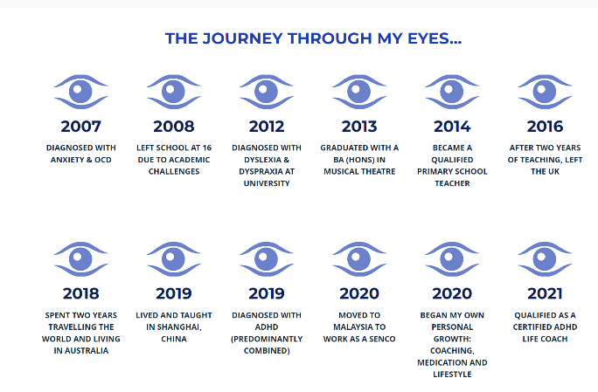
Journey of my Young adult / Teens life.

Recent Publications

Photograph

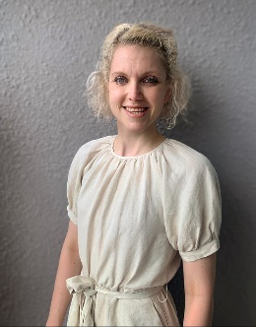
Biography (150 word limit)
Natasha Hickling is a Certified ADHD/Life Coach with a background in primary education and Special Educational Needs. After two years in education, she left the UK to pursue international experience where she became a SENCo in a private institution. From there, she began her business, Indigo Hub, in 2021 after years of struggling with undiagnosed ADHD and other coexisting conditions. She is passionate and dedicated to using her own life experience to relay knowledge and help others unlock their true potential.
She predominantly works with teens, young adults, and families to help them realign their lives, take steps in the right direction, and most of all, to help individuals view the world truly through “their eyes”. She is now undergoing additional training through ADDCA in elective family coaching and advanced ADHD life coaching.

Email: indigohub.adhd@gmail.com

