SULFORAPHANE ATTENUATES NEUROINFLAMMATION, OXIDATIVE STRESS AND COGNITIVE IMPAIRMENT ON ALUMINUM-INDUCED ALHZEIMER’S DISEASE IN WISTAR RATS
Ogunlade B.*¹, Adelakun S.A.¹, Fidelis O.P.²,
¹ Human Anatomy Department, Federal University of Technology Akure, Ondo State.
²Biomedical Technology Department, Federal University of Technology Akure, Ondo State.

*Correspondence author:Ogunlade B.
Human Anatomy Department, Federal University of Technology Akure, Ondo State.
bogunlade@futa.edu.ng

Authors name and address:
- Dr.Ogunlade B. Human Anatomy Department, Federal University of Technology Akure, Ondo State.bogunlade@futa.edu.ng
- Mr.Adelakun S.A.Human Anatomy Department, Federal University of Technology Akure, Ondo State.saadelakun@futa.edu.ng
- Mr.Fidelis O.P. Biomedical Technology Department, Federal University of Technology Akure, Ondo State. opfidelis@futa.edu.ng

ABSTRACT
Alzheimer’s disease is the most common form of dementia related to neuropathological and neurobehavioral changes. This study is aimed at evaluating the neuroprotective activities of sulforaphane on aluminum chloride induced Alzheimer’s disease in wistar rats. Twenty -eight male wistar rats were divided into four groups (n=7). Group A (control) received normal saline solution orally; Group B received 200 mg/kgbw of Aluminum chloride orally; Group C received 200 mg/kgbw of sulforaphane and 200 mg/kgbw of Aluminum chloride orally, while Group D received 200 mg/kgbw of sulforaphane alone orally. The experiment lasted for 45 days after which behavioural test (Morris water maze, Y maze, open field test) were conducted, serum was obtained for electrolyte concentration analysis (Na, K, Ca, Zn and Cu) and brain tissues were processed for histology, antioxidant parameters (CAT, GSH, SOD), oxidative stress parameters (MDA, H₂O₂ and Nitrite Levels), brain monoamine neurotransmitters (Dopamine, Serotonin and Norepinephrine), enzymes activity (AChE and Na-K ATPase).
Results showed that Sulforaphane improved learning and memory in rats treated with Sulforaphane and Aluminum chloride compared with Aluminum chloride only group. Also, the Aluminum chloride treated rats showed decreased SOD, CAT and GSH activities as opposed to the sulforaphane treated group with improved antioxidant enzymes level. Furthermore, the levels of MDA, H₂O₂ and nitrite in Aluminum chloride group showed significant increase as compared to sulforaphane treated group. In addition, administration of sulforaphane with Aluminum chloride improved the monoamine neurotransmitters, brain enzymes activities, serum electrolyte concentration and protects hippocampal histomorphology when compared with Aluminum chloride only group. In conclusion, Sulforaphane ameliorates the neurotoxic effects of alumimum induced rat model of Alzheimer’s disease by improving memory and learning skills, alleviating the neurological disorders thereby acting as powerful antioxidant.
Keywords: Alzheimer’s disease, Antioxidant, Behavioural stress test, Oxidative stress.
Abbreviations
Na: sodium
K: potassium
Ca: calcium
Zn: zinc
Cu: copper
CAT: Catalase
GSH: glutathione
SOD: superoxide dismutase
MDA: Malonyldialdehyde
AChE: acetylcholinesterase
ATPase: Adenosine TriPhosphatase

Professional Biography
Dr. Babatunde OGUNLADE, completed his PhD at the age of 33 years in June, 2018 from University of Lagos, Nigeria on the thesis titled “Histomorphological and Immunohistochemical Responses to 1-Isothiocyanato-4-(Methylsulfyn1) Butane and D-Ribose-L-Cysteine on Puncture Induced intervertebral Disc Degeneration in Rabbit Model”. I am currently seeking postdoctoral fellowship in research institution outside my country.
I am a lecturer and independent neurobiology researcher at the Federal University of Technology, Akure, Nigeria, in the Department of Human Anatomy, School of Health and Health Technology. I possessed good theoretical and technical laboratory skills such as Electrophysiology, Immuno-cytochemistry, Immuno-histochemistry, Neurobiochemistry, Cell culture, and Computed reconstruction and quantitation (stereology) among others. I have published more than 37 papers in reputed journals. I am positive about academic excellence, motivation for research, professionalism, personal experience, passionate dedication or interpersonal skills.


Email address: bogunlade@futa.edu.ng

Comments:
I would like to have a poster presentation for this work if accepted. In addition, I will appreciate if I could be notified early before middle of December, 2019 if this abstract is accepted. The University where am working currently would like to sponsor me for this conference with evidence of abstract acceptance.
LIST OF FIGURES
Figure 1: Effect of SFN on behavioral studies (Y-maze and MWM) in normal and Alzheimer’s group rats (n=7).
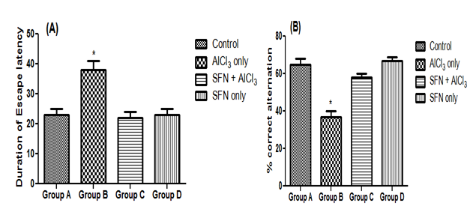
*: p < 0.05 as compared to group 1.

Figure 2: Effect of SFN on behavioral study (Open field test) in normal and Alzheimer’s group rats (n=7).
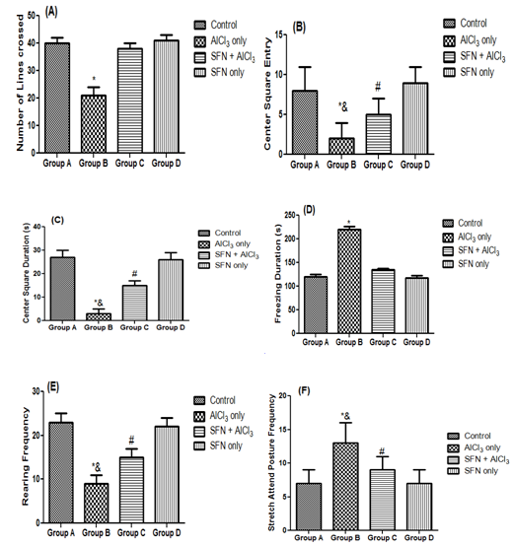
*: p < 0.05 as compared to group A; &: p < 0.05 as compared to group C; #: p < 0.05 as compared to groups A and D.

Figure 3: Effect of SFN on brain antioxidant parameters: SOD levels (units/mg protein), Catalase level (μmol of H₂O₂ decomposed/mg protein/min) and GSH level (nmol/mg protein) in normal and Alzheimer’s group rats (n=7).
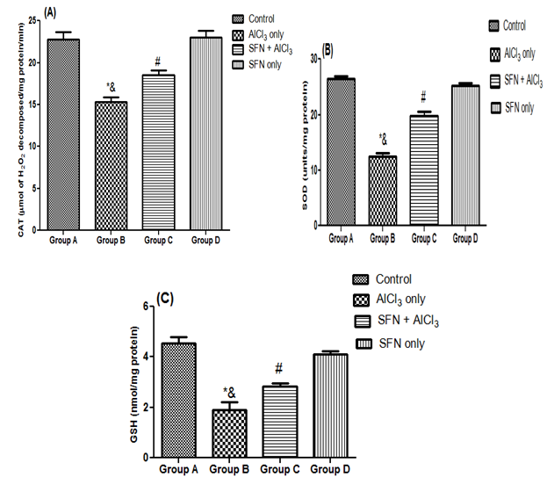
*: p < 0.05 as compared to group A; &: p < 0.05 as compared to group C; #: p < 0.05 as compared to groups A and D.

Figure 4: Effect of SFN on brain oxidative stress markers: MDA levels (nmol/mg protein), H₂O₂ (mM/g), NO (µM/g)in normal and Alzheimer’s group rats (n=7).
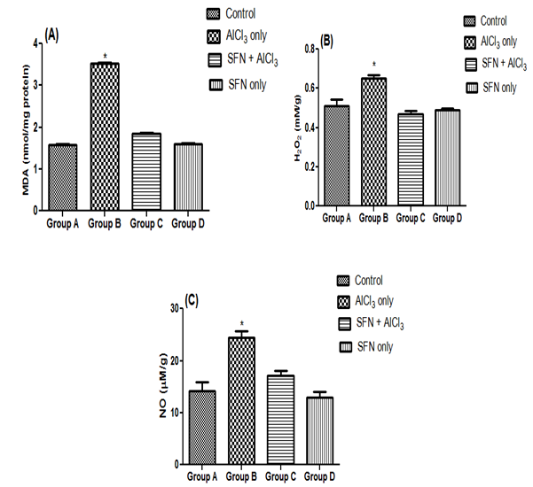
*: p < 0.05 as compared to group A

Figure 5: Effect of SFN in brain monoamine neurotransmitters (DA, 5-HT and NE) in normal and Alzheimer’s group rats (n=7).
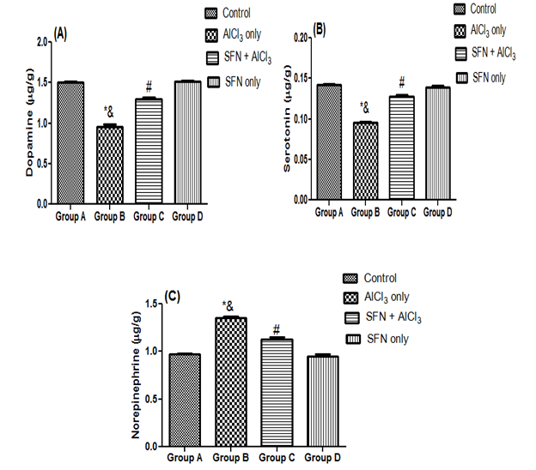
*: p < 0.05 as compared to group A; &: p < 0.05 as compared to group C; #: p < 0.05 as compared to groups A and D.

Figure 6: Effect of SFN on enzymes activity (AChE and Na-K ATPase)in normal and Alzheimer’s group rats (n=7).
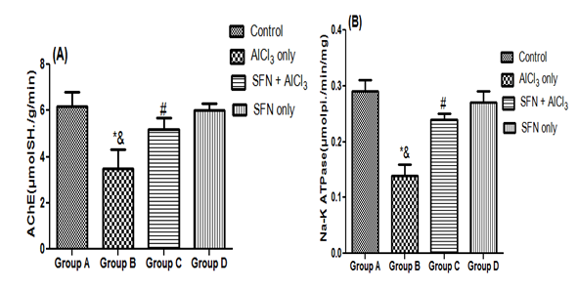
*: p < 0.05 as compared to group A; &: p < 0.05 as compared to group C; #: p < 0.05 as compared to groups A and D.

Figure 7: Effect of SFNin serum electrolyte concentration in normal and Alzheimer’s group rats (n=7).
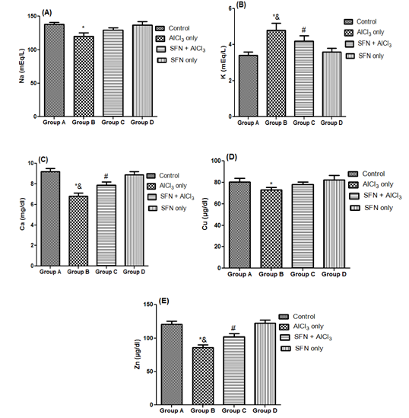
*: p < 0.05 as compared to group A; &: p < 0.05 as compared to group C; #: p < 0.05 as compared to groups A and D.

