Thromboembolic risk in inflammatory neuromuscular disease patients on long-term intravenous immunoglobulin
Dr Aisling Carr, MRCP Neurol., PhD
MRC Centre for Neuromuscular Diseases
National Hospital for Neurology and Neurosurgery,
Queen Square, London, UK

Abstract

Background Case reports and observational studies suggest that IVIg may be associated with an increased risk of thromboembolic events (TEEs), including myocardial infarction (MI), stroke, and venous thromboembolism.^{1,2}

The presence of traditional cardiovascular risk factors, the underlying condition or characteristics of IVIg administration have been proposed as contributory.^{3,4}

There is no guidance on risk management in patients who are potentially high risk but require ongoing IVIg treatment.

Aims: To ascertain (a) frequency of and (b) risk factors for thromboembolic events in a cohort of patients undergoing regular IVIg for neuromuscular disease.

Methods: Retrospective case note review of patients treated with regular IVIg for neuromuscular disease in our institution between Jan 2015-July 2016.

Diagnosis, dose, frequency, vascular risk factors, pre and post IVIg plasma IgG levels and viscosity were recorded..

Results: 112 patients were treated with IVIg during the study period.

Indications for IVIg were CIDP (61), Multifocal motor neuropathy with conduction block, (MMNCB) (41), other inflammatory neuropathies including CANOMAD and CISP (6) and other diagnoses including small sensory neuronopathy and inflammatory myositis (4).

Patients received a mean (S.D.) dose of IVIG of 1.6 (1.2) g/kg/month at a mean interval of 4.4 (3.0) weeks; range 1-18 weeks.

Twelve TEEs were documented during the study period including 6 MIs, 2 strokes and individual occurrences of DVT, TIA, PE and SVC obstruction secondary to line thrombosis.
 | Population based rates* ** | IVIg cohort*
TEE | 7.6 (7.6,7.7) | 53.6 (30.9,91.3)
ATE | 6.5 (4.4,6.5) | 35.7 (18.2,68.9)
VTE | 1.2 (1.2,1.2) | 22.3 (9.6, 51.2)

* per 1000 person years (95% CI)

**Based on hospital admissions data 2014-16 NHS digital

TEE risk did correlate with QRISK2 score (CVRF). However, one third of patients who had a TEE had a QRISK2 score of <20.

IVIg dose g/kg/month and IVIg dose/day were not associated with an increased risk of TEE

Lower ∆ plasma IgG and lower post IgG plasma viscosity did not reduce the risk of TEE.

Conclusion

TEE rate is higher in inflammatory neuromuscular disease patients on longterm IVIg than that of the general population. Reduction of IVIg dose or infusion rate did not reduce this risk. Large scale, age, sex and CVRF-matched studies in IVIg treated(case) and IVIg naïve patients(control) are required to determine the quantify risk of TEE in attributable to this treatment and appreciate its thrombophilic mechanism.
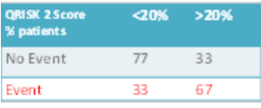
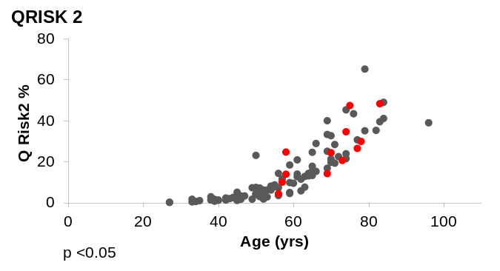

1.Ramieriz et al. Thromb Res 2014 Jun; 133 (6) 1045-51

2.Rajabally and Kearney J Neurol Sci 2011 Sep 15; 308(1-2)

3. Ammann et al. Am J Hematol 2016 Jun; 91(6) 594-605

4. Basta et al. Clin Exp Immunol 2014 Dec 178 (Suppl 1) 153-155


Biography
Aisling Carr works is a consultant neurologist on the Peripheral Nerve team in the National Hospital for Neurology and Neurosurgery where she leads the intravenous immunoglobulin service. Her areas of interest include diagnosis, treatment and patient-centered management of inflammatory neuromuscular diseases. She trained in Trinity College Dublin, Belfast Health and Social Care Trust Neurosciences Department, l’hopital Pitie de la Salpetriere Paris and the National Hospital of Neurology and Neurosurgery, Queen Square London.
Email: aisling.carr@uclh.nhs.uk

Notes/Comments:

