Abnormal calcium entries and Calcium Channels in DMD : New therapeutic targets.
Bruno Constantin PhD, STIM Laboratory, CNRS, France

Abstract (300 word limit)
Duchenne Muscular Dystrophy (DMD) is cause by the absence of dystrophin a cytoskeleton protein. The absence of dystrophin results in a loss of dystrophin-associated proteins at the sarcolemma such as syntrophin, and in calcium transfer deregulation through ion channels. This alteration in cell signalling may contribute to the death of muscle cells. The abnormalities in resting calcium permeability of DMD muscles have supported the idea of a small and persistent inward calcium leak leading to deleterious calcium mishandling. Studies on mouse muscle fibres also demonstrated that store-dependent calcium currents are more important in fibres from mdx dystrophic mice and we have shown that these Cation entries are restored by forced expression of a minidystrophin. Our group provided new insights by demonstrating the existence of a macromolecular complex including TRPC1 and TRPC4 channels associated with dystrophin and the adaptator Alpha1-syntrophin, which regulates through its PDZ domain the cation influx through TRPC. Consequently, the loss of dystrophin and Alpha1-syntrophin at the sarcolemma in DMD skeletal muscle leads to the loss of the repressing effect exerted on cation entries through TRPC channels. These disorders may be relevant for DMD physiopathological processes since overexpression of TRPC channels and increased calcium influx are sufficient for promoting the development of muscular dystrophy in mice. Elevation of calcium entry via TRPV2 cationic channels also promotes muscular dystrophy in animal models. Our studies on human muscle from DMD patients confirmed the alterations of Store-operated calcium entries and their regulation by syntrophin, as well as the implication of TRPV2 in additional abnormal entries. Moreover we also demonstrated that TRPV2 is also involved in abnormal constitutive calcium entries observed in ventricular cardiomyocytes from mdx dystrophic mice, and also in axial stretch-dependent influx. This cation channels could offer new therapeutic pharmacological targets, for counteracting calcium-induced muscle degeneration and cardiomyopathy in DMD.
Image
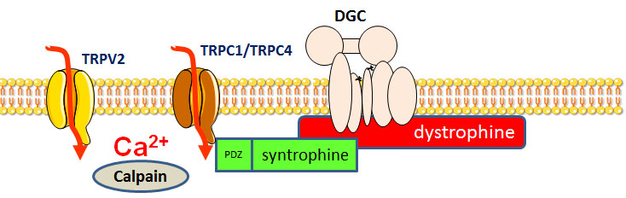
Fig.1 : The syntrophin/dystrophin complex regulates calcium entries through TRPC1/4 channels as well as TRPV2 channels. In DMD the absence of the complex leads to overactivation of these channels and abnormal calcium entries, which participate to muscle necrosis in dystrophynopaties. This cation channels could offer new therapeutic pharmacological targets.
Recent Publications (minimum 5)
- E. Aguettaz, J.J. Lopez, A. Krezsiak, L. Lipskaia, R. Hajjar, C. Cognard, B. Constantin, and S. Sebille. (2016) Axial stretch-dependent calcium entry in dystrophic cardiomyopathy: involvement of several TRPs channels. Cell Calcium. 59:145-55.
- Harisseh R., Chatelier A., Magaud C., Déliot N. And Constantin B. (2013) Involvement of TRPV2 and SOCE in calcium influx disorder in DMD primary human myotubes with a specific contribution of α1-syntrophin and PLC/PKC in SOCE regulation. American Journal of Physiology – Cell Physiology 304:C881-94.
- Sabourin J., Harisseh R., Harnois T., Magaud C., Bourmeyster N., Déliot N. and Constantin B. (2012) Dystrophin/Alpha1-syntrophin scaffold regulated PLC/PKC-dependent store-operated calcium entry in myotubes. Cell Calcium. 52:445-56.
- Sabourin J., Lamiche C., Vandebrouck A., Magaud C., Rivet J., Cognard C., Bourmeyster N., Constantin B. (2009) Regulation of TRPC1 and TRPC4 cation channels requires an alpha-syntrophin-dependent complex in skeletal mouse myotubes. J. Biol. Chem.; 284:36248-61.
5. Vandebrouck A., Sabourin J., Rivet J., Balghi H., Sebille S., Kitzis A., Raymond G., Cognard C., Bourmeyster N. and Constantin B. (2007) Regulation of capacitive calcium entry by α1-syntrophin: association of TRPC1 with dystrophin complex and the PDZ domain of α1-syntrophin. FASEB 21:608-17.

Biography (150 word limit)
Bruno Constantin is Research Director at CNRS and has his expertise in electrophysiology, cell biology and calcium channels and signaling. He worked on calcium signaling during skeletal muscle development during its phD thesis. He was recruited by CNRS in 1998 and has long studied the function of dystrophin in skeletal muscle and the mechanisms of calcium mishandling in Duchenne Muscular Dystrophy. His research was supported by AFM-Telethon in France, and this work highlighted the crucial role of TRP channels in the calcium alterations observed in DMD. He is nowadays the deputy director of STIM laboratory in Poitiers University and founded a new team working on calcium channels and signaling in stem cells.
Email: bruno.constantin@univ-poitiers.fr

Notes/Comments:

