Cognitive and Personality Characteristics of Sasang Constitution using Neuropsychological and Personality Tests
Yunyoung An, KMD, Woosuk Univ., Republic of Korea
Munsu Kang, KMD, PhD, Woosuk Univ., Republic of Korea
Lakhyung Kim*, KMD, PhD, Woosuk Univ., Republic of Korea

Abstract
Statement of the Problem: Sasang constitutional medicine (Sasang typology) is one of the characteristics of Korean traditional medicine, and it classifies human beings into four constitutional types; Taeumin, Taeyangin, Soyangin, and Soeumin. Sasang constitutional medicine shares the same concept of the personalized medicine contained that even same drug causes different drug reactions or effects depending on his or her Sasang constitution classification. Therefore, the classification of the constitution is very important in the diagnosis and treatment of diseases. The purpose of this study is to evaluate the personality traits and cognitive characteristics of the Sasang constitution by comparing the Eysenck Personality Questionnaire (EPQ), Temperament and Character Inventory (TCI), Continuous Performance Test (CPT) and Stroop Test. Methodology & Theoretical Orientation: One hundred and six healthy subjects (age 20 to 40) were analyzed; 45 Taeeumin, 30 Soyangin and 31 Soeumin. The Sasang constitution was diagnosed by a Sasang constitutional medicine specialist based on the results of Two Step Questionnaire for Sasang Constitution Diagnosis (TS-QSCD). The results of the EPQ, TCI, CPT and Stroop Test were compared between Sasang constitutions. Findings: Among the seven dimensions of EPQ, Taeeumin and Soyangin scored significantly higher than Soeumin in Extraversion. Soyangin scored significantly higher than Soeumin in Impulsiveness. Among the four temperament dimensions of TCI, Taeeumin and Soyangin scored significantly higher than Soeumin in novelty seeking, reward dependence and persistence. Soeumin scored significantly higher than Taeeumin and Soyangin in harm avoidance. Among the three character dimensions of TCI, Soyangin scored significantly higher than Taeeumin in self transcendence. The results for CPT showed no significant differences between Sasang constitutions. Taeeumin had a significantly higher color score in the stroop test than Soeumin. Conclusion & Significance: The personality tests showed significant differences between Sasang constitutions, but the neuropsychological test did not show any differences.

Image

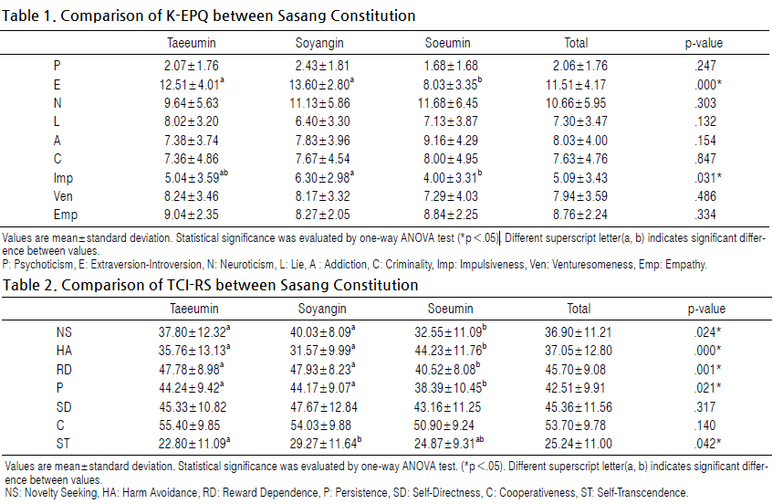

Recent Publications
- HC Park, G Yu, LH Kim (2017) A Study of Different Character Strengths in the Sasang Constitution. J of Oriental Neuropsychiatry 28(1):39-47.
- G Yu, LH Kim, ST Yu (2015) Relationships between Mother-Child Temperamental Interactions and Parenting Stress in Korean School-Aged Children. J Pediatr Korean Med. August 29(3):12-20.
- WC Choi, WG Kim, JM Song, LH Kim (2013). The Differences of Learning Characteristics in Sasang Constitution. J of Oriental Neuropsychiatry 24(2):163-178.
- WY Sung, JY Kim, LH Kim (2011) Temperament and Character Profiles of Sasang Constitution in Middle School Students. J of Oriental Neuropsychiatry 22(3):55-64
- GR Lee, DY Shin, YW Kim, JH Lee, JM Song, LH Kim (2007) Changes of HRV according to Emotional Stimulus in Sasang Constitutional Groups. J of Oriental Neuropsychiatry 18(2):25-34.

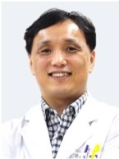 Biography
Lakhyung Kim is a doctor of Korean Medicine and treats patients with Neurocognitive disorders and psychiatric disorders. Sasang Constitution Medicine is one of the traditional medicine of Korea. Everyone is classified into four types, and physiology, pathology, diagnosis and treatment differ depending on the type of constitution in Sasang Constitutional medicine. He has conducted many studies about the psychological and behavioral characteristic of each types in Sasang Constitutional Medicine for over 10 years. He has used personality psychological test such as TCI, EPQ and computerized neurocognitive tests. This research was supported by Basic Science Research Program through the National Research Foundation of Korea(NRF) funded by the Ministry of Education(NRF-2015R1D1A1A01058954)..
Email: kimlak@hanmail.com

