

These are the *mandatory fields that must be filled in for abstract submission

*Middle meningeal artery embolization for chronic subdural hematoma in a young patient with refractory thrombocytopenia secondary to leukemia: more evidence for a paradigm shift

Dr Emalee Burrows, MBBS, Neurosurgical Service of Western Australia, SCGH, Perth, Western Australia, Australia
Seng Chye Lee, MBBS, Neurosurgical Service of Western Australia, SCGH, Perth, Western Australia, Australia
Omar K. Bangash, MBBS, Neurosurgical Service of Western Australia, SCGH, Perth, Western Australia, Australia
Timothy J. Phillips, MBBS, CCINR, Neurosurgical Service of Western Australia, SCGH, Perth, Western Australia, Australia
Sharon Lee, MBBS, Neurosurgical Service of Western Australia, SCGH, Perth, Western Australia, Australia

Abstract
The Problem: Chronic subdural hematoma (CSDH) is one of the most common neurosurgical presentations, with an increasing number now also presenting with concurrent thrombocytopenia. Although middle meningeal artery (MMA) embolization has been considered in elderly patients with high comorbidities, it may permit treatment of CSDH in patients who are at high risk for recurrence or deemed unsuitable for surgical management due to thrombocytopenia.

Observations: A 35-year-old man who had severe thrombocytopenia due to blast cell crisis with chronic myeloid leukemia developed an atraumatic CSDH. The patient developed severe headaches in the hospital while being treated for febrile neutropenia. He remained neurologically intact. MMA embolization was undertaken due to the morbidity and mortality risks associated with surgery and the high risk of recurrence due to severe thrombocytopenia. At 2 months post-procedure the patient was asymptomatic and there was almost complete resolution of the hematoma.

Lessons: Thrombocytopenia in the presence of a CSDH is becoming increasingly common. This case highlights the particular role of MMA embolization in patients with severe thrombocytopenia where surgery carries high morbidity and increased mortality.

Image: Postoperative CT images of the brain at 1-week postembolization (left) with a reduction in midline shift from 14 mm to 9 mm and at the 1-month follow up (right) with complete resolution of CSDH.

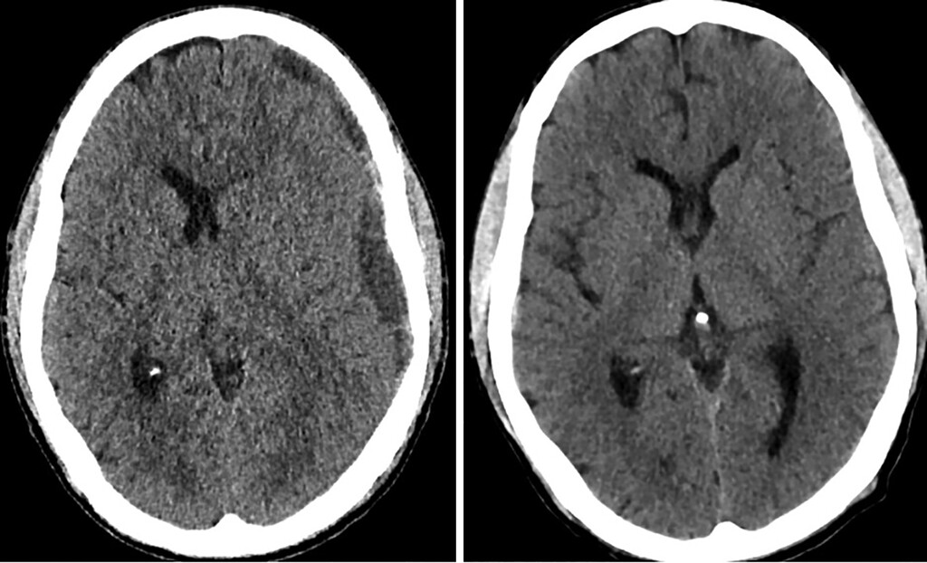
Recent Publications
- Fiorella D, Arthur AS. Middle meningeal artery embolization for the management of chronic subdural hematoma. J Neurointerv Surg. 2019;11(9):912–915.
- Fiorella D, Arthur AS. Middle meningeal artery embolization for the management of chronic subdural hematoma. J Neurointerv Surg. 2019;11(9):912–915.
- Cannarsa G, Olexa J, Chryssikos T et al. Stand-alone middle meningeal artery embolization for treatment of giant chronic subdural hematoma in elderly frail patients: a case series. Neurosurg Open. 2021;2(1):okaa025. 10.1093/neuopn/okaa025.
- Srivatsan A, Mohanty A, Nascimento FA, et al. Middle meningeal artery embolization for chronic subdural hematoma: meta-analysis and systematic review. World Neurosurg. 2019;122:613–619
- Feghali J, Yang W, Huang J. Updates in chronic subdural hematoma: Epidemiology, etiology, pathogenesis, treatment, and outcome. World Neurosurg. 2020;141:339–345.

Photograph

Biography
Dr Emalee Burrows is a current resident at Sir Charles Gairdner Hospital Neurosurgical Department in Perth Western Australia. She is on the education board for the Brainbook foundation, involved in enhancing neurosurgical education for medical students, medical professionals, and the community alike. She has formerly been involved in a number of international trials, including the POSTVenTT trial, OPERAS and May Measurement Month. She earned first class honours in her medical program, and received the Don Watts High Achievers Academic scholarship. She was involved in founding the Curtin Surgical Student Society and research program at Curtin Medical school.

Name to be displayed in the Certificate: Dr Emalee Burrows
Type of Presentation: Speaker
Email ID: emalee.burrows@gmail.com
Contact number/Whatsapp: 61 0409215125
LinkedIn ID: emalee-burrows-327a85182

