Effectiveness of a new neural motor recruitment method combined with transcranial direct current stimulation to induce and guide motor recovery in incomplete paraplegic patients
Ahmad Rifai Sarraj, PT PhD, Lebanese University, Lebanon Mariam Al-Zaher, PT Msc, Lebanese University, Lebanon
Manuella Haddad, PT Msc, Lebanese University, Lebanon
Ahmad Ramadan, PT Msc, Lebanese University, Lebanon
Pamela Nohra, PT Msc, Lebanese University, Lebanon
Ahmad Diab, Eng. PhD, Lebanese University, Lebanon

Abstract
Traumatic Spinal Cord Injury (TSCI) is a catastrophic unexpected and devastating event that can be occurred along the spinal column (cervical, thoracic, and lumbar). Reorganization of central nervous system (CNS) after injury has been demonstrated in animals then in human allowing better understanding of the repair process that can happen through various mechanisms. Neurorehabilitation has been demonstrated as effective to induce and guide histological and/or functional recovery in SCI patients. However, evidence from clinical trials concluded that conventional and compensatory rehabilitative strategies should be replaced by restorative strategies. Our study aimed to examine the effectiveness of a new neural motor recruitment method (NMR), combining specific motor imagery, specific sensory inputs and transcranial direct stimulation tDCS. Fifty paraplegic patients are randomly assigned into 3 groups. Conventional group (n=20) where patients received a standardized conventional type of intervention (stretching, strengthening, neuro-muscular facilitation), Experimental Group (n=20) who receives the neural motor recruitment protocol (NMRP) and the Transcranial Direct Current Stimulation (tDCS) Group (n=10) receiving the NMRP in addition to the tDCS. Outcome measures included Motor and sensory (light touch and pin prick) assessment of the American Spinal Injury Scale (ASIA) and assessment of movement attempted intensity and frequency. Protocols were approved by the ethical local committee of the Faculty of Public Health of the Lebanese University and were conducted in accordance with the ethical principles of the Declaration of Helsinki (2013). A significant difference in Motor and sensory Assessment of ASIA scale was found between the different groups with the highest difference in tDCS group. After the tDCS, we identified a significant increase in the alpha power over the motor cortex, the frontal, parietal, and parieto-occipital areas compared to the other groups. Our hypothesis of the effectiveness of Neural Motor Recruitment, especially when combined with tDCS, was partially validated in a small group of TSCI patients. Additional investigations must include the mechanism of such a restorative rehabilitation protocol aimed to induce and restore voluntary control and sensibility over paralyzed extremities in incomplete TSCI.

Recent Publications (minimum 5)
- Potter-Baker KA, Janini DP, Lin Y-L, Sankarasubramanian V, Cunningham DA, Varnerin NM, et al. Transcranial direct current stimulation (tDCS) Paired with massed practice training to promote adaptive plasticity and motor recovery in chronic incomplete tetraplegia: a pilot study. J Spinal Cord Med. 2017 Aug 7;1–15.
- Donovan L, Francis L, Muter P, Nevin S, Warren R. Spinal cord injuries: overcoming barriers to seamless care for patients. Br J Nurs Mark Allen Publ. 2017 Mar 23;26(6):324–30.
- Hansen CN, Faw TD, White S, Buford JA, Grau JW, Basso DM. Sparing of Descending Axons Rescues Interneuron Plasticity in the Lumbar Cord to Allow Adaptive Learning After Thoracic Spinal Cord Injury. Front Neural Circuits [Internet]. 2016 Mar 2;10.
- Chen X, Wan L, Qin W, Zheng W, Qi Z, Chen N, et al. Functional Preservation and Reorganization of Brain during Motor Imagery in Patients with Incomplete Spinal Cord Injury: A Pilot fMRI Study. Front Hum Neurosci. 2016;10:46.
- Aikat R, Dua V. Mental Imagery in Spinal Cord Injury: A Systematic Review. J Spine [Internet]. 2016 [cited 2017 Aug 26];5(3).

Biography
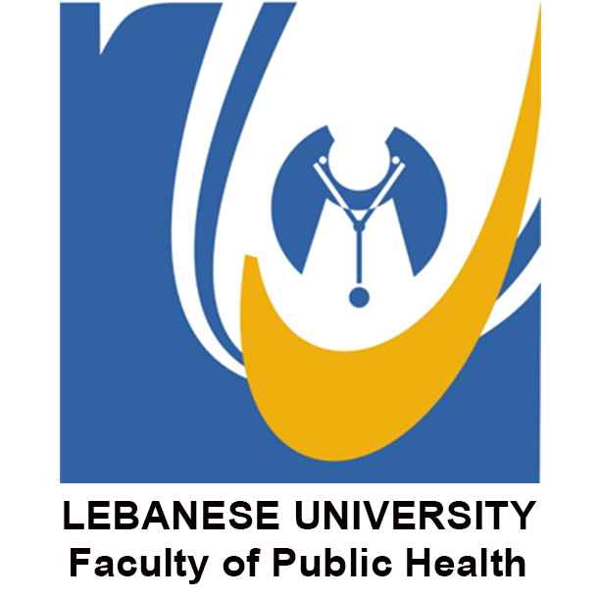
Ahmad Rifai Sarraj, Ph.D. PT is a movement scientist and Professor in Physical Activity and Neurorehabilitation at the Department of Physical Therapy of the Lebanese University in Beirut. He is also the Director of the communication at the International Neurological Physical Therapy Association. My research interests include methodologies for human movement monitoring and analysis with emphasis on neurorehabilitation. My research aims to study mental training, to improve motor function and intervention programs in aging and patients with movement disorders. He has published more than 30 papers in PLOSone, Annals of Physical Medicine and Rehabilitation and many peer-reviewed journals. In the previous 5 years, he received over 25000$ in research funding about his new method of neural motor recruitment from the Lebanese University and the National Center for research in Lebanon

Email: ahmadrifaisarraj@ul.edu.lb

Notes/Comments

