Mai M.Anwar¹, Ola S.M.Ali², Laila A. Rashed.³, Badawi A.M.¹, Nadia A.Eltablawy¹
¹Department of Biochemistry, National Organization for Drug Control and Research (NODCAR), Giza 12511, Egypt.
²Department of Biochemistry, Faculty of Pharmacy, Al-Azhar University, cairo 11311, Egypt.
³Department of Biochemistry and Molecular Biology, Faculty of Medicine, Cairo University, Giza 12511, Egypt.
Corresponding Author: Mai Mamdouh Anwar
Assistant Lecturer at Department of Biochemistry, National Organization for Drug Control and Research (NODCAR), Egypt
6-Abou Hazem St., Pyramids Ave., Giza 12511, Egypt.
Phone: (+00201000993347) Email: (mainwr@hotmail.com)

The Efficiency of Intracerebral and Intravenous MSCs Administration in Resolving Diffused and Neuritic Amyloid-β aggregates by Recruiting Bone marrow-Induced Microglia M2 type in Alzheimer’s disease Rat Model

ABSTRACT
Background: Mesenchymal stem cells (MSCs) are a very promising kind of cell-based therapy depending on differentiation capacity, immune system initiation and secretion of vital factors. The activation of microglial M2 type is consistently observed in the brain of Alzheimer’s disease (AD) model following MSCs transplantation where M2 can clear different types of amyloid-β plaques via phagocytosis and neurotrophic secretion. Aim: To evaluate the efficiency of MSCs in improving neurological functions and to optimize the most effective pathway for MSCs administration whether intracerebrally or intravenously (IV) with respect to the feasibility, efficiency and safety. Material/Methods: Two experiments (E1&E2) were constructed separately. Twenty four albino rats were divided into three groups per each experiment (8 rats per each group). Experiment1 (E1):(GI) control ;(GII) rats received lipopolysaccharide (LPS) as a method of inducing non-manipulated AD type ;(GIII) AD rats received MSCs in a single IV dose. Experiment2 (E2):(G1) control;(G2) rats received LPS;(G3) AD rats received MSCs in a single intracerebral administration protocol. T-Maze behaviour study was done for E1 while Morris water maze (MWM) was done for E2. Histopathological studies was done. Results: The intracerebral and IV administration of MSCs resulted in significant improvement in behaviour and memory functions following transplantation. Conclusion: Both intracerebral and IV administration of MSCs do have a favourable effect on brain recovery functions in AD rats by migrating from the injection site to the injury site with M2 polarization. Our data suggests that intracerebral implantation of MSCs could be of a better approach for AD localized cell-based therapy while IV may be also suggested but for a longer period as kind of systemic more safe therapy.
Keywords: Intracerebral MSCs, Intravenous MSCs, Diffused plaques, Neuritic plaques, Microglia M2, Alzheimer’s disease.
Recent Publications:
- Anwar, M.M., Ali, O. S., Rashed, L. A., Badawi A.M., Eltablawy, N.A.(2018). Regulation of miRNA-124, Nuclear Factor-Kappa B and β-Catenin Expression in Response to Novel Therapeutic Protocol in LPS Induced Alzheimer’s disease in Rats. Research in Neuroscience;7(1):14-30 doi:10.5923/j. neur-oscience.20180701.03.

- Anwar, M.M., Ali, O. S., Rashed, L. A., Badawi A.M., Eltablawy, N.A.(2018). The Neuroprotective and Neuroregenerative Actions of Hydrogen Sulphide Donor, Intracerebral MSCS, Ginko Biloba and Kefir in Attenuating Neuropathological Hallmarks of Alzheimer's Disease Induced by Lipopolysaccharide. 3rdGlobal Pharmacy and Healthcare Research Symposium (GPHRS).RRJPPS;7(4),2320-1215.

- Ali, O. S., Rashed, L. A. Badawi A.M., Anwar, M.M. (2016). The Approaching Therapy Targeting Alzheimer’s disease using Kefir grain and Mesenchymal Stem Cells International journal of Applied Pharmaceutical and biological Research; 1:1-21. SSN: 2456.

Mai Mamdouh Anwar Biography
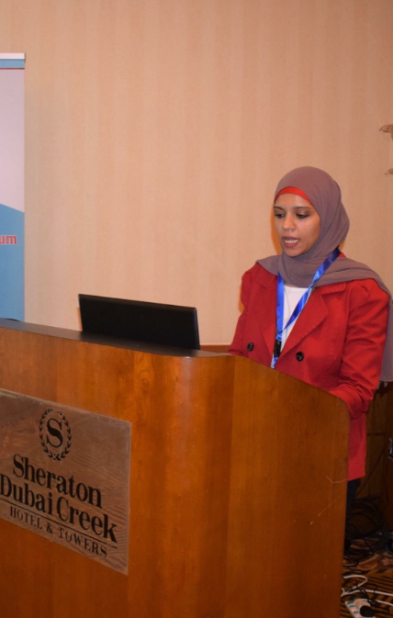
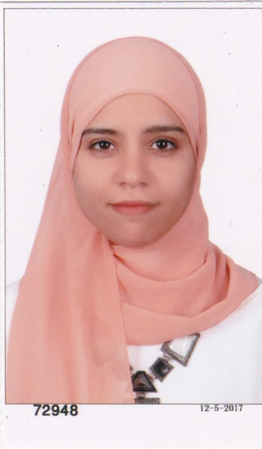

Assistant Lecturer at NODCAR {National Organization for Drug Control and Research} in the Field of Biochemistry responsible for confirming the release of drugs and all biological kits in the Egyptian market according to the Egyptian Ministry of Health, WHO and FDA regulations (QC/QA/R&D).Highly trained to collect various types of specimen and to perform most of laboratory Biological tests. Reviewer at Bioscience reports journal, Biochemical Society (neuroscience). Eight years’ experience as QA&QC. Highly trained and qualified to deal/work on: Mesenchymal stem cells homing and developing techniques, PCR, western blotting technique, electrophoresis, Elisa, spectrophotometer, HPLC, dissolution and disintegration. Successfully trained & passed the QMS ISO 9001:2008 documentation, implantation training & internal audit.
Phone: (+00201000993347)
Email: (mainwr@hotmail.com)

