The efficacy of endovascular embolization in the treatment of blood blister-like aneurysms and intracranial pseudoaneurysms using a rivet-like technique

Shaochun Yang, M.D., Dept. of Neurosurgery, First Affiliated Hospital of Gannan Medical University, China

Renhui Yi, M.D., Dept. of Neurosurgery, First Affiliated Hospital of Gannan Medical University, China Muyun Luo, M.D., Dept. of Neurosurgery, First Affiliated Hospital of Gannan Medical University, China Chuanzhen Qiu, M.D., Dept. of Neurosurgery, First Affiliated Hospital of Gannan Medical University, China

Feng Zheng, M.D., Dept. of Neurosurgery, First Affiliated Hospital of Gannan Medical University, China

Abstract
Statement of the Problem: Supraclinoid internal carotid artery blood blister-like aneurysms (BBAs) and traumatic intracranial pseudoaneurysms (PSAs) are rare but dangerous aneurysm subtypes with high mortality rates. This study is aimed to evaluate the efficacy and safety of endovascular embolization using a Rivet-like technique for treating BBAs and PSAs.

Methodology & Theoretical Orientation: Six patients with ruptured BBAs and 1 patient with PSA of the internal carotid artery underwent endovascular embolization treatment using rivet-like technique were collected from First Affiliated Hospital of Gannan Medical University (Ganzhou, China) between Mar. 2012 and Dec. 2017. Clinical data, including Postoperative cerebral angiography results and follow-up information of patients were analyzed retrospectively.
Findings: Complete treatment using rivet-like technique was achieved in all 7 patients, and the clinical data revealed four patients discharged from the hospital with a mRS score of 1, two with mRs 2 and one with mRS 3. The mRS at 6 months after surgery were as follows: 0 score in 2 patients, 1 scores in 3, 2 scores in 1 and 3 scores in 1. Five patients with angiography follow-up ranged from 3 to 6 months after surgery, and no recurrent aneurysms and parent vessel occlusion were detected at early or intermediate follow-up.
Conclusion & Significance: Our study suggest that rivet-like technique can effectively increase the metal coverage of the aneurysm neck and potential further reduce the rate of aneurysm recurrence, is a viable endovascular option for ruptured BBAs and PSAs of the internal carotid artery. Short-term efficacy is safe and effective, but further experience and follow-up are needed to determine the long-term efficacy of this treatment.

Image
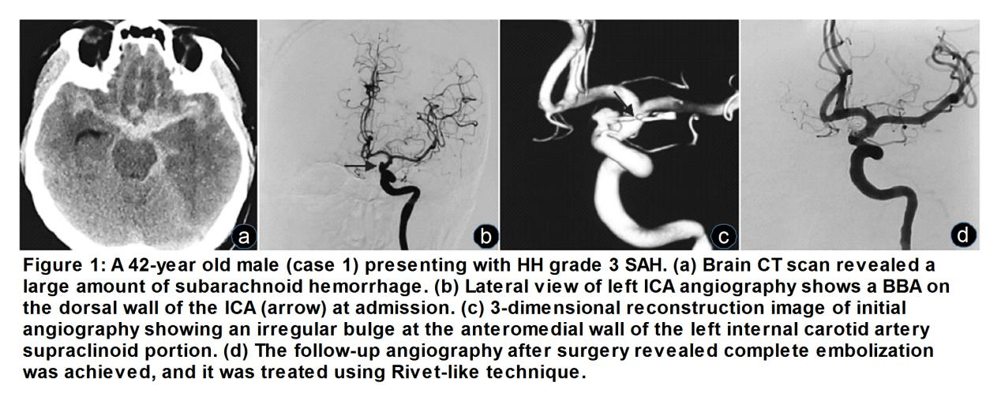
Recent Publications (minimum 5)
- Gaughen JR Jr, Hasan D, Dumont AS (2010) The efficacy of endovascular stenting in the treatment of supraclinoid internal carotid arteryblister aneurysms using a stent-in-stent technique. AJNR Am J Neuroradiol. Jun;31(6):1132-8.
- Yong Cheol Lim, Byung Moon Kim, Sang Hyun Suh (2013) Reconstructive treatment of ruptured blood blister-like aneurysms with stent and coil. Neurosurgery. Sep;73(3):480-8
- Song J, Oh S, Kim MJ (2016) Endovascular treatment of ruptured blood blister-like aneurysms with multiple (≥3) overlappingEnterprise stents and coiling. Acta Neurochir (Wien). Apr;158(4):803-809.
- Brzezicki G, Rivet DJ, Reavey-Cantwell J (2016) Pipeline Embolization Device for treatment of high cervical and skull base carotid artery dissections: clinical case series. J Neurointerv Surg. Jul;8(7):722-8.
- Khattar NK, White AC, Fortuny EM (2017) Management of Unruptured Traumatic Middle Meningeal Artery Pseudoaneurysms through Onyx Embolization. Cureus. Oct 23;9(10)

Biography (150 word limit)
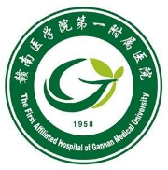
Shaochun Yang，Professor, Director of the department of neurosurgery of First Affiliated Hospital of Gannan Medical University. Dr. Yang has expertise in surgical treatment and basic research in cerebrovascular disease and glioma, especially in endovascular treatment of intracranial aneurysms.
Email: yangshch680709@hotmail.com

