Surgical resolution of severe headache and ataxia caused by Spontaneous spinal cerebrospinal fluid leak secondary to cerebrospinal fluid venous fistula – case report
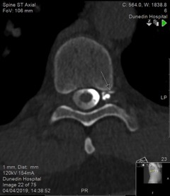
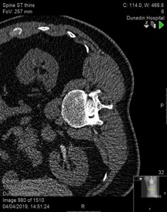
Richard Timoney, MBChB, BSc. UK.
Abstract

CSF venous fistulas (CVF) are a rare and only recently recognised cause of spontaneous spinal cerebrospinal fluid leak (SSCSFL). CVF are notoriously difficult to diagnose yet have been shown to have good surgical outcomes. The case reported highlights the presentation of the first documented case in New Zealand and outlines some of the challenges in diagnosis.

A 63 year old man presented with a long history of headaches, subsequently developing progressive ataxia and cognitive impairment. The patient was initially found to have features of intracranial hypotension on MRI head, though no cause could be elucidated. Multiple neuroimaging techniques were arranged over many years, no evidence of spinal CSF leak could be found. The patient was treated with 3 separate epidural blood patches, each only providing temporary relief. Ultimately a CT myelogram provided evidence of a CVF which was managed surgically with good clinical outcome.

The case reported exemplifies the difficulties in reaching a diagnosis of CVF and the paucity underlying of research. Diagnostic clues in myelography such as: the renal excretion of contrast and the hyperdense paraspinal vein are demonstrated – giving merit to further research.

CT Thoracic myelogram demonstrating Left renal excretion of contrast CT (Right) Thoracic myelogram demonstrating Left T9 CSF-venous fistula (Left)

Dr Timoney is currently an anaesthetic trainee in South Wales. This case report was written when he was working in Dunedin Public hospital in the south Island of New Zealand.

03rtimoney@gmail.com

References

- Jaclyn R Duvall, Carrie E Robertson, et al. [2019] Headache due to spontaneous spinal cerebrospinal fluid leak secondary to cerebrospinal; fluid-venous fistula: case series. Cephalagia;39:1847-1854.
- Peter G. Kranz, MD, Linda Gray, MD, et al. [2019] Spontaneous Intracranial Hypotension: Pathogenesis, Diagnosis and Treatment. Neuroimag Clin N Am; 29:581-594
- Schievink WI, Schwartz MS, Jean-Pierre S, et al. [2016] A classification system of spontaneous spinal CSF leak. Neurology;87:673-9
- Mokri B. [1999] Spontaneous cerebrospinal fluid leaks: From intracranial hypotension to cerebrospinal fluid hypovolemia – evolution of concept. Mayo Clin Proc; 74:1113-1123
- Kranz PG, Tanpitukpongse TP, Choudhury K R, et al. [2016] How common is normal cerebrospinal fluid pressure in spontaneous intracranial hypotension? Cephalgia;36: 1209-1217

