Paroxysmal Autonomic Instability with Dystonia Syndrome: a rare complication of tuberculous meningitis: A Case Report
Lowrence Precious C. Dichoso, MD¹; Gerald T. Pagaling, MD¹; Roland Dominic G. Jamora, MD¹; Veeda Michelle M. Anlacan, MD¹²
¹Department of Neurosciences, College of Medicine and Philippine General Hospital, University of the Philippines Manila, Manila, Philippines
²Department of Neurology, Institute of Neurological Sciences, The Medical City, Pasig City, Philippines

Abstract
We report a 20 -year-old male who developed acute severe brain damage from tuberculous meningitis. The patient then developed paroxysmal episodes of bilateral dystonic extensor posturing accompanied by dysautonomia. The essential features of this episodic autonomic hyperactivity with extensor posturing were hypertension, tachycardia, tachypnea, hyperthermia, and diaphoresis. We diagnosed the patient as suffering from Paroxysmal autonomic instability with dysautonomia (PAID) syndrome, which is a relatively uncommon complication of various central nervous system diseases and usually seen after a traumatic brain injury. A Paroxysmal Sympathetic Hyperactivity Assessment Measure (PSH-AM) scale was used to diagnose and assess severity. PAID syndrome should be distinguished from adrenergic manifestations of sepsis, pulmonary embolism, or seizures and early recognition is essential to avoid unnecessary diagnostics and treatments. In our resource-limited setting, we gave a trial of gabapentin, clonazepam, and propranolol, with observed decrease in episodes of paroxysms. Urgent recognition and treatment are necessary to prevent both complications of PAID and serious iatrogenic complications from the exaggerated response due to autonomic hyperactivity.
Image
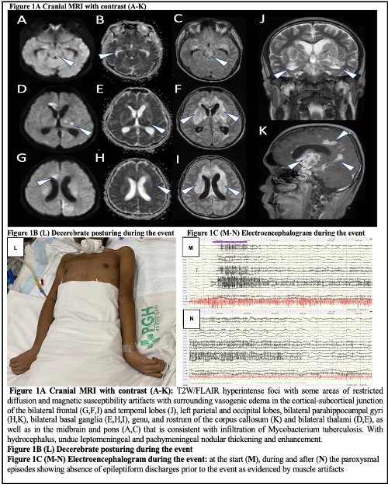
Recent Publications (minimum 5)
Not applicable

Photograph

Biography
Dr Dichoso is an Adult neurology resident in Philippine General hospital and is passionate in improving healthcare in a resource limited setting.
Email: lcdichoso@up.edu.ph

