Household Waste Impacts on Physicochemical Variables in Port Harcourt
DR JOHNBOSCO EMEKA UMUNNAKWE Ph.D
Department of Environmental Management
Federal University of Technology, Owerri. Nigeria.

ABSTRACT
Statement of the Problem Indiscriminate dumping of household wastes in Port Harcourt metropolitan city is assuming alarming status and this condition impacts the natural environment esthetically and health wise. They harbor flies, mosquitoes, rats and other disease vectors, which could cause spread of vector borne diseases such as Malaria, Yellow Fever and Lassa fever. A combination of rapid increase in the population of the city and the unorganized system whereby household wastes are dumped in open lots, on road sides, in gutters and in small suburbs dumps poses risks to public health. The paper aims to show how the present approach to household waste handling impact the physicochemical variables in Port Harcourt metropolis. Method and theoretical orientation. The methodology involved field sampling for water and sediment at three stations; upstream, discharge and downstream laboratory and statistical analysis using standard methods. Soil samples were dug with auger at both top (0-15cm) and bottom (15-30cm) at different radial co-ordinates. Borehole water was collected with containers from stations close to where household wastes are dumped. Findings. The result shows that conductivity, salinity, turbidity, sulphate, phosphate, magnesium, total hardness and lead exceeded WHO limits for drinking water qualities; while pH and manganese also exceeded the limits for sediments. The mean soil pH was acidic at top (2.96) and bottom (3.01), while elevated levels of iron and lead were detected in borehole water, soil, sediment and surface water samples. Conclusion and Significance. The results of the analyzed physicochemical parameters showed that household wastes influences the measured variables negatively and poses health risk to the inhabitants. Constant monitoring serves as a useful tool to determine when allowable limits are exceeded. Recommendations. The number of physicochemical and bacteriological parameters should be increased with more sophisticated methods for calibrating results and monitoring should involve spatial and temporal variations.
IMAGE
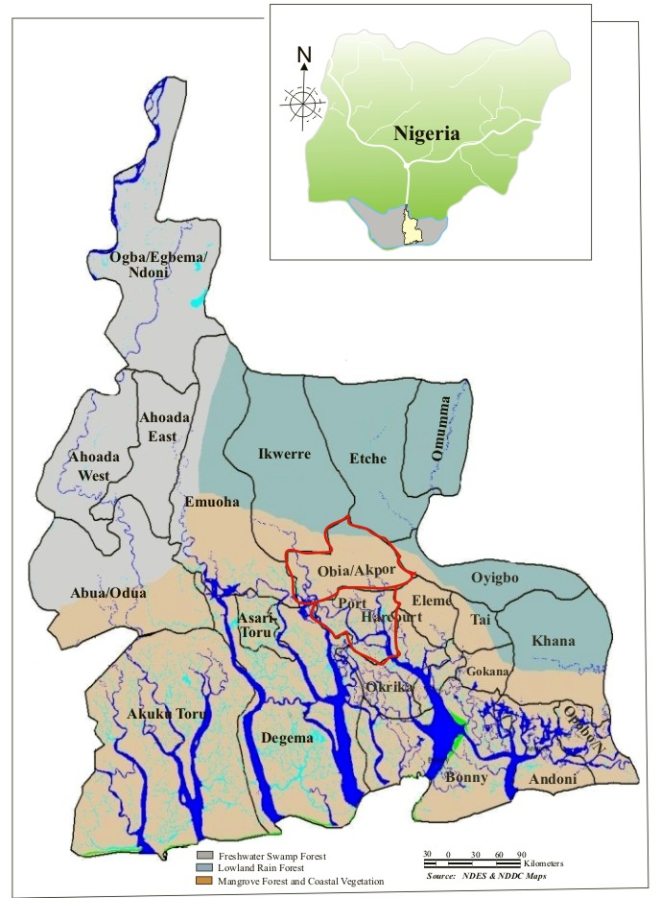
Fig. 1. Map of Rivers State, Nigeria showing Study Area | Obio-Akpor
Fig. 1. Map of Rivers State, Nigeria showing Study Area | Lat.: 4⁰ 38’ 10” | Long.: 7⁰ 00’ 07”
 | Port Harcourt
 | Lat.:4º 43’ 07” | Long.: 6º 56’ 04”
RECENT PUBLICATIONS

1. Amalu T E, Ajake A O (2014) Appraisal of solid waste management practices in Enugu City, Nigerian. Journal of Environmental and Earth Science 4(1): 97 – 98.

2. Ayuba K A, Manaf L A, Sabrina A H, Azmin, S W (2013) Current status of municipal solid waste management practice in FCT Abuja. Research Journal of Environmental and Earth Sciences. 5(6:296 – 304.

3. Ayotamuno M J, Gobo A E (2004) Municipal solid waste management in Port Harcourt, Nigeria; obstacles and prospect. Management of Environmental Quality. An International Journal, 15 (4): 358 – 389.

4. Kpobari W N, Wegwu M O, Essien E B (2013) Heavy metals concentration in four selected seafood from crude oil polluted waters of Ogoniland Rivers State, Nigeria. Archives of Applied Research 5(4): 97 -104.

5. Wood B (2009) Taking waste to new levels The Journal for Waste and Resource Management Professionals. 5: 43 – 45.

Biography
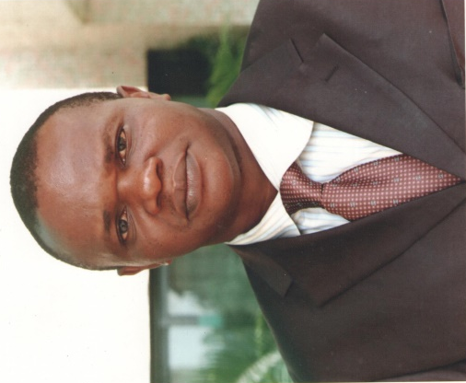

Dr Johnbosco Umunnakwe has his expertise in Environmental Chemistry/Health in areas of water quality, food and household waste for sustainable environment and improved public health. This work is predicated on years of research, teaching in the University, consultancy services and environmental advocacy. The research is based on experiments and questionnaire administration to generate data and elicit information from respondents during field work for research findings. Presently the author lectures in the Department of Environmental Management and a Research Associate in the Institute of Environmental Health and Environmental Justice, Federal University of Technology, Owerri Nigeria. He has also done so much work with the Institute of Pollution Studies, Rivers State University Port Harcourt Nigeria. Dr Umunnakwe is a licensed Public Analyst in the Institute of Public Analysts of Nigeria, a body under the Federal Ministry of Health Nigeria. He is a member of the Nigerian Environmental Society.

