Abstract Template
Abstract Title: Anticonvulsant and anti-inflammatory effects of the polysaccharide rich extract from Genipa americana leaves

Dayanne T. T. Nonato¹, Maria G. Pereira^{1,2}, Raquel M. C. B. Craveiro¹, Anny B. S. Peixoto¹, Letícia F. Lima¹, Samira L. Almeida², Camila Fernandes¹, Ana M. S. Assreuy¹, Gislei F. Aragão³, Edna M. C. Chaves¹
¹Universidade Estadual do Ceará, Instituto Superior de Ciências Biomédicas- ISCB, Av. Dr. Silas Munguba, 1700, Itaperi, 60714-903, Fortaleza, Brazil.
² Laboratório de Polissacarídeos Bioativos, Faculdade de Educação Ciências e Letras do Sertão Central (FECLESC/UECE), Quixadá-CE, Brazil.
³Núcleo de Pesquisa e Desenvolvimento de Medicamentos (NPDM), Universidade Federal do Ceará, Fortaleza, Brazil.

Abstract (not more than 300 words)

Plant polysaccharides present some activities involving the central nervous system, such as neuroprotective, antidepressant, antioxidant and anti-inflammatory. We aim to evaluate the anticonvulsant and anti-inflammatory effects of the polysaccharide rich extract from G. americana leaves in mice. The leaf dry powder (5 g) was depigmented in methanol and the polysaccharide-rich extract (PRE) obtained by extraction with NaOH followed of precipitation in absolute ethanol. PRE was dissolved in 0.9% NaCl and administered (9 mg/kg) in male Swiss mice (25-35 g) by intraperitoneal (i.p.) route, 30 min before seizures induced by a single dose of pentylenetetrazole (PTZ: 70 mg/kg, i.p), n=7/group. The synergism of PRE effect was evaluated by its association with diazepam (DZP: 0.01 mg/kg). After euthanasia, the prefrontal cortex (CPF), hippocampus (HC) and striatum (EC) were removed for the quantification of myeloperoxidase levels (MPO) by o-dianisidine method. Experimental protocol was approved by Animal Ethics Committee (UECE Nº 2451142/2014). The PRE increased the seizure latency (9 mg/kg: 171,7 ± 29,62 versus saline: 62.00 ± 4,709 s) and death latency (9 mg/kg: 597.4 ± 101,5 versus saline: 150.0 ± 14.52). The association of PRE with diazepam potentiated the protective effect of DZP, increasing seizure latency (DZP: 128,3 ± 24,62 versus PRE + DZP: 222.4 ± 47.57), without altering in death latency. MPO levels was reduced in hippocampus (PRE: 34.24 ± 7.167, DZP: 42.27 ± 9.559 and DZP + PRE: 31.26 ± 5.726 versus saline + PTZ: 81.91 ± 11.70) and striatum (PRE: 17,89 ± 3,310, DZP + PRE: 18.69 ± 3.776 versus saline + PTZ: 37.27 ± 5.169). However there was no difference between groups (DZP, PRE or DZP + PRE) in each brain area. We conclude that PRE of G. americana leaves protects against seizures and promote anti-inflammatory effects in brain.
Keyword- Anti-inflammatory, Genipa Americana, plant polysaccharide, seizures.
Sponsor's names: (CNPq/ CAPES/FUNCAP)

Fig. 1
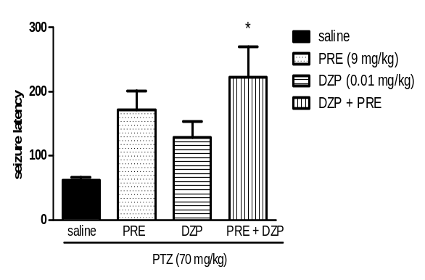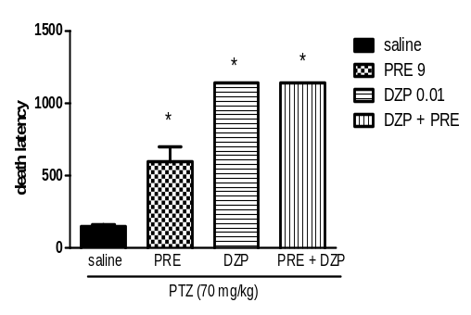

Fig 2
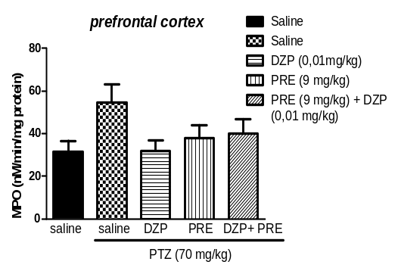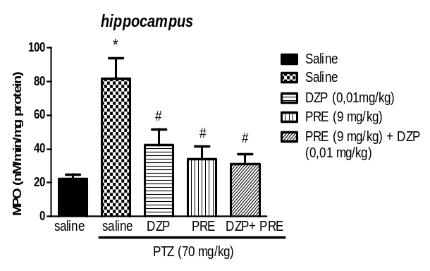
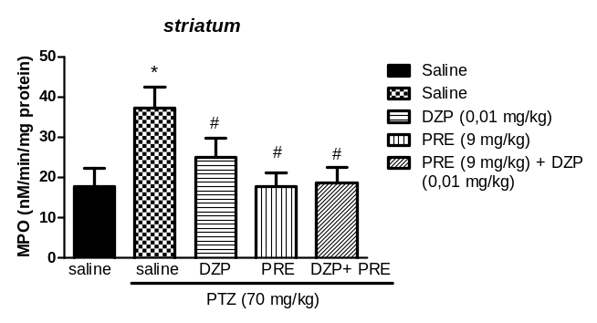

Professional Biography

Edna Maria Camelo Chaves finished her doctorate at the age of 6 at the Federal University of Ceará, in Pharmacology. She is an Adjunct Professor at the State University of Ceará, working in the Graduate Program in Physiology and Nursing. She has published more than 13 articles in renowned magazines and has served as a reviewer of scientific journals.


Paste your Photograph here

Email Id: ednacam3@gmail.com

Any Comments:

