Reversible cerebral vasoconstrictive syndrom and differential diagnostics of migraine
E.M.Tashkenov, G.S. Rakhimboeva, D.T.Abdukodirova, U.T.Abdukodirov, E.M. Mirkhidoyatov
Andizhan State Medical Institute (Uzbekistan).
Key words: Reversible cerebral vasoconstriction syndrome, migraine,
Reversible cerebral vasoconstriction syndrome (RCVS) is characterized by cerebral blood vessels segmental vasoconstriction, spontaneous recurrent vasodilation within 3 months, impairment of cerebral arteries regulation. One of the main symptoms proved to be intensive course severe headache. The disease of migraine initially begins with the headache; then this condition is followed by moderate paroxysmal intensification, pulsating headache and nausea.
Investigation of reversible cerebral vasoconstriction syndrome and differential diagnostics of migraine.
Investigation included examination of neurological patients who were undergone both In- and Out- Patient treatment in Neurological Department of Andizhan State Medical Institute; magnetic resonance angiography examination was carried out by Namangan Anamed Medical Service. 60 patients have been studied. They were divided into two groups. The first group included 35 patients with reversible cerebral vasoconstriction syndrome. The second group included 25 patients with migraine. There were 17 male(48,5%) and 18 females(51%) aged 29-72, the average age is 50,5 years old within the first group. There were 10 male(40 %) and 15 females(60%) aged 15-45, the average age is 30 years old within the second group. Patients of the first group suffered from severe intensive headaches(Visual Analog Scale - VAS) onset of headache was initiated within few minutes and aggravated on physical exertion. According to MMSE (Mini – Mental State Examination), 25 patients (72%) from the first groupdemonstrated 24-27 points; mild cognitive impairments have been observed during examination of neurological condition; the rest 10 patients(28%) demonstrated 28-30 points. Cerebral arterial vasoconstriction was observed in patients of the first group on magnetic resonance angiography examination.
Patients of the second group suffered from moderate intensive headaches(VAS); onset of headache was initiated within few hours, neurologic examination failed to reveal any pathologic changes. According to MMSE, the first group patients demonstrated 28-30 points. Cerebral arterial vasoconstriction was not observed in the second group patients on magnetic resonance angiography examination.
In comparison with migraine,reversible cerebral vasoconstriction syndrome results from severe intensive headaches within short period of time, mild cognitive impairments are observed, cerebral vasoconstriction is observed on magnetic resonance angiography examination.
Title | scientific degree of PhD
First  name | Elyor
Last  name | Tashkenov
 | 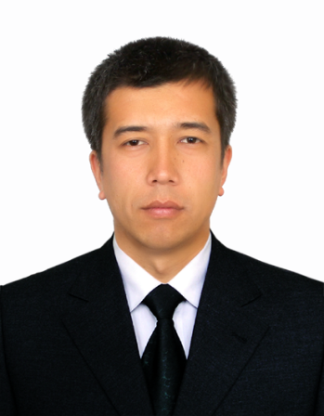
Affiliation | Andizhan State Medical Institute, department of Neurology.
EDUCATION: | 1993-2004 Secondary School №9 (Uzbekistan, Andizhan, Asaka city.)  2005-2012  Andizhan State Medical Institute, Bachelor degree.  2013-2016  Andizhan State Medical Institute, Master degree  2016-2017  Andizhan State Medical Institute, department of neurology, assistant professor.  2018  Andizhan State Medical Institute, scientific degree of PhD  PhD paper title: Reversible cerebral vasoconstrictive syndrome, diagnostics and optimization of treatment methods.
Fields of clinical and research interest: | The main fields of my clinical researches are neurology. I am interested in differential diagnostics and treatment headache.

