OPTIMIZATION OF MANAGEMENT OF PRIMARY CHRONIC HEADACHE WITH THE USE OF BOTULOTOXIN A
Anna Prokhorova, Nigora Kadyrkhodjayeva

¹Anna Prokhorova (Tashkent Medical Academy)
²Nigora Kadyrkhodjayeva (Tashkent Medical Academy)

Abstract
GOAL: The aim of the study was to review the quality of life of the patients with daily chronic headache (CDH) and determine the effectiveness of Botulinum toxin type A (BTA) influence on improving the quality of life by reducing the daily headache.
MATERIAL AND METHODS: Fifty-four patients, from both sexes, with a minimum age of 18 years old were studied. The inclusion criteria were the presence of primary daily chronic headache with more than 4-hour duration, a frequency of 15 days or more monthly, in the last three months and a disease duration of 3 years. For the treatment of CDH was used BTA. The study involved 54 patients, of whom where 31 women and 23 men with an average age of 42 years. The patient’s condition was evaluated on the third day, on the 7th day and on the 15th day after the BTA injection and assessed every 15 days for 3 months. The efficacy of BTA was evaluated by several measurements of VAS (Visual Analog Scale), Headache Intake Questionnaire: HSQoLQ (Headache Specific Quality of Life Questionnaire), HMQ (Headache Management Questionnaire), HDQ (Headache Disability Questionnaire).
RESULTS: After 3 months 2 (4%) patients had no changes, 7 (13%) patients with less than 50 percent reduction in pain, 23 (43%) reported 70 to 95 percent pain relief, and 22 (40%) had complete relief.
CONCLUSION: The work presented here has profound implications for future studies of BTA injections for patients with CDH. The obtained results testify to an improvement in the quality of life of patients with CDH against the background of injections of BTA.

Keywords—Botulinum toxin type A injection, Daily chronic headache, Primary headache.

Professional Biography

My name is Kadyrkhodjayeva Nigora. I finished my study at the Tashkent Medical Academy in 2006. After that, I was studying Psychiatry and Psychotherapeutics from 2006 till 2007 at the Tashkent Institute of Postgraduate Medical Education. I was trained in Neurology at the Tashkent Institute of Postgraduate Medical Education 2007-2009. I have been practicing as a Neurologist since 2009. I passed Clinical attachment in Neurology Department of Rashid Hospital, Dubai, UAE. I have valid practice license from UAE. I successfully passed BLS&ACLS course in 2018 and have Certificate. From September 2017 I study my Ph.D. at the Tashkent Medical Academy. I have published 3 articles in reputed journals and several articles, abstracts in local journals.

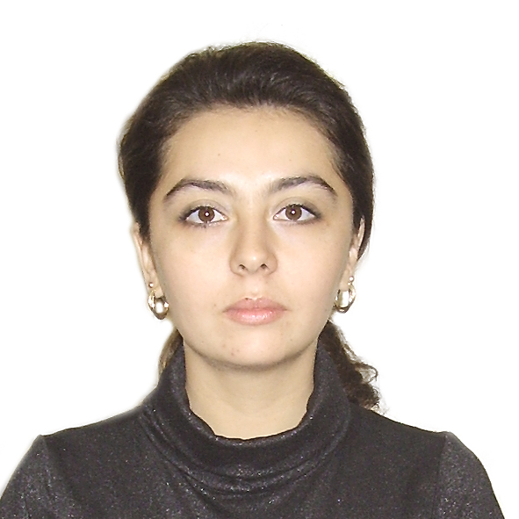

Email Id: kadyrkhodjayeva@hotmail.com

Any Comments:
Good day, dear. Mr./Mrs./Ms.!

I am a young specialist from Uzbekistan who currently study Ph.D. in Tashkent Medical Academy.
I would like to become a part of your prestigious organization and I would be very happy if you could print my abstract and article in your journal. Since this will greatly help me in my work to move forward one step further. Sincerely I hope that my work will interest you.

If you have any further questions, please feel free to contact me.
Thank you for your time and consideration.

Best regards,
Dr. Nigora Kadyrkhodjayeva

