Investigating visual strategies during the recognition of static and dynamic facial affect in TBI and control cohorts
- Leanne Greene, Sheffield Hallam University, UK
- Dr Lynne Barker, Sheffield Hallam University, UK
- Dr John Reidy, Sheffield Hallam University, UK
- Dr Nicholas Morton, Rotherham Doncaster and South Humber NHS Trust, UK
- Alistair Atherton, Sheffield Community Brain Injury Rehabilitation Team, UK
Abstract
Objectives: TBI often precipitates socioemotional problems which impinge on social relationships. Although socioemotional impairments are debilitating the mechanisms underpinning these are poorly understood. Social interactions are dynamic yet research frequently employs static assessments. We investigated eye scan patterns of TBI and controls viewing static/dynamic facial expressions.
Design: Factorial analysis investigated correct response, reaction time, fixation duration/count to areas of interest (eyes, nose, mouth) across six emotions (anger, disgust, fear, happy, sadness and surprise).
Methods: Seventeen TBI participants were recruited from the NHS and age/gender matched controls were recruited using stratified opportunity sampling. Images from the Amsterdam Dynamic Facial Expression Set (ADFES) were presented on a Tobii T120 Eye Tracker screen. Multivariate and correlational methods were used to analyse data.
Static Results: Controls displayed greater fixation durations and counts to eyes and were more accurate and quicker identifying emotions than TBI participants. The TBI group focused more on the nose compared to controls. Higher scores on the ADFES correlated with quicker responses across all emotions for all participants and positive relationships between empathy, emotion recognition and fixation patterns were revealed. Gaze-patterns for the six emotions differed slightly between the groups although fearful faces induced more/longer fixations and happy faces the least/shortest fixations.
Dynamic Results: Controls were more accurate at identifying emotions than the TBI group but no group differences were found for gaze-patterns. Happy faces induced more/longer fixations and sad faces the least/shortest fixations. A positive correlation between correct scores on the ADFES and empathy scores across all emotions for all participants was established.
Conclusions: Irregular gaze-patterns could underpin some socioemotional problems after TBI, highlighting the potential for innovative rehabilitation approaches. Visual strategies underlying the recognition of static/dynamic emotions may differ. The key limitation was the small sample size which will hopefully be rectified in future work.
Keywords: AOI, brain injury, eye tracking, facial expressions.

Oral or poster presentation

l.greene@shu.ac.uk

01302 796336


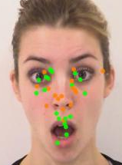
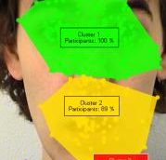
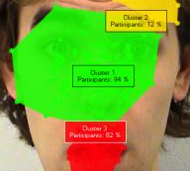

A
B
Figure 1. A cluster map to illustrate the disparity between eye scan patterns of the TBI group (A) and control group (B) when viewing a static surprised facial expression. The cluster map visually represents areas with high concentrations of gaze data.

Figure 2. A bee swarm to illustrate the visual strategies of TBI (orange dots) and control participants (green dots) when viewing a dynamic surprised facial expression. The bee swarm displays gaze fixation of all participants in the form of points that attract the most attention. This image displays a stop-frame on the 4th second of a 5 second video.

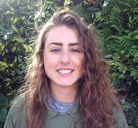
Biography
Leanne has completed a BSc in Psychology and an MSc in Applied Cognitive Neuroscience. She is near the completion of her PhD, supported by Sheffield Hallam University, which has investigated social cognition and saccadic eye scan patterns in TBI and control groups. She currently works as an Assistant Psychologist for Rotherham Doncaster and South Humber NHS Trust in the Neuro Rehabilitation Outreach and Stroke team. Socioemotional problems post-TBI are often not assessed or rehabilitated (Kelly, McDonald & Frith, 2016) and Leanne is passionate about raising awareness of social cognition after TBI and in the future developing contemporary and ecologically valid clinical assessments and rehabilitation programmes.

