The mirror neuron system in the successful aging: new opportunities neuropsychological tasks
Alexander Erzin, PhD in Clinical Psychology, OrSMU, Orenburg, Russia
Anastasiia Kovtunenko, Orenburg Regional Clinical Psychiatric Hospital No. 1, Orenburg, Russia

This publication was prepared with the support of a grant from the President of the Russian Federation
(No. MK-5837.2018.6, agreement No. 075-15-2019-105)

Abstract (300 word limit)
Since the discovery by Rizzolatti in the 80-90s of the 20th century the first mirror cells in the premotor cortex, the researchers found various functional specialization subsystems of mirror neurons in other cortical and subcortical brain structures: somatosensory, auditory cortex, limbic system. The aim of our study was to establish the nature of the influence of the mirror neurons systems on perceived successful aging in the elderly. The study involved 26 people (70.56 ± 9.9), of which 9 males and 17 females. The control group included 18 young people (21-22 years old). To assess subjective well-being, the "Index of successful aging" Inventory was used. The mirror neurons was studied by means of 24 video and audio clips and images that we developed that supposedly stimulate the activity of mirror-cell networks of different functions: motor, tactile, emotional, and acoustic nonverbal networks. The study showed that the accuracy of identifying emotional and acoustic stimuli has the most positive effect on successful aging. The subjective assessment of emotional stimuli has a negative effect. Excessive affectation serves as a negative predictor of successful aging, while attaching importance to tactile and acoustic stimuli has a positive effect on it.

Image
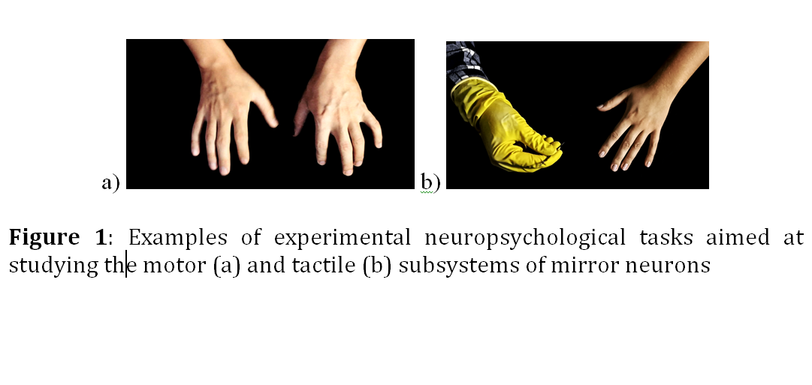
Recent publications (minimum 5)
- Avenanti, A., Bueti, D., Galati, G., Aglioti, S.M. Transcranial magnetic stimulation highlights the sensorimotor side of empathy for pain. Nat. Neurosci., 8 (2005): 955-960.
- Bonini, L., Rozzi, S., Serventi, F.U., Simone, L., Ferrari, P.F., Fogassi, L. Ventral premotor and inferior parietal cortices make distinct contribution to action organization and intention understanding. Cereb. Cortex. 2010; 20: 1372–1385.
- Erzin, A.I., Kovtunenko, A.Yu. (2019). Neurocognitive functions in successful aging. Part 1: The state of the art. Neurodynamics. Journal of clinical psychiatry and psychiatry, 1(1): 1–18. http://doi.org/10.5281/zenodo.3484717
- Ferrari, P.F., Rizzolatti, G. Mirror neuron research: the past and the future. Philos. Trans. R. Soc. Lond. B: Biol. Sci., 369 (2014), p. 20130169.
- Ishida, H., Nakajima, K., Inase, M., Murata, A. Shared mapping of own and others' bodies in visuo-tactile bimodal area of monkey parietal cortex. J. Cogn. Neurosci. 2010; 22: 83–96.

 Biography (150 word limit)
Alexander Erzin is an associate professor at the Department of Clinical Psychology and Psychotherapy at the Orenburg Medical University, Russian Federation. Clinical psychologist. Educational psychologist. Lecturer in neuropsychology, clinical neuropsychology and psychophysiology. Editor-in-chief of The "Neurodynamics. Journal of Clinical Psychology and Psychiatry". Head of the Council of Early Career Specialists of the Russian Society of Psychiatrists. Curator of psychophysiological and clinical psychological laboratory.

Email: alexerzini@gmail.com

Notes/Comments:

