Approaches to immunomodulation in relapsing multiple sclerosis.

Alexey Boyko

The BCD-132 and BCD-054 (JSC BIOCAD, Russia) are novel immunomodulating therapeutic options for relapsing form of multiple sclerosis (MS) treatment.

The BCD-054 is a conjugate of recombinant human interferon β1a and linear polyethylene glycol (PEG) with a molecular weight of 30kDA. Such conjugation decreases renal clearance, increases half-life of drug and, consequently, allows to prolong the duration of action and reduce the frequency of injections compared with non-pegylated forms of interferon.

The interim 20-week results of BCD-054 III phase study showed significant reduction in brain MRI disease activity on PEG interferon β1a therapy compared with placebo. It was proven, what two studied doses of BCD-054 superior to placebo for the primary efficacy endpoint represented by combined unique active (CUA) lesion counts. Assessment of clinical performance demonstrated the reduction of relapse rate: BCD-054 180 μg - 10, 62%, BCD-054 240 μg - 6,14%, low dose interferon β1a (LIB) - 15,93%, placebo - 15,79%.

Another potential treatment of MS is BCD-132, an innovative the 3rd generation humanized afukosylated anti-CD20 antibodies. It has increased affinity for FcγRllla, thereby effectively induces antibody-dependent cytotoxicity and antibody dependent phagocytosis.

Direct strictly specific effect of BCD-132 on B lymphocyte in a wide range of doses (100-1000 mg) was established by dynamic assessment of such cells lever in phase I clinical trial after intravenous administration of increasing doses in two dosage regimens.

The obtained data shows that BCD-132 has an expected pharmacodynamic effect of long-term depletion of CD19⁺ and CD20⁺ B cell lineage and an acceptable safety profile when used to treat patients with MS in all studied doses.

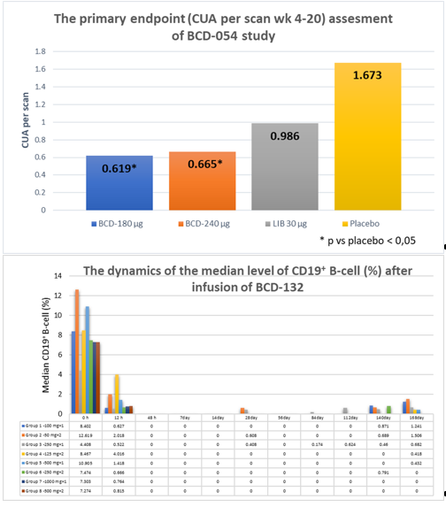

Recent publications (minimum 5)
- Melnikov M., Rogovskii V., Boyko A.N., Pashenkov М. Dopaminergic Therapeutics in Multiple Sclerosis: Focus on Th17-Cell Functions. J Neuroimmune Pharm 2019, April 1, https://doi.org/10.1007/s11481-019-09852-3
- Baulina N, German G, Kiselev I, Popova E, Boyko A, Kulakova O, Favorova O. MiRNAs from DLK1-DIO3 imprinted locus at 14q32 are associated with multiple sclerosis: Gender-specific expression and regulation of receptor tyrosine kinases signaling. Cells 2019, 8, 133; doi:10.3390/cells8020133
- Kiselev I, Bashinskaya V, Baulina N, Kozin M, Popova E, Boyko A, Favorova O, Kulakova O. Genetic differences between primary progressive and relapsing-remitting multiple sclerosis: The impact of immune-related genes variability. MSRD 2019, 29: 130-136 doi.org/10.1016/j.msard.2019.01.033
- Boyko AN, Boyko OV. Cladribine tablets’ potential role as a key example of selective immune reconstitution therapy in multiple sclerosis. Degenerative Neurological and Neuromuscular Disease. 2018, 8: 35–44 doi: 10.2147/DNND.S161450
- Melnikov M, Rogovskii V, Boyko A, Pashenkov M. The influence of biogenic amines on Th17-mediated immune response in multiple sclerosis. MSRD 2018: 21 19–23 doi: 10.1016/j.msard.2018.02.012

- Baulina N, Kulakova O, Kiselev I, Osmak G, Popova E, Boyko A, Favorova O. Immune-related miRNA expression patterns in peripheral blood mononuclear cells differ in multiple sclerosis relapse and remission. J Neuroimmunol 2018, 317: 67-76 https://doi.org/10.1016/j.jneuroim.2018.01.005
- Boyko A. Kobelt G, Berg J, Boyko O, Popova E, Capsa D, Eriksson J, The European Multiple Sclerosis Platform. New insights into the burden and costs of multiple sclerosis in Europe: Results for Russia. Mult Sler 2017, 23(2S): 155-165 doi: 10.1177/ 1352458517708668
- Alroughani R, Boyko A. Pediatric multiple sclerosis: a review. BMCNeurology 2018, 18: 27 doi:10.1186/s12883-018-1026-3
- Boyko A, Melnikov M, Zhetishev R, Pashenkov M.The Role of biogenic amines in the regulation of interaction between the immune and nervous systems in Multiple Sclerosis. Neuroimmunomodulation. 2016; 23(4): 217-223. doi: 10.1159/000449167
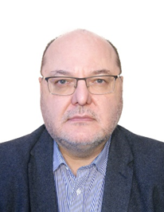
Alexei Boyko gained his MD and PhD from the Russian State Medical University, Moscow and has been Professor of the Department of Neurology and Neurosurgery at this university since 1997. He was the Chief Neurologist of the Department of Health Care of the Government of Moscow in 2001-2015, Director of the Moscow Multiple Sclerosis Center in 2004-2014 and Director of the MS Clinical and Research Center of Neuroclinic since 2015, Director of the Neuroimmunological Department of the Federal Center CVPS. Professor Boyko has been a member of the "Oslo International Think-tank on MS Epidemiology, Analytical Approaches to Study of the Aetiology" at the Center for Advanced Studies of the Norwegian Academy of Science and Letters in 1994-1995, and worked at UBC MS Center in 1998 (Vancouver, Canada). He is also a member of the Presidium of the All-Russian Society of Neurologists, Co-ordinator of the Medical Consulting Boards of Moscow and All-Russian MS Societies, President of RUCTRIMS, member of ECTRIMS Council.
Email: boykoan13@gmail.com

Notes/Comments:

