Speedy/RINGO as a neuroprotector in neurodegeneration
Aysegul Yildiz, PhD, Mugla Sitki Kocman University, Faculty of Science, Molecular Biology and Genetics Department, Mugla, Turkey.
Yesim Kaya, MSc, Mugla Sitki Kocman University, Faculty of Science, Molecular Biology and Genetics Department, Mugla, Turkey.
Seren kucukvardar, MSc, Istanbul Technical University, Molecular Biology - Genetics and Biotechnology Programme, Istanbul, Turkey.

Abstract
Statement of the Problem:Neurodegeneration is the progressive loss of function and structure of neurons that cause neuronal cell death. Although neurodegeneration is a multifactorial process, one of the main causative factors is elevated intracellular calcium levels which leads to apoptosis by inducing p53, thus negatively affecting two pathways:mitogenic extracellular signal-regulated kinase/mitogen activated protein kinase(ERK/MAPK) and survival phosphoinositide 3-kinase/protein kinaseB(PI3K/AKT) pathways. Speedy/rapid inducer of G2/M progression in oocytes (Speedy/RINGO) is a cell cycle regulatory protein that increases survival of p53-positive mitotic cells by inhibiting the apoptosis. Moreover,we showed for the first time that this protein elicits p53-dependent anti-apoptotic effects in calcium-induced degenerated primary hippocampal neurons. Methodology&Theoretical Orientation: Our laboratory is currently investigating whether Speedy/RINGO exerts this anti-apoptotic function through ERK/MAPK and PI3K/AKT pathways. For this purpose, we used undifferentiated p53 and Speedy/RINGO-expressing neuronal-like neuroblastoma cells as preliminary model. Findings:Our previous investigations indicated that Speedy/RINGO protects neurons against calcium-mediated p53-dependent apoptosis without decreasing p53 levels. This finding implies that the anti-apoptotic effect of Speedy/RINGO is downstream of p53 activation, not directly on p53 itself. The most remarkable downstream targets of p53, in terms of generating an apoptotic effect on neurons, are ERK/MAPK and PI3K/AKT pathways. Within this context, silencing of the Speedy/RINGO gene significantly alters expression levels and phosphorylation states of certain members of these pathways. This leads to apoptotic death of neuroblastoma cells, likely due to the absence of Speedy/RINGO’s regulatory function on these two pathways. Conclusion&Significance:Preliminary data indicates that Speedy/RINGO plays an essential role on the regulation of ERK/MAPK and PI3K/AKT pathways that directly affect the apoptotic state and survival rate of cells giving insights about molecular mechanism of Speedy/RINGO in neuronal survival. However, to understand the exact mechanism of Speedy/RINGO’s anti-apoptotic function in neurons, studies is being performed in our laboratory both with in vitro degenerated primary neuron models.

Image
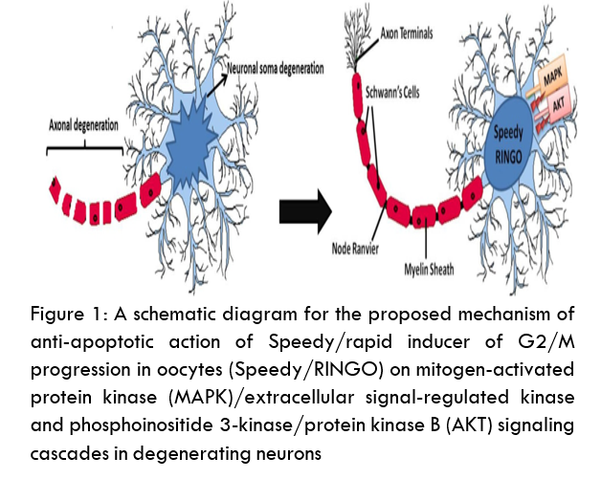
Recent publications
- Yildiz Unal A, Korulu S, Karabay A (2012) SpeedyRINGO inhibits calpain-directed apoptosis in neurons, J Alzheimers Dis 31:779-91.
- Sonkusare SK, Kaul CL, Ramarao P (2005) Dementia of Alzheimer’s disease and other neurodegenerative disorders – memantine, a newhope. Pharmacol Res 51:1–17.
- Kaya Y, Yildiz A (2018) Speedy/RINGO: A Molecular Savior in Spinal Cord Injury-Based Neurodegeneration?, Neuroimmunology and Neuroinflammation 6:5.
- Huang H, Liu H, Yan R, Hu M (2017) PI3K/Akt and ERK/MAPK signaling promote different aspects of neuron survival and axonal regrowth following, rat facial nerve axotomy, Neurochem Res 42:3515-24.
- Golipour A, Myers D, Seagroves T, Murphy D, Evan GI, et al. (2008) The Spy1/RINGO family represents a novel mechanism regulating mammary growth and tumorigenesis, Cancer Res 68:3591-600.


Biography
Aysegul Yildiz has her expertise in neurodegeneration and prevention of neurodegenerative diseases. She focused on Speedy/RINGO protein which has an anti-apoptotic effect in DNA-damaged mitotic cells, allowing for their survival. She has firstly demonstrated that Speedy/RINGO used as an alternative to prevent neural death in neurodegenerative diseases. She works as an Assistant Professor in Mugla Sitki Kocman University at Molecular Biology and Genetics Department.
Email: aysegulunal@mu.edu.tr

Notes/Comments:

