Neuroinflammation and chronic psychiatric disorders
Dr. Barış Önen Ünsalver, MD, Uskudar University, Istanbul, Turkey

Abstract (300 word limit)

Various studies have indicated that inflammation might have a significant role for the development of psychiatric disorders such as depression, anxiety, alcohol use disorder, schizophrenia, autistic spectrum disorders and neurodegenerative disorders like Alzheimer’s disease.

The evidence that has accumulated over the years suggests that there exists a cross-talk between the neurotransmitters and the immune system. This cross-talk might have a role in the etiology of psychiatric disorders. Inflammation may affect different neurotransmitter systems. For example, inflammation may increase the expression and function of serotonin transporter and GABA receptors in the hippocampus, or induces the enzyme indoleamine 2,3-dioxygenase, which may eventually influence glutamatergic neurotransmission. Immune cells are also adept at synthesizing and releasing neurotransmitters like GABA. GABA exposure inhibits the inflammatory response in vitro and in vivo, in a mouse model of obesity. This cross-talk can influence the response to anti-depressant drugs. In fact, one mechanism in the therapeutic effects of antidepressants might be their anti-inflammatory effects. Inflammatory response markers like IL-6, TNF-alpha, and CRP in plasma decrease over time in patients that respond to treatment.

The suggested sources of inflammation in psychiatric diseases are psychological stress, early life stress, obesity, inflammatory diet (high-fat diet, imbalance of n-6/n-3 polyunsaturated fatty acids), oxidative stress due to ethanol metabolism, insufficient sleep and unbalanced gut microbiota.

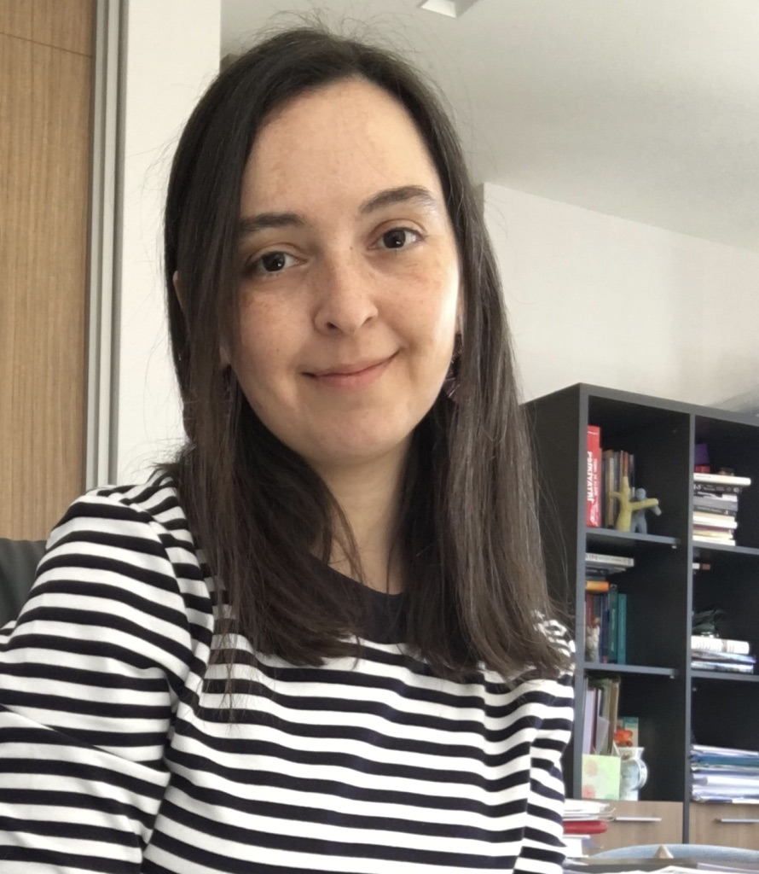
In this session cases of neuroinflammation in chronic psychiatric disorders will be presented with a brief review of current literature on the subject.

Recent Publications (minimum 5)
- Fuglewicz AJ, Piotrowski P, Stodolak A. Relationship between toxoplasmosis and schizophrenia: A review. Adv Clin Exp Med. 2017 Sep;26(6):1031-1036. doi:10.17219/acem/61435.
- Wang TY, Lee SY, Hu MC, et al. More inflammation but less brain-derived neurotrophic factor in antisocial personality disorder. Psychoneuroendocrinology. 2017 Nov;85:42-48. doi:10.1016/j.psyneuen.2017.08.006.
- Bhakta A, Gavini K, Yang E, Lyman-Henley L, Parameshwaran K. Chronic traumatic stress impairs memory in mice: Potential roles of acetylcholine, neuroinflammation and corticotropin releasing factor expression in the hippocampus. Behav Brain Res. 2017 Sep 29;335:32-40. doi:10.1016/j.bbr.2017.08.013.
- Kajitani K, Yanagimoto K, Nakabeppu Y. Serum galectin-3, but not galectin-1, levels are elevated in schizophrenia: implications for the role of inflammation. Psychopharmacology (Berl). 2017 Oct;234(19):2919-2927. doi:10.1007/s00213-017-4683-9.
- Kim YK, Won E. The influence of stress on neuroinflammation and alterations in brain structure and function in major depressive disorder. Behav Brain Res. 2017 Jun 30;329:6-11. doi: 10.1016/j.bbr.2017.04.020.
- Bjorklund G, Saad K, Chirumbolo S, Kern JK, Geier DA, Geier MR, Urbina MA.Immune dysfunction and neuroinflammation in autism spectrum disorder. Acta Neurobiol Exp (Wars). 2016;76(4):257-268.
- Neupane SP. Neuroimmune Interface in the Comorbidity between Alcohol Use Disorder and Major Depression. Front Immunol. 2016 Dec 27;7:655. doi: 10.3389/fimmu.2016.00655. eCollection 2016.

Photograph

Biography (150 word limit)
Dr. Barış Önen Ünsalver is currently an Assistant Professor of Psychiatry at the Uskudar University, Istanbul, Turkey. She has been working at the NP Istanbul Brain Hospital for 9 years. She has been working in the area of neuropsychiatry, neuropsychophilosophy, and published over 40 papers in peer-reviewed journals, as well as invited chapters in books. Her research and clinical interests focus on psychosomatics, neurophilosophy and brain-stimulation therapies in neuropsychiatric disorders.
Email: baris.unsalver@uskudar.edu.tr

Notes/Comments:

