The Serum Amyloid β Level in Multiple Sclerosis: A Case-Control Study
Dr. Keyvan Ghadimi, MD, Isfahan, Iran

Abstract (300-word limit)

Background: Multiple sclerosis (MS) is one of the most common autoimmune diseases in adults that cause disability in patients. Different studies were conducted on the more rapid diagnosis of the disease such as measuring serum or cerebrospinal fluid (CSF) contents.

Objectives: The current study aimed at measuring amyloid β (Aβ) serum levels in patients with relapsing-remitting MS.

Materials and Methods: In the current case-control study, the serum levels of Aβ were measured in 48 patients with RRMS and 33 healthy controls using the enzyme-linked immunosorbent assay (ELISA) technique in Isfahan, Iran, from 2014 to 2016. Data analysis was conducted with SPSS.

Results: The mean serum level of Aβ in the case (patients with RRMS) and control groups were 192.75±125.65 and 128.11±85.20 pg/mL, respectively; so serum Aβ levels in the RRMS group was significantly higher than healthy controls (p=0.02). Also, there was a significant positive correlation between the serum Aβ levels and the expanded disability status scale (EDSS) (r=+0.85, p<0.0001).

Conclusions: Owing to the increase of serum Aβ level in patients with RRMS and its significant increase in severe MS cases (higher EDSS scores), so serum Aβ level can be considered as a marker for MS and its progression.
Image
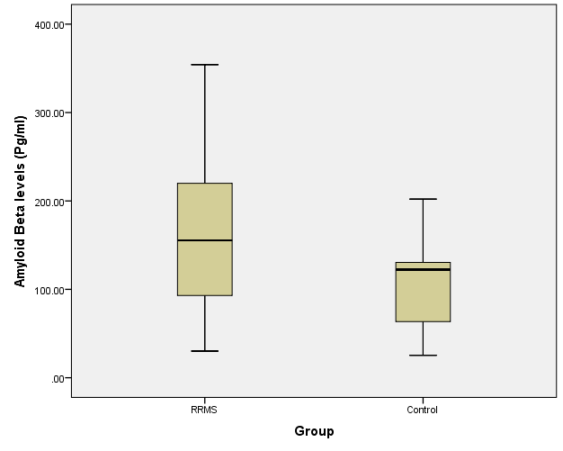
Recent Publications (minimum 5)
- Farrokhi, M., Dabirzadeh, M., Dastravan, N., Etemadifar, M., Ghadimi, K., Saadatpour, Z., & Rezaei, A. (2016). Mannose-binding Lectin Mediated Complement Pathway in Autoimmune Neurological Disorders. Iranian Journal of Allergy, Asthma, and Immunology, 15(3), 251.‏
- Dehghani, M., Sahranavard, A., Ghadimi, K., & Andalib, A. (2017). Outcomes of Fixation of Radial Head Fractures with Kirschner Wire (K-Wire) in Adult Patients with Terrible Triad of Elbow Dislocations. Journal of Orthopedic and Spine Trauma, (In Press).‏
- Abbasi S, Ghasemi M, Khorvash F, Ghadimi K, Madahian P. Evaluation of Clinical Symptoms in Patients with Different Severities of Carpal Tunnel Syndrome. Caspian J Neurol Sci 2017; 3(10): 143-150.
- Mehvari J, Zare M, Andami R, Ghadimi K, Tabrizi N. Ictal and Interictal Electroencephalography of Mesial and Lateral Temporal Lobe Epilepsy; A Comparative Study. Caspian J Neurol Sci 2017; 3(11): 222-230
- Etemadifar M, Ghadimi M, Ghadimi K, Alsahebfosoul F. The Effect of Serum Amyloid Β Levels on Multiple Sclerosis: A Case Control Study. Caspian J Neurol Sci 2017; 3(11): 214-221
- Shakibaei F, Kahkeshani M, Ghadimi K. The Effect of Triphala Lavender Tablets on the Treatment of Children with Attention Deficit/Hyperactivity Disorder. J Isfahan Med Sch 2018; 36(466): 42-8.

Photograph


Biography (150-word limit)
Keyvan Ghadimi has completed his medical education at the Isfahan University of Medical Sciences-Iran. He works in different fields of research. His research fields include Neurology, Neuroscience, Neuroimmunology, Neurosurgery, Neuropsychiatric, and Surgery. He has also been active in statistics and is the dominant SPSS software
Email: Keyvanghadimi@yahoo.com

Notes/Comments:

Thank you for your invitation for me as speaker, I want to be founded and accommodation for perception in the conference.

