Effects of prenatal tramadol injection on cerebellar Purkinje cells development in newborn mice
Huda R. Kammona, MBChB, PhD, Al-Nahrain University, Baghdad, Iraq
Hayder A. Al-Aubaidy, MBChB, PhD, La Trobe University, Melbourne, Australia
Muthanna Al-Kaabi, MBChB, PhD, Al-Nahrain University, Baghdad, Iraq
Thair M. Farhan, PhD, Al-Nahrain University, Baghdad, Iraq
Herbert F. Jelinek, BSc, PhD, Charles Sturt University, Albury, Australia

Abstract (300-word limit)
Cerebellar neurons are generated in the germinative neuroepithelia which then undergoes further proliferation and migration processes. Purkinje cells are among the first neurons to be generated, these cells are vulnerable to noxious effects of drug exposure during prenatal development. Tramadol is a synthetic analogue of opioids, which can inhibit the growth and neural development of the neural cells. This study aims to evaluate the effect of prenatal exposure to tramadol on cerebellar Purkinje cells development in newborn mice using histological and immunohistochemical studies.
Methodology and Theoretical Orientation:
Sixty pregnant mice were divided into four groups: one Control group received distilled water (D.W) daily intra peritoneally, and three Study groups (A, B, and C), which received intraperitoneal injection of tramadol daily in three variable doses (40, 60, and 80 mg/kg), respectively. Cerebellar cortices of day one newborn mice were prepared for paraffin sections, and stained with H & E, cresyl violet stain, and immunohistochemical stain for APP (rabbit polyclonal antibodies) that were assessed by Aperio ImageScope analysis software v.9 using the positive pixel count algorithm.
Findings:
There were evident histological changes seen in the cerebellar cortex including cortical atrophy with changes in the configuration of folia and sulci, widening of 4th ventricle, and reduction in its choroid plexus component. In addition, there was noticeable cortical hemorrhage, apoptosis in cerebellar cortex nuclei, and agenesis of Purkinje cells layer.
APP protein expression showed significant increase in cerebellar cortex between control and test groups (p≤0.05), in a dose dependent manner to the extension of histological changes.
Conclusion and Significance:
These findings indicate that tramadol possessed neurodegenerative effects on the cerebellar development, specifically Purkinje cells agenesis, associated with a proportional rise in the levels of the APP which may reflect its neuroprotective effects.

Image:
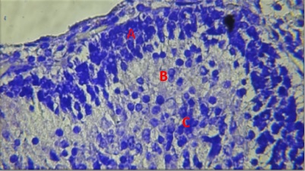

Figure (1) Control group cerebellum, showed the trilaminar cortex, A Molecular layer, B. Purkinje cells, C. Granular layer. Cresyl Violet stain (40X)
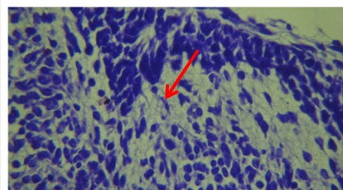
Figure (2): Test group with prenatal tramadol exposure shoed agenesis of Purkinje cells layer in cerebellar cortex (arrow) Cresyl violet stain (40X).

Recent Publications (minimum 5)
- Al-Kaabi M, Hussam F, Al-Marsoummi S, Al-Anbaki A, Al-Salihi A, Al-Aubaidy H (2018) Expression of ZO1, vimentin, pan-cadherin and AGTR1 in tanycyte-like cells of the sulcus medianus organum. Biochemical and Biophysical Research Communications 502(2):243-249.
- Sueud T, Hadi N, Abdulameer R, Jamil D, Al-Aubaidy H (2019) Assessing urinary levels of IL-18, NGAL and albumin creatinine ratio in patients with diabetic nephropathy. Diabetes and Metabolic Syndrome: Clinical Research and Reviews. 13:564-568.
- Mohammad BI, Raheem AK, Hadi NR, Jamil DA, Al-Aubaidy HA (2018) Reno-protective effects of TAK-242 on acute kidney injury in a rat model. Biochemical and Biophysical Research Communications 503(1):304-308.
- Gupta A, Jacobson GA, Burgess JR, Jelinek HF, Nichols DS, Narkowicz CK, Al-Aubaidy HA (2018) Citrus bioflavonoids dipeptidyl peptidase-4 inhibition compared with gliptin antidiabetic medications. Biochemical and Biophysical Research Communications 503(1):21-25.
- Russell, RD, Hu, D, Greenaway, T, Blackwood, S, Dwyer, RM, Sharman, JE, Jones, G, Squibb, KA, Brown, A, Boman, M, Al-Aubaidy, HA, et al. (2017). Skeletal muscle microvascular-linked improvements in glycemic control from resistance training in individuals with type 2 diabetes. Diabetes Care. 40(9):1256-1263.
- Bassam K. & Kammona, H (2018) age related changes in topographic and immunohistochemical expression of star and malondialdehyde in rat suprarenal cortex during perinatal development. Biochemical and Cellular Archives. 18(2):2329-2338.

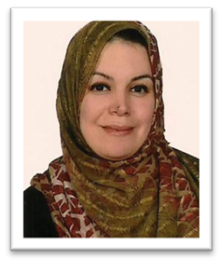 Huda Kammona
Biography
Assistant Professor of human anatomy at A-Nahrain College of Medicine (Baghdad/ Iraq). Huda’s research focusses on perinatal developmental and pregnancy related changes, aging, based on routine histological and immunohistochemical methods.
Email:
huda.r.kammona@gmail.com

 Hayder Al-Aubaidy
Biography
Hayder Al-Aubaidy started recently as a Senior Lecturer at the School of Life Sciences, La Trobe University. Hayder possesses extensive experience in research, evaluation, teaching and administrative duties in both national and international Australian universities. His research interest is in the biochemical markers of chronic disease. He is a member of the Australasian Association of Clinical Biochemists, the Australian Institute of Medical Scientists and the Iraqi Medical Association.
Email: H.AlAubaidy@latrobe.edu.au

 Muthanna Al-Kaabi
Biography
Muthanna Al-Kaabi is an Assistant Professor of Human Anatomy, Histology and Embryology at Al-Nahrain College of Medicine. He has gained wide experience through working at various national and international academic and medical institutions in Iraq, Egypt and Australia. He also contributed to humanitarian medical projects in conflict zones. In addition to teaching, his research interests focus on the neuroanatomical and neuromuscular studies. As part of his academic duties he worked many years as Head of the Human Anatomy Department, and Deputy Head before that, in addition to humanitarian medical projects manager. He continues his professional development now in Melbourne, Australia.
Email: muthakabi@yahoo.com

 Thair Farhan
Biography
Thair M Farhan, M.Sc. in histological and embryological science from Al-Nahrain University, Medical College, in 2017 and a Bachelor of Science in Biology from Baghdad University in 2013, worked as a lecturer of embryology at Alfaluja Medical College 2018. He is interested in the study of drug effects on body tissues.

Email:
Thair_farhan@yahoo.com

 Herbert Jelinek
Herbert Jelinek has been organizing a rural diabetes screening clinic for over twenty years and has published widely in ECG signal processing, image analysis, data mining and biochemistry analysis of disease progression associated with diabetes. Recently his focus has been on nonlinear analysis of multisensory data in major depression disorder and suicidality as well as complex trauma biosignals. His research interests include neurogenetics of diabetes, cognitive decline and complex trauma. Currently Dr Jelinek is investigating clinical efficacy of bioneurofeedback using multisensory data. He is a member of the IEEE Biomedical Engineering Society and the Applied Neuroscience Society of Australia.
.
Email:
hjelinek@csu.edu.au

