Abstract Title: Modern Clinical Neuro-psychology as Described by Dostoevsky
Mitra Assadi, Capital Institute for Neurosciences, New Jersey, USA

This presentation uses the biography and works of Dostoevsky, one of the most powerful classical writers, to explore several topics in neuropsychology. We will begin by reviewing the author’s biography, in particular his history of epilepsy. We will then proceed to discuss his neuropsychological deficits including inability to experience negative emotions, hypo-sexuality, hyper-graphia and hyper-religiosity. Moreover, we will discuss the semiology pertaining to his seizures including his euphoric auras. We will confirm a diagnosis of right temporal lobe epilepsy with involvement of the amygdala. To further explore the above topics, we will use his novel “The Idiot”, which is considered (semi)autobiographical. At the end, we will discuss status epilepticus which was the fate of the protagonist of the novel.

Further, we will review author’s addiction to gambling and explore the potential underlying fronto-temporal networks responsible for addiction behavior in epilepsy. To this end, we will discuss yet another (semi)autobiographical master piece of the author: “The Gambler”. We will discuss the underlying neurological substrate for addiction behavior and impulse control, including the role of dopaminergic signaling in frontal lobe networks.

We will then proceed to discuss author’s greatest masterpiece, “Crime and Punishment”. The discussion will mostly focus on forensic psychology. At the end, we will review of the “Brothers Karamazov” mostly focusing on pseudo-seizures and criminal behavior.

In conclusion, Dostoevsky suffered with right temporal lobe epilepsy resulting in the classical triad of hypo-sexuality, hyper-graphia and hyper-religiosity seen in this condition. Due to the involvement of amygdala, he was unable to experience negative emotions. Conceivably, involvement of the fronto-temporal networks was responsible for his gambling addiction.

Image 1: Mechanism of synaptic plasticity in the hippocampus, courtesy of Neurology, 2018

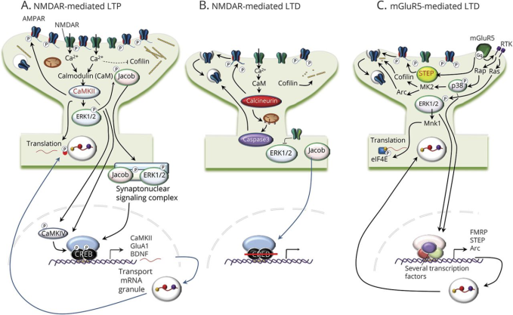

Image 2: Dopaminergic cell signaling, courtesy of Neurology, 2014
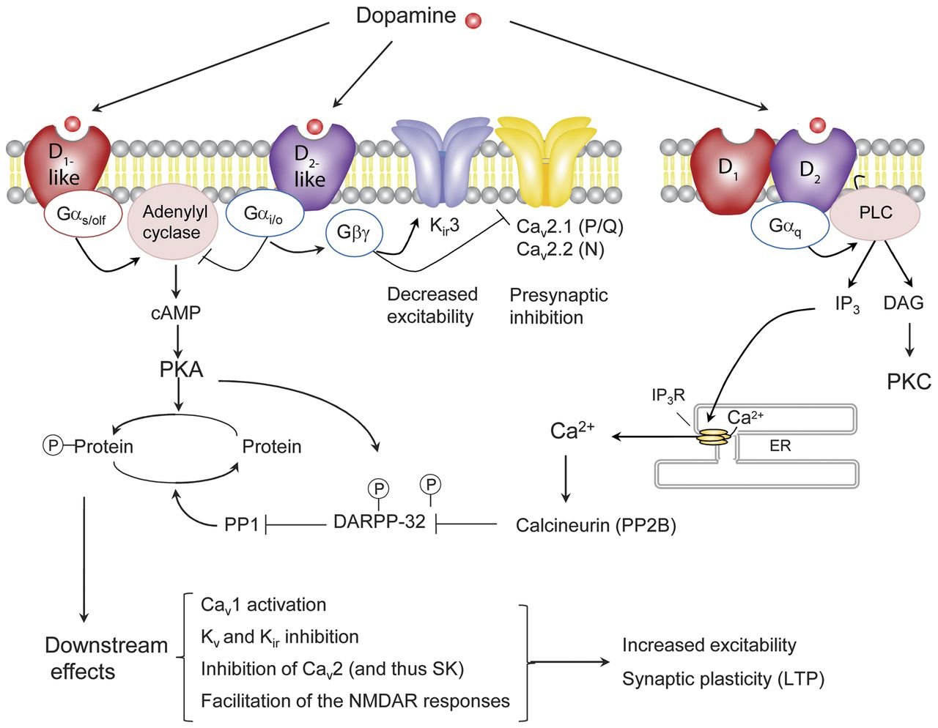

Recent Publications by Mitra Assadi, MD

- Assadi, M, Zerafati, G, Leone, P. Prevalence, cognizance and burden of Migraine in Adolescents girls. Journal of Pediatric Neurology, 10: 29-34, 2012

- Leone, P, McPhee, S Francis, J Assadi, M, Janson, C. Use of AAV vector for gene therapy of Canavan disease, Science Translational Medicine, 4: 1-18, 2012

- Assadi, M, Wang, DJ, Anderson, K, Carran, M, Bilaniuk, L, Leone, P. Vitamin K Antagonist for Palliative Treatment of MLD, Journal of Central Nervous System Diseases, 4: 73-79, 2012

- Assadi, M, Zerafati, G, Leone, P. Do the genetic influences determine the phenotypic severity of migraine? Journal of Pediatric Neurology, 11: 15-21, 2013

- Assadi, M, Wang, DJ, Leone, P. Multi-voxel H-MRS in metachromatic leukodystrophy, Journal of Central Nervous system diseases, 5: 25-30, 2013

- Assadi, M, Zerafati, G, Leone, P. Phenotypic differences between probable migraine and definite migraine. Journal of Pediatric Neurology, 11: 171-175, 2013

- Assadi, M, Dougherty, M Genetics of Epilepsy, what general neurologists need to know, BMC, May 2015

- McAbee, G, Santilli, A, Assadi, M. The pediatric aspects of headache classification in ICHD-3. Current Pain and Headache Reports, 20:7, 2016

- Assadi, M, Liebman, K, Binning, M, Vez, E. The impact of endovascular treatment of cerebral aneurysms on headache, the neurologist, 22:6, 2017

Brief Bio of Mitra Assadi, MD

Dr. Mitra Assadi is director of the Headache Medicine and Pediatric Neurology at the Capital Institute for Neurosciences. Board certified in neurology and clinical neurophysiology, Dr. Assadi was among one of the first neurologists in the United States to obtain a board certification in headache medicine in 2008. Dr. Assadi is actively involved in teaching and research. She is a Professor of Neurology at Robert Wood Johnson Medical School and the Director of the Neurology Clerkship at Capital Health system. Dr. Assadi’s research has mostly focused on neuro-genetic disorders, in particular leukodystrophies. She has served as a clinical investigator at the Center for Cell and Gene Therapy at the Rowan University since 2004. She has special expertise in Canavan Disease and her published research on the use of lithium in Canavan patients has established the standard of care for these patients in the scientific community.

