Amyloid-neuroinflammatory cascade in neurodegenerative diseases – role of pro-inflammatory S100 proteins.
Ludmilla A. Morozova-Roche
Department of Medical Biochemistry and Biophysics, Umeå University, Umeå, Sweden

Chronic neuroinflammation is a hallmark of neurodegenerative diseases, associated with increased levels of pro-inflammatory factors in the brain tissues.
Methodology and Theoretical Orientation:
The research was conducted by using a range of biophysical and biochemical techniques such as AFM, fluorescence, NMR, surface plasmon resonance, circular dichroism, ELISA and western blots; cell biological methods and immunohistochemistry and immunocytochemistry.
Findings:
We have shown that the pro-inflammatory mediator and highly amyloidogenic protein S100A9 is involved in the amyloid-neuroinflammatory cascades in Alzheimer’s disease, where it co-aggregates with Aβ peptide, contributing to amyloid plaque formation and intracellular aggregation [1], in Parkinson’s disease – it forms co-aggregates with α-synuclein and involves in Lewy body formation [2], and in traumatic brain injury – S100A9 is highly abundant in the brain tissues and forms numerous precursor-plaques. In wild-type mouse model the intranasal administration of S100A9 amyloids induces wide-spread cellular stress responses in the brain tissues and Alzheimer’s-like behavioural impairment in passive avoidance test [3]. In vitro S100A9 easily aggregates under native pH 7.4 and 37 °C conditions and this process is well quantitatively described by generic Finke-Watzky two-step nucleation-autocatalytic growth model [4]. The co-aggregation of S100A9 with Aβ peptide or α-synuclein occurs significantly faster and leads to formation of larger amyloid aggregates than the self-assembly of individual proteins. S100A9 amyloid oligomers are more toxic than those of Aβ or α-synuclein, while the co-aggregation with Aβ/ α-synuclein mitigates the cytotoxicity of S100A9 oligomers. The levels of S100A9 follow those of Aβ in cerebrospinal fluid during the development of Alzheimer’s disease and S100A9 together with Aβ can serve as a biomarker for early stages of Alzheimer’s disease, starting from mild cognitive impairment [5].
Conclusion and Significance:
The finding of S100A9 involvement in neurodegenerative diseases may open a new avenue for therapeutic interventions targeting pro-inflammatory S100A9 and preventing the amyloid self-assembly in affected brain tissues.
Image:
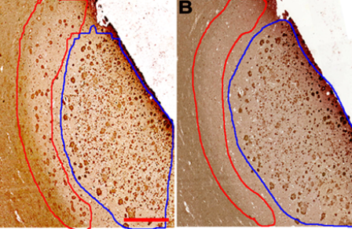
Red line encircles the area with the plaques reactive only with S100A9 antibodies. Blue lines encircles the area with plaques stained also with Aβ antibodies.
Recent Publications:
[1] Wang, C., et al. Acta Neuropath. 127, 507, 2014.
[2] Horvath, I., et al J. Neuroimmun. 2018.
[3] Iashchishyn, I.A., et al ACS Chem Neurosci. 2018.
[4] Iashchishyn. I.A., et al ACS Chem Neurosci. 8, 2152, 2017.
[5] Horvath, I., et al. ACS Chem. Neurosci.7, 34, 2016.


Ludmilla Morozova-Roche is a Professor in Medical Biophysics at the Umeå University, Sweden. She and her research group has been conducting research on S100 proteins in neurodegenerative and inflammatory diseases during last ten years and showed that S100A9 in particular plays critical role in driving the amyloid-neuroinflammatory cascade in Alzheimer’s, Parkinson’s and traumatic brain injury and therefore can be used as a prospective therapeutic and diagnostic target.
Email: Ludmilla.morozova-roche@medchem.umu.se

