Plasmatic leptin levels and sleep habits in children affected by autism spectrum disorder medication-naïve.
Marco Carotenuto, MD, PhD, Associate Professor
Clinic of Child and Adolescent Neuropsychiatry, Department of Mental Health, Physical and Preventive Medicine, Università degli Studi della Campania “Luigi Vanvitelli, Naples, Italy
Francesco Precenzano, MD
Clinic of Child and Adolescent Neuropsychiatry, Department of Mental Health, Physical and Preventive Medicine, Università degli Studi della Campania “Luigi Vanvitelli, Naples, Italy

Michele Roccella, MD; PhD, Associate Professor
Child Neuropsychiatry, Department of Psychology and Pedagogical Sciences, University of Palermo, Palermo, Italy

Abstract
Autism spectrum disorder (ASD) is a neurodevelopmental disorder characterized by lifelong deficits in both socializing and non-verbal behaviors. Parents often reported children's sleep disorders (about from 44% to 83% of cases), as difficulty in sleep onset at bedtime, and alterations in sleep stability and continuity.
The first aim of the present study is to evaluate the putative relationship between leptin plasmatic levels and sleep habits in a cohort of ASD children naïve to any antipsychotic drug treatment compared to a group of controls. The second aim, is to investigate the relationship between social impairments and the leptin plasmatic levels.

Methodology and Theoretical Orientation:
The ASD group included 76 ASD medication-naïve children (49 males/37 females) and the control group consisted of 105 typical developing children (40 males/65 females).
To evaluate sleep habits and disturbances, all children’s mothers filled out the Sleep Disturbances Scale for Children (SDSC). Serum leptin levels were measured using the commercial ELISA kit.
Findings:
The analyses of the mean scores on the sleep disorder scale (SDSC) and its subscales revealed a significant group effect. Specifically, the ASD group showed a significantly higher rate of sleep disorders in all subscales investigated by the SDSC scale (Table 1). Also measures of serum leptin levels showed significant effect group with a higher rate in the ASD group (ASD: 1.69 ng/ml ± 0.09; TDC: 0.95 ng/ml ± 0.20; p < .0001]. Correlations were all significant and positive in the overall sample. (Table 2)
Conclusion and Significance:
The present study findings showed not only that ASD could be considered as a relevant risk factor for referred sleep troubles disorders, but that plasmatic leptin levels may be a putative biochemical marker for them.
Image:

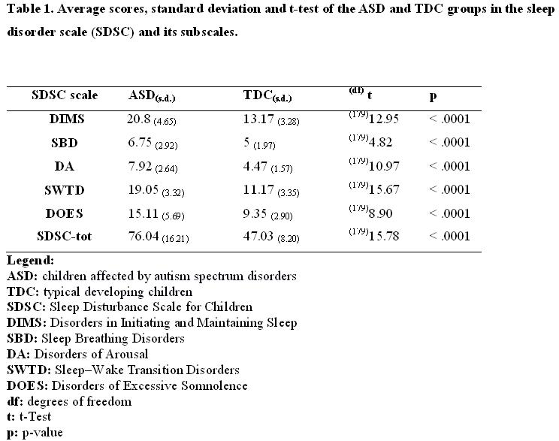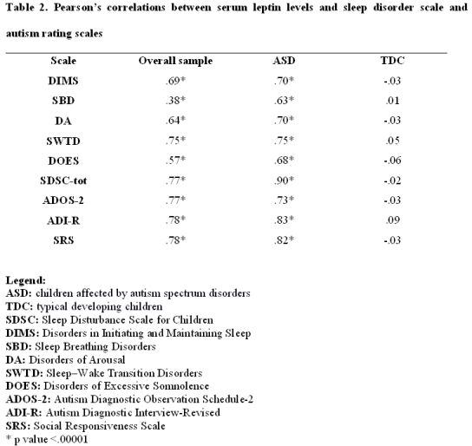

Recent Publications
- Mazzone, L., Postorino, V., Siracusano, M., Riccioni, A., Curatolo, P. 2018. “The Relationship between Sleep Problems, Neurobiological Alterations, Core Symptoms of Autism Spectrum Disorder, and Psychiatric Comorbidities.” J Clin Med. May 3;7(5). pii: E102. doi: 10.3390/jcm7050102
- Precenzano, F., M. Ruberto, L. Parisi, M. Salerno, A. Maltese, D. Verde, G. Tripi, et al. 2017. “Sleep Habits in Children Affected by Autism Spectrum Disorders: A Preliminary Case-Control Study.” Acta Medica Mediterranea 33: 405–9. https://doi.org/10.19193/0393-6384_2017_3_059
- Ashwood, P., C. Kwong, R. Hansen, I. Hertz-Picciotto, L. Croen, P. Krakowiak, W. Walker, I.N. Pessah, and J. Van De Water. 2008. “Brief Report: Plasma Leptin Levels Are Elevated in Autism: Association with Early Onset Phenotype?” Journal of Autism and Developmental Disorders 38 (1): 169–75. https://doi.org/10.1007/s10803-006-0353-1.
- Blatt, G.J., and S.H. Fatemi. 2011. “Alterations in GABAergic Biomarkers in the Autism Brain: Research Findings and Clinical Implications.” Anatomical Record 294 (10): 1646–52. https://doi.org/10.1002/ar.21252
- Messina, A., I. Bitetti, F. Precenzano, D. Iacono, G. Messina, M. Roccella, L. Parisi, et al. 2018. “Non-Rapid Eye Movement Sleep Parasomnias and Migraine: A Role of Orexinergic Projections.” Frontiers in Neurology 9 (FEB). https://doi.org/10.3389/fneur.2018.00095
.


Biography (150-word limit-mandatory)
Marco Carotenuto is Associate Professor and Chief of Clinic of Child and Adolescent Neuropsychiatry at the Università degli Studi della Campania Luigi Vanvitelli in Italy.
Presently, he is currently involved in specific clinical research area such as pediatric sleep disorders, autism spectrum disorders neurochemistry, neurochemical alterations in neurodevelopmental disorders.

Email: marco.carotenuto@unicampania.it

Notes/Comments

