Language ability and behavioral self- regulation in children with arachnoid cysts
Florencia Rubio de Anda, Bs, Universidad Nacional Autónoma de México , México
Dr. Guillermina Yáñez Téllez, PhD, Universidad Nacional Autónoma de México, México
Dr. Antonio García Méndez , MD, Centro Médico Nacional “La Raza”, México

Abstract

Statement of the problem: Due to its congenital origin, it has been postulated that arachnoid cysts (AC) may result in atypical cerebral organization. However, because of limitations of cerebral plasticity, AC can cause behavioral problems and deficiencies in various cognitive domains, being language one of the most affected.
Objective: This study seeks to determine behavioral problems and language deficiencies in AC sample and to know if there is any relationship between both domains, assuming the important role of language in behavioral self-regulation. Methodology: 18 pediatric patients from 7 to 16 years with the presence of an AC (frontal n = 4, temporal n = 13 and occipital n = 1) of different severity level, without any surgical intervention were studied. Wechsler Intelligence Scale for Children, Neuropsychological Battery for Learning Disorders and the Assessment System for Children and Adolescents were applied. Results: Mild phonological processing deficiencies were found; however, these failures did not affect reading and writing abilities. The use of grammar and expressive language were inadequate. The capacity for organization, planning and behavioral verification was also deficient. Specific scales with poor scores were Personal and Social Resources, Emotional Intelligence and Isolation. Between behavioral and linguistic variables only a significant correlation was found between the use of grammar and the degree of isolation.Conclusion: Pediatric population with AC show deficits in phonological processing, expressive language and grammar use as well as behavioral problems, mainly low emotional intelligence and isolation. However, no important correlations were found between language variables and behavioral self-regulation.

Image

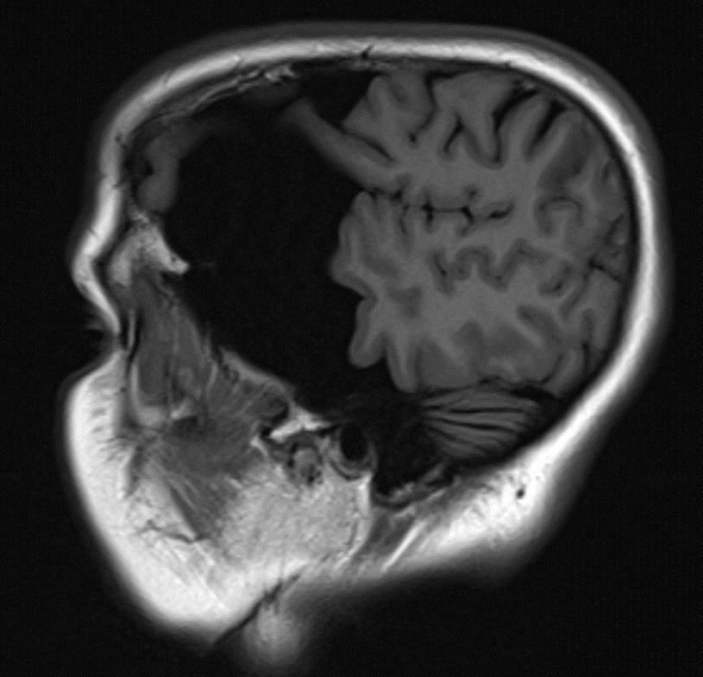

FIGURE 1. Arachnoid cyst Galassi III. From MedPix. Public Domain

References
- Balak, N. (2014). The Sylvian fissure, cistern and arachnoid membrane. British journal of neurosurgery, 28(1), 98-106

- Galassi, E; Tognetti, F; Gaist, G; Fagioli, L; Frank, F; Frank, G. (1982). CT scan and metrizamide CT cisternography in arachnoid cysts of the middle cranial fossa: classification and pathophysiological aspects. Surgical Neurology 17:363–369

- Gjerde PB, et al. Intracranial arachnoid cysts: impairment of higher cognitive functions and postoperative improvement. J Neurodev Disorders 2013;5

- Laporte, N., De Volder, A., Bonnier, C., Raftopoulos, C., & Sébire, G. (2012). Language impairment associated with arachnoid cysts: recovery after surgical treatment. Pediatric neurology, 46(1), 44-47.

- Park, Y. S., Eom, S., Shim, K. W., & Kim, D. S. (2009). Neurocognitive and psychological profiles in pediatric arachnoid cyst. Child's Nervous System, 25(9), 1071-1076.

Biography


Florencia Rubio de Anda is a master´s degree student in Clinical Neuropsychology at Universidad Nacional Autónoma de México (UNAM), and is trained in (theoretical and in practical) neuropsychological assessment and intervention with children and adults with psychiatric, neurological or neurosurgical diseases, evaluating courses of illness through time and in patients with critical conditions. The thesis to obtain her master´s degree focuses on congenital lesions (arachnoid cyst) and seeks to understand if there is a link between the linguistic ability of these children and their behavioral self-regulation. Other areas of knowledge are cognition in patients who receive electroconvulsive therapy as treatment for psychiatric diseases and in transcranial electrical stimulation. She has experience teaching biological bases of behavior to psychology students.

Email: florencia.rubio.deanda@gmail.com

Notes/Comments

