The mechanisms that used by the Neurons in the brain to avoid attack of immune cells.

Ahmed Ali Hussein, Master of Microbiology, Iraq.
Ahmed Ali Hussein, Master of Microbiology, Iraq.

Abstract

There are several sites in the body that do not develop immune responses to pathogens, tumor cells, or histoincompatible tissue transplants, these sites, include the brain, eye, testis, ovary, and placenta, so-called because of mechanisms of immune tolerance that operate to protect the tissues from immune-mediated damage. The central nervous system complying the brain and spinal cord is an essential organ for survival, because the inflammation in these sites can lead to loss of organ function. The blood-brain barrier plays an important role in maintaining the separation of CNS from the systemic immune system but the presence of the blood-brain barrier, does not, on its own, provide immune privilege. Activated immune cells secret molecules that are neurotoxic and the encasement of the brain in the skull does not permit excessive infiltration of immune cells. Neurons are highly susceptible to damage by inflammatory responses and have limited ability to regenerate. Since the brain lacks a lymphatic system, and the immunoregulatory mechanisms in the brain circumvent damage to neurons and supporting cells such as oligodendrocytes and astrocytes. Mechanisms known to operate in the protection of neurons from attack by CD8 + cytotoxic T cells involve lack of expression of HLA class Ia A, B and C receptors by neurons. Astrocytes express cell surface FasL which promotes apoptosis in activated T cells by engagement with Fas. (Figure 1). Another mechanisms known to operate in the protection of neurons from attack by natural killer cells is the induced expression of HLA class Ib G receptors that bind to NK inhibitory receptors such as KIR. Astrocytes upregulate surface PD-L1 receptors which promotes apoptosis in activated T cells by engagement of PD-1 receptors. In addition, microglial cells inhibit T cell proliferation by mediating depletion of tryptophan with IDO (indolamine 2,3-dioxygenase).
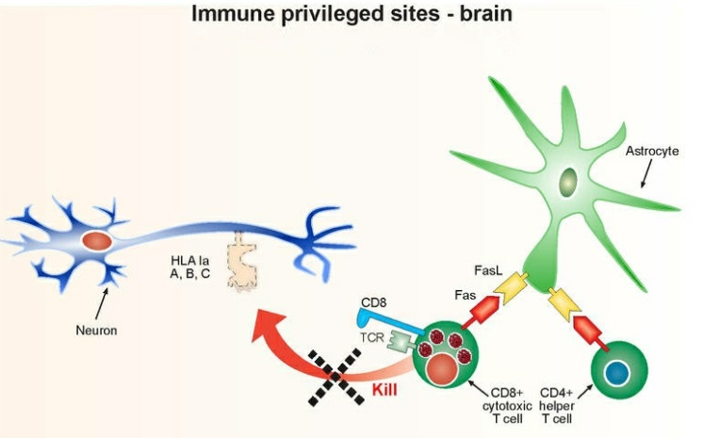
figure 1 Mechanism protection of neurons from attack by CD8+ cytotoxic T cells that involve lack of expression of HLA class Ia A, B and C receptors.
Recent Publications
1. Block, M.L., Zecca, L. & Hong, J.S. (2007). Microglia-mediated neurotoxicity: uncovering the molecular mechanisms. Nat. Rev. Neurosci. 8, 57–69 .
2. Lampson, L. A .(1995).Interpreting MHC class I expression and class I/class II reciprocityin the CNS: reconciling divergent findings. Microsc. Res. Tech. 32, 267–285.
3. Gimsa, U., N. Avrion, M., and Weinzierl, M, C, B. (2013). Immune Privilege as an Intrinsic CNS Property: Astrocytes Protect the CNS against T-Cell-Mediated Neuroinflammation. Hindawi Publishing Corporation. 1-11 .
4. Rajagopalan, S., Long, E. O. (1999) A human histocompatibility leukocyte antigen (HLA)-G–specific receptor expressed on all natural killer cells. J. Exp. Med. 189, 1093–1100.
5. Saas, P., Walker, P. R., Hahne, M., Quiquerez, A. L., Schnuriger, V., Perrin, G., French, L., Van Meir, E. G., Tribolet, N. de., Tschopp, J., Dietrich, P. Y.(1997). Fas ligand expression by astrocytoma in vivo: Maintaining immune privilege in the brain? J. Clin. Invest. 99, 1173–1178.
6. Lipp, M., Brandt, C., Dehghani, F., Kwidzinski, E., Bechmann, I. (2007). PD-L1 (B7-H1) regulation in zones of axonal degeneration. Neurosci. Lett. 425, 156–161 .
7. Kwidzinski, E., Bunse, J,. Aktas, O., Richter, D., Mutlu, L., Zipp, F. Nitsch, R., Bechmann, I. (2005). Indolamine 2,3-dioxygenase is expressed in the CNS and down-regulates autoimmune inflammation. FASEB J. 19, 1347–1349 .


Biography
Ahmed Ali Hussein completed a master's degree at the age of 26 years in microbiology and immunology from the University of Qadisiyah - College of Science had gotten a master's degree in 2016. It has been published of a number of research's in local and international journals, I have a book about immunology titled " Medical Immunology ". I was assigned to supervise a number of undergraduate graduate studies for the purpose of obtaining a diploma degree, and I also provided a lot of advice to postgraduate students (Masters and PhD) in the field of immunology.
Email: immunologist_ahmed@yahoo.com
Notes/Comments: Immunology is a modern medical science and needs all of us to do more for the purpose of identifying it closely, and in the treatment of incurable diseases such as AIDS and cancer in the event of concerted efforts.

