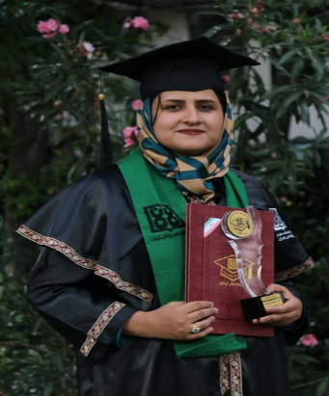


Title: Effectiveness of Cue-based Feeding Versus Scheduled Feeding in Preterm Infants: Using Feeding Assessment Scales

Name: Faride kamran

Tehran University of Medical Science, Iran

Objectives: Achievement of full oral feeding is a key factor in preparing an infant for discharge from the neonatal intensive care unit (NICU). The present study aimed at investigating the effectiveness of cue-based feeding in preterm infants.
Methods: A randomized, clinical trial study was designed to compare preterm infants <34 weeks gestational age (GA) in the cue-based feeding group and the scheduled feeding group. All participants were evaluated by Preterm Infant Oral Feeding Readiness Assessment Scale (PIOFRAS) and Early Feeding Skill Assessment (EFS) in four different stages as follows: before the intervention, at the first oral feeding, at the full oral feeding, on the day of discharge.
Results: 40 preterm infants (n =20 cue-based feeding group and n = 20 scheduled feeding group) were included. There was no difference in the distribution of gender, gestational age, birth weight between the two groups. The postmenstrual age (PMA) at the first oral feeding, at full oral feeding, and the day of discharge were statistically lower in the cue-based feeding group than the scheduled feeding group. The cue-based feeding group achieved full oral feeding on average 2.95 days sooner (3.55± 1.27 vs 6.50±2.1) and infants were discharged on average 11.5 days earlier (15.25±5.1 vs 26.30±8.4).
Conclusion: Cue-based feeding is an effective and safe approach in the setting of Iran’s NICU that results in preterm infant’s early achievement of oral feeding and consequently shorter hospitalization.
Keyword: Cue-based Feeding, Neonatal Intensive Care Unit, Oral Feeding, Preterm Infant, Scheduled Feeding

Biography

I has completed his bachelor in major of speech and language pathology at the age of 28 years from Semnan University of medical science, Iran and master studies from Tehran University of Medical Science, Iran. My field of study is interventions of feeding and swallowing in infants.

Mail id: F.kamran90@yahoo.com or F-kamran@razi.tums.ac.ir
Contact number: 989177622352
Oral Presentation

