The Score of seven: A proposed resuscitation selectio criteria for newborn infants delivered at 23 weeks gestation age. A retrospective study
Aim:
To evaluate the outcome of a cohort of infants born at 23-weeks’ gestation age after introducing a new resuscitation selection score (The Score of Seven).

Methods:

A population-based, retrospective cohort study using data from Pearl-Peristat Maternal and newborn registry, Vermont Oxford database related to WWRC -NICU and patient’s chart for infants born since 2016 till mid-2018 of ELBW infants born at 23 weeks gestation age. On February 2018, we introduced a new protocol to streamline the delivery room resuscitation decision making regarding ELBW infants born in 22-24 weeks gestation. Seven elements were chosen, four antenatal and three immediate postnatal. Each component will receive zero, one or 2 according to its presence or absence.
Baby will not be resuscitated if the score below 7 and will receive active resuscitation and admitted to THE NICU if score ≥7. A short satisfaction survey was conducted after 6 months from application to identify the comprehension, practicality and ethical comfort of the medical staff.

Results:

Sixty baby infants delivered during the period off assement. The DR death rate was 23/60 (38.3%), The NICU admission was 37 infants (61.7%). Half of the admitted infants died before 2 weeks of age. The Survival rate until discharge was 35% (13/37). Infants died in the DR with a score < 7 was 13/20 (65%) versus zero/17 when the score was ≥ 7. Amongst those infants admitted to the NICU (37), seven infants admitted with a score less than 7; 2 of them survived till discharge (≈29%) while among 17 infants admitted with a score ≥ 7, seven infants survived till discharge (41.5%). Satisfaction survey included full time 33 neonatal physicians, 32 voted for easy to comprehend, 26 voted for easy to implement, and 30 physicians voted for ethical relief and comfort.

Conclusions

While managing 23 weeks’ gestational age, delivery, decision making resuscitation score (The score of seven) was associated with an improved survival rate till discharge. The score was described by the NIC physicians as functional and convenient. It offers ethical reassurance to the dedicated medical staff and provides a practical platform for delivery room resuscitation decision making. Applying the score was not associated with an increase in the number of delivery room deaths.

Table 1: limits of viability 22-24 weeks gestation resuscitation decision making guideline
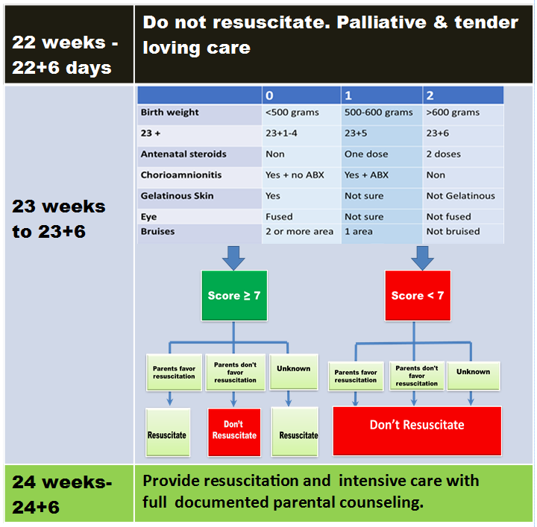
Unknown:
1. Rapid delivery without meeting parents.
2. No antenatal consultation.
3. Mother cannot be approached (in active labor) or unapproachable husband/partner.
4. Multiple pregnancies: each is evaluated as an individual case.
Chorioamnionitis: clinical active symptoms within 1 week of labor.
Assisted pregnancy due to long infertility (IVF): needs special consideration
Significant bruises: bruises involve 2 or more of (head & scalp), trunk & limbs.

Figure 2. Total number of infants died within the first 2 weeks versus those died after two weeks versus lived till discharge (infants)

Figure 3. Impact of applying resuscitation score on the 23 weeks gestation infants*

* Only 37/60 baby was able to retrieve the full score characteristics.

Figure 4. Death related risk factors in 60 preterm 23 weeks gestation age infants

PLOTS = probability of death *100 ( P value =0.126)

*Respirator dependent > 15 days on > 50% FiO2.
* Significant Bruises

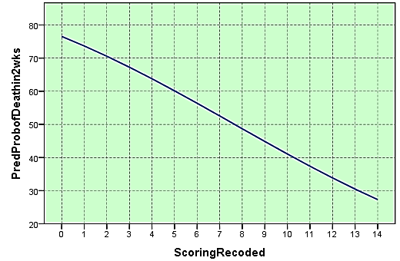
P = 0.162

Table 1. Odds Ratios for death at 2 weeks of 60 infants at 23 weeks Gestation.

 |  | OR 95% C. I
Maternal infection | No | 0.21 (0.05 -0.87)†
Maternal antibiotics | No | 8.9 (1.56 - 51.18)†
Antenatal steroids | None | 13.3 (2.19 - 81.23) †
Antenatal steroids | Incomplete | 2.7 (0.42 - 16.83)
Bruises | Yes | 7.7 ( 1.66 - 35.69) †
Gelatinous skin | Yes | 2.2 (0.55-9.02)
Fused eyes | Yes | 1.4 (0.38 - 5.44)
Birth weight | ≤750g | 1.9 (0.305-13.02) †
Age at intubation | >=5 mins | 1.0 (0.20 - 4.96)
IPPV & Fio2 > 50 % at 2 weeks of age | Yes | 22.8 (3.55 - 145.8) †
Surfactant doses | ≥ 2 doses | 1.15 (0.24-5.39)
Blood transfusion | Yes | 0.1 (0.02 - 0.49) †
Pulmonary hemorrhage | Yes | 5.0 (0.49 - 50.83)
IVH III/IV | Yes | 2.5 (0.46 - 13.52)
Mode of delivery | NVD
Mode of delivery | CS | 0.44 (0.04 - 5.38)
Lung collapse | Yes | 0.6 (0.09 - 0.32)
Pneumothorax | Yes | 1.1 (0.07 - 20.02)
Pie | Yes | 0.8 (0.21 - 3.47)
† Statistically significant at p<0.05

