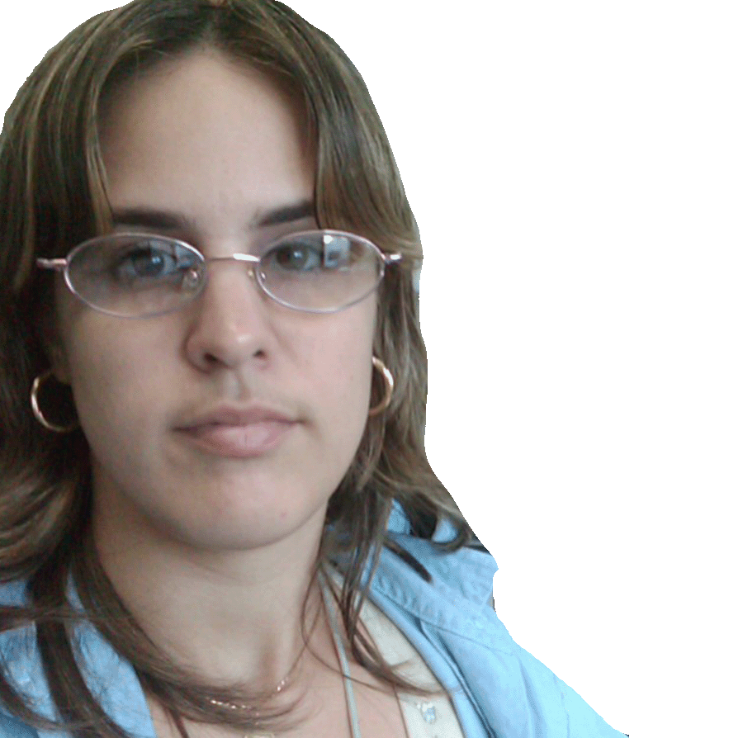


Title: Monoclonal antibodies for the newborn screening of inherited metabolic disorders.
Name: Greilys Morejón Garcia

Immunoassay Center, 134 Street and 25th Avenue, Postal Code 11600, Cubanacán, Playa, Havana, Cuba

Neonatal diagnosis guarantees timely treatment for patients suffering from hereditary metabolic disorders. In Cuba, the ultramicroanalytic system (SUMA) was created, a technology of our own, adaptable to our health system and compatible with its limited financial resources. The Immunoassay Center (CIE) develops and produces kits for diagnostic purposes based on SUMA. This technology has allowed the implementation of newborn screening (NBS) programs for heredo-metabolic disorders in Cuba and other Latin American countries.
Obtaining specific monoclonal antibodies (MAbs) for biomarkers of these diseases allows the development of new assays, the improvement of the production process and the analytical performance of existing kits, as well as the guarantee of availability of these raw materials. In the present work, the hybridoma technology is applied to generate MAbs useful for the detection of three inherited metabolic disorders.
Of all the hybridomas obtained, 7G11E3 secretes an anti-TSH MAb that effectively replaces the two solid-phase MAbs of the UMELISA® TSH Neonatal and UMELISA® TSH diagnostic kits by NBS and the confirmation of congenital hypothyroidism, respectively. MAb 6E2G9 against 17α-hydroxyprogesterone is useful in the solid phase of UMELISA® 17OH Progesterone Neonatal for NBS of congenital adrenal hyperplasia. This MAb replaces rabbit polyclonal antibodies that were used. Of the hybridomas generated against human trypsin, 4C9C9 and 4C9E11 MAbs was used to design a sandwich-type UMELISA®. A new assay for the quantification of immunoreactive trypsin, UMELISA® TIR Neonatal, was developed, whose pilot study of 2018 showed that it can be used for cystic fibrosis NBS.

Biography
Greilys Morejón graduated in 2009 from Microbiologist in the Faculty of Biology of the University of Havana. She did a Master's Degree in Trends in Contemporary Biotechnology culminated in 2018. She has participated in twelve presentations in national or international events and two articles published in journals of wide international visibility, like Applied Biochemistry and Biotechnology (2018) and Clinica Chimica Acta (2018). She works since 2009 in the Laboratory of Monoclonal Antibodies of the Immunoassay Center, in the obtaining and characterization of Monoclonal Antibodies for the diagnosis of hereditary metabolic and chronic diseases.

Mail id. greilys.morejon@cie.cu

