Abstract Template

Abstract Title: Neocosur HIC as an early risk prediction model of severe IVH: How effective is it?
Ziad A. El Ghannudi

¹ Ziad El Ghannudi Affiliation (University of Southampton, UK)

Abstract (not more than 300 words)

Background:
Intraventricular hemorrhage (IVH) is a huge problem in the neonatal care setting accounting for a considerable part of the neonatal morbidity as it occurs in about 25% of very low birth weight infants (VLBWI). Despite a gradual decline in the incidence of most severe grades of IVH, the increased survival of very low birth weight infants has resulted in an increase in the absolute number of infants with IVH. While low gestational age and birth weight were consistent risk factors to develop IVH in many studies, other risk factors such as amnionitis, being outborn, vaginal delivery, male gender, intubation in the delivery room, surfactant, RDS, pneumothorax, NEC-associated perforation and HFOV were suggested to be associated with an increased incidence of severe IVH.
Neocosur HIC is a web-based SIVH early-risk calculator developed by Luque et al. (2014) and is available at https://www.neocosur.org.
The aim of this review is to answer the following question: Is the use of Neocosur HIC model in VLBWI effective in the early identification of patients with SIVH (grade III-IV)?
The process of inclusion and exclusion of relevant papers is summarized in (Figure 1).
Results:
Of the eight factors consisting the Neocosur HIC five factors were shown to be consistently associated with decreased SIVH risk. These are the use of antenatal corticosteroids, caesarean section, female gender, gestational age and birth weight (Figure 2). The other factors were not fully studied in all the three papers included in the review. A comparison of RDS was made with further two other papers (Figure 3).
Conclusion:
This review suggests that Neocosur HIC could be useful in the prediction of cases of SIVH as early as 12 hours of age. However, further studies aiming to validate Neocosur HIC as an early SIVH prediction model in VLBWIs are needed.

Keywords—Neocosur HIC, Risk factors, SIVH, VLBW.

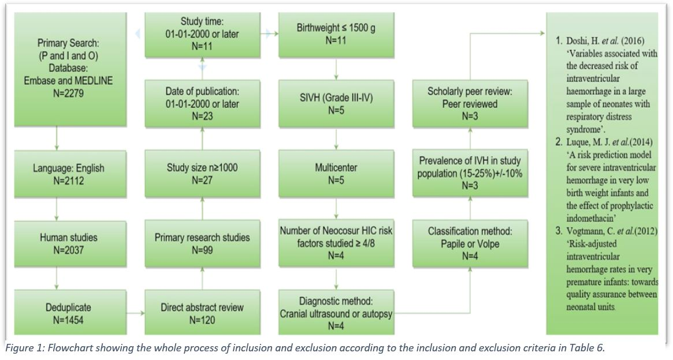
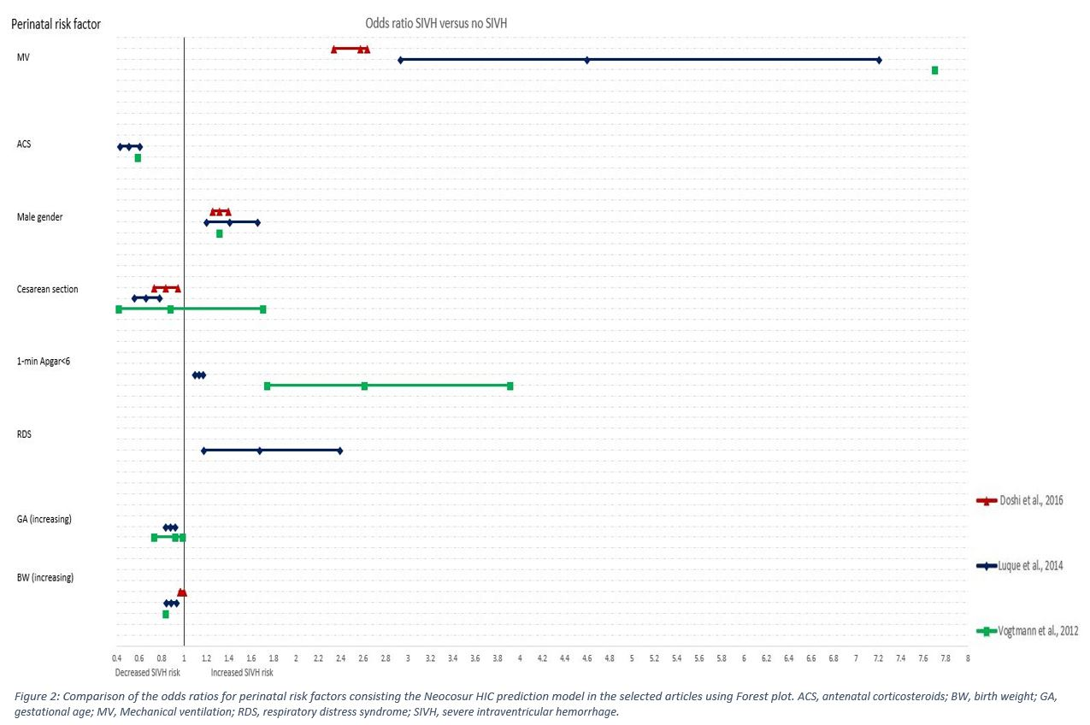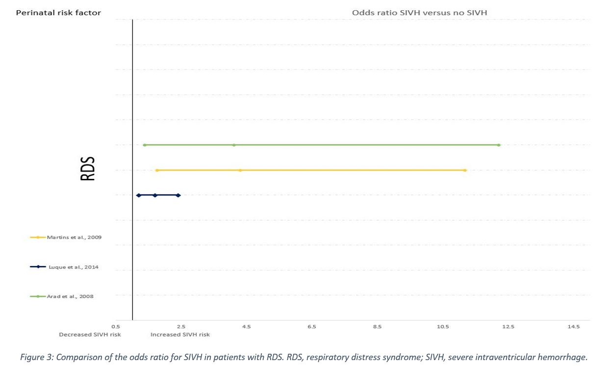

Professional Biography (100-150 words)

Ziad El Ghannudi has completed his MBBCH at the age of 24 years from Zawia University-Libya and is now a final year pediatric resident at Centralsjukhuset Kristianstad-Sweden and a MSc in Neonatology student at University of Southampton-UK. He/She is the member of several medical organizations in Libya, Sweden and Europe including LDS, BLF, SBKF, AEPC and ESPNIC and the Head of ULSS, Union of Libyan Students in Scandinavia. Having spent most of career in clinical work this would be the first published work in a scientific forum.


Paste your Photograph here

Email Id: ziadelghannudi@pediatrician.com

Any Comments:

