Simultaneous Effect of Medicinal Plants as Natural Photosensitizers and Low-Level Laser on Photodynamic Inactivation
Dr Zahra Aghaebrahimi, Biophotonics PhD, Central Tehran Branch, Islamic Azad University, Iran
Dr Jamshid Sabaghzadeh, Photonic PhD, Central Tehran Branch, Islamic Azad University, Iran
Dr Sasan Soudi, Biophysics PhD, Central Tehran Branch, Islamic Azad University, Iran
Dr Mohamad Reza Tanhayi Ahary, physics PhD, Central Tehran Branch, Islamic Azad University, Iran
Dr Seyed Hasan Nabavi, Photonic PhD, Modares University, Iran
Dr Maliheh Ranjbaran, Photonic PhD, Central Tehran Branch, Islamic Azad University, Iran

Abstract
Photodynamic inactivation (PDI) technology is a promising alternative to antibiotics. This technology is defined as the inhibition of bacterial growth with photosensitizers while irradiated with low-level laser light in the wavelength of 532 +/- 2.08 nm. A challenging area in this field is selecting photosensitizers with antibacterial potential. In this paper, to enhance the antibacterial efficiency, the photosensitizers (the selected plant extracts) with a high absorption peak at the selected laser frequency, 532 nm, were prepared. Low-concentration ethanolic plant extracts of Hibiscus sabdariffa and Opuntia ficus-indica were found to exhibit significant antibacterial activity against, Acinetobacter baumannii ATCC 19606 and, Staphylococcus aureus ATCC 33591 as two important human pathogenic bacteria. The effectiveness of these natural photosensitizers was measured by determining their Minimum Inhibitory Concentration (MIC) and Minimum Bactericidal Concentration (MBC) values and by performing a time-killing assay in the absence and the presence of laser irradiation. Our results showed that the combination of low-level laser irradiation and the selected photosensitizers had excellent potential for treating in vitro bacterial infections. Therefore, PDI technology has great potential as a viable alternative to traditional antibiotics for combating bacterial infections. This study presents a promising avenue for further exploration of PDI and the use of laser technology in medical science.

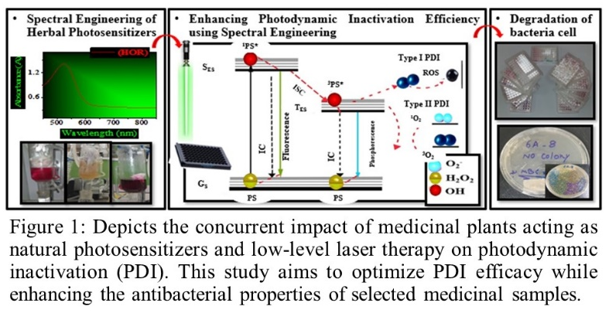
Recent Publications (minimum 5)
- E Polat, K Kang (2021) Natural Photosensitizers in Antimicrobial Photodynamic Therapy. Biomedicines 9, 9060584.
- Karim Makdoumi, Marie Hedin, Anders Bäckman (2019) Different photodynamic effects of blue light with and without riboflavin on methicillin-resistant Staphylococcus aureus (MRSA) and human keratinocytes in vitro. Lasers in Medical Science 34, 1799–1805.
- Lyu JI, Ryu J, Jin CH, Kim DG, Kim JM, Seo KS, Kim JB, Kim SH, Ahn JW, Kang SY, Kwon SJ (2020) Phenolic Compounds in Extracts of Hibiscus acetosella (Cranberry Hibiscus) and Their Antioxidant and Antibacterial Properties. Molecules 25(18):419. doi: 10.3390/molecules25184190. PMID: 32932699
- N Vaou, E Stavropoulou, C Voidarou, C Tsigalou, E Bezirtzoglou (2021) Towards Advances in Medicinal Plant Antimicrobial Activity: A Review Study on Challenges and Future Perspectives. Microorganisms 9, 2041.
- Yang Y, Liu Q, Shi X, Zheng Q, Chen L, Sun Y (2021) Advances in plant-derived natural products for antitumor immunotherapy. Arch Pharm Res 44(11):987-1011. doi: 10.1007/s12272-021-01355-1. PMID: 34751930

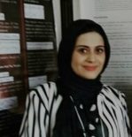Biography
Dr. Zahra Aghaebrahimi brings a wealth of expertise in microbiology, botanical sciences, and laser technology to her research endeavors. Her focus lies in exploring the antimicrobial properties of medicinal plants, particularly pertinent in the context of escalating antibiotic resistance. Leveraging her deep knowledge and experience, she employs cutting-edge methodologies such as photodynamic inactivation and laser-assisted techniques, customized for medicinal plant extracts. With a proven track record of presentations at national and international conferences, she continues to spearhead innovative solutions in combating antibiotic resistance and having ideas for natural products.This approach is responsive to all stakeholders and has a different way of focusing.

Email: z.aghaebrahimi@gmail.com

Notes/Comments:

Dear conference organizers,

I (Zahra Aghaebrahimi) am honored to have been invited to present my research at this prestigious conference. As both the presenter and speaker, I am thrilled to share insights from my study. However, I must humbly express my need for full support, particularly regarding expenses. The financial burden of travel is substantial for me, especially given the economic challenges and sanctions in my country.

My research addresses a pressing need in our global community, focusing on a novel and essential topic. I am confident that my project holds significant relevance and potential impact. Thus, I earnestly hope for the scientific community's support in this endeavor.

Thank you for considering my request, and I eagerly anticipate the opportunity to contribute to our shared knowledge and advancement.

Warm regards,
Zahra Aghaebrahimi

