Chemical and Antimalarial Investigations on Eremophila-Derived Alkaloids and Semisynthetic Ether Analogues
Chen Zhang, PhD Candidate, Griffith Institute for Drug Discovery, Grifffith University, Australia
Dr Kah Yean Lum, Griffith Institute for Drug Discovery, Grifffith University, Australia
Assoc. Prof. Rohan Davis, Griffith Institute for Drug Discovery, Grifffith University, Australia

Abstract (300 word limit)

Undertaking pharmacological investigations on unique and under-investigated terrestrial or marine biota holds great potential for the identification and development of new lead or drug compounds from nature. Whilst terrestrial plants have been studied by the pharmaceutical sector for hundreds of years, discoveries of new drugs continue to be made. Over the past 50 years the Australian plant genus Eremophila has been the source of both new and novel chemistry that has shown promising biological activity in a variety of biomedical relevant assays. Even though numerous secondary metabolites or extracts reported from this source have been shown to exhibit novel and significant bioactivity, few of the 287 species have undergone chemical investigation. Moreover, only three of over 200 Eremophila secondary metabolites contain nitrogen, one of which is microthecaline A, the known antimalarial quinoline serrulatane alkaloid from the roots of Eremophila microtheca. This alkaloid was targeted for large scale isolation and subsequent semisynthetic library generation. Microthecaline A was converted to 10 new semisynthetic ether derivatives using a diverse series of commercially available alkyl halides. Chemical structures of the new semisynthetic compounds were fully characterized following 1D/2D NMR, MS, UV, ECD and [α]D data analysis. Antimalarial evaluation of all analogues will be undertaken against P. falciparum 3D7 (drug-sensitive) and Dd2 (drug-resistant) strains and will be presented.

Image
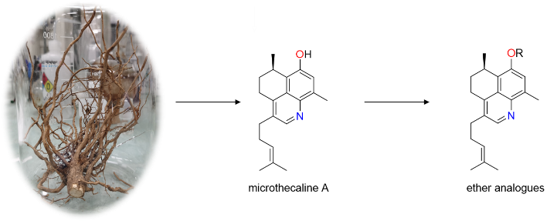
Recent Publications (minimum 5)
1. Zhang C, Lum KY, Davis RA (2021) Design, synthesis and screening of a drug discovery library based on an Eremophila-derived serrulatane scaffold. Phytochemistry, 190: 112887.
2. Zhang C, Lum KY, Davis RA (2023) Using a Bioactive Eremophila-Derived Serrulatane Scaffold to Generate a Unique Carbamate Library for Anti-infective Evaluations. Journal of Natural Products, 86: 557-565.
3. Kumar R, Duffy S, Avery VM, Davis RA (2017) Synthesis of antimalarial amide analogues based on the plant serrulatane diterpenoid 3, 7, 8-trihydroxyserrulat-14-en-19-oic acid. Bioorganic & Medicinal Chemistry Letters, 27: 4091-4095.
4. Kumar R, Duffy S, Avery VM, Carroll AR, Davis RA (2018) Microthecaline a, a quinoline serrulatane alkaloid from the roots of the Australian desert plant Eremophila microtheca. Journal of Natural Products, 81: 1079-1083.
5. Barnes, EC, Kumar R, Davis RA (2016). The use of isolated natural products as scaffolds for the generation of chemically diverse screening libraries for drug discovery. Natural Product Reports, 33: 372-381.

Photograph

Biography (150 word limit)
Ms Zhang is currently a 3rd year PhD candidate from Griffith Institute for Drug Discovery, Grifffith University, Queensland, Australia. She has investigated natural products chemistry since 2020. Chen has experience in natural products isolation and structure determination, as well as semisynthetic library generation. She is undertaking discovery and development of anti-infective natural products and derivatives from Eremophila plants for her PhD project.
Email:chen.zhang7@griffithuni.edu.au

Notes/Comments:

