Phytopharmaceutical investigations of Diospyros malibarica (leaf and bark) extracts in various polarity dependent solvents
Dr Zohra Zreen, PhD, , Government College University, Faisalabad, Pakistan
Dr. Shumaila Kiran*, PhD, Government College University, Faisalabad, Pakistan
Dr Amjad Hameed, PhD, Nuclear Institute for Agriculture and Biology (NIAB), Faisalabad, Pakistan

Abstract (300 word limit)

The current study was carried out to study the phytochemical components and antioxidant capability, and invitro biological activities of leaf and bark extracts of Diospyros malabarica (D. malabarica), prepared in various polar and nonpolar solvents (petroleum ether, dichloromethane, ethyl acetate, ethanol, methanol, and water in increasing order of polarity). Various phytochemicals like flavonoids, terpenoid, saponins, tannins were analyzed qualitatively while total phenolic and flavonoid contents of all prepared extracts were investigated quantitevely. Biological activities like antibacterial, antifungal, anticancer, anti-diabetic, and anti-inflammatory were explored. The results revealed that all the tested solvents displayed a vital role in the extraction yield, the content of phytochemicals, and the studied biological activities. Methanol was found as best solvent followed by the ethanol for the extraction, representing the highest extraction yield (18.3%), rich diversity of phytochemicals as well as the highest total phenolic contents, total flavonoid contents in bark extract. Furthermore, methanol bark extract showed high in-vitro antibacterial activity (30.25 mm ± 0.9), antifungal activity(18.25 mm ± 0.2), anticancer activity (48%), anti-diabetic activity (68%) and anti-inflammatory activity (62%) followed by ethanol amongst other extracts of D. malabarica. Our findings suggest that phytochemical compounds (flavonoids, tannins, phenols, saponins, and terpenoids,) found in the bark extract of D. malabarica may be attributed to evaluate potent anti-inflammatory, anticancer, anti-diabetic, antibacterial, and antifungal activities.

Image
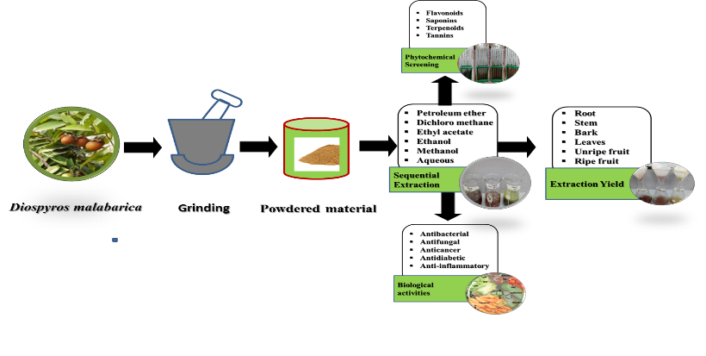
Recent Publications (minimum 5)
- Ghaffar A., Kiran S., Rafique M.A., Iqbal S., Nosheen S., Hou Y., Afzal G., Bashir M., Aimun U (2021). Citrus paradisi fruit peel extract mediated green synthesis of copper nanoparticles for remediation of Disperse Yellow 125 dye. Desalination and Water Treatment, 212:368-375.
- Iqbal S., Khan A., Nazir R., Kiran S., Perveen S., Khan K.M., Choudhary M.I. (2020) Pharmacological treatment of alcohol dependence: Target symptoms and target mechanisms. Pharmacology and therapeutic Synthesis of β-Ketosulfone Derivatives As New Non-Cytotoxic Urease Inhibitors In Vitro. Medicinal Chemistry, 16 (2):244-255
- Kiran S., Rafique M.A., Iqbal S., Nosheen S., Naz S., Rasheed A (2020). Synthesis of nickel nanoparticles using Citrullus colocynthis stem extract for remediation of Reactive Yellow 160 dye. Environmental Science and Pollution Research, 27(26):32998-33007.
- Zreen Z., Kiran S., Hameed A., Gulzar T., Farooq T (2019). Phytochemical and comparative biological studies of Diospyros kaki extracts. International journal of Biosciences, 14(1):207-223.
- Riaz H., Nosheen S., Kiran S., Jahan N., Abrar S., Riaz S (2016). Investigation of free radical scavenging and immunomodulatory activity of Anethum graveolens (sowa). Oxidation Communications, 39(4):3012-3026.


I, Dr Shumaila Kiran has expertise in Dyes Synthesis, Dyes degradation Treatment, technologies, Estimation of Phyto-constituents of Medicinal Plants and their Antimicrobial activities.
Email: shumaila.asimch@gmail.com

