Turmeric an alternative treatment to calm cytokine storms in COVID-19 through alteration of macrophage polarization
Dr.NATESAN GNANASEKARAN, Department of Medical Biochemistry, School of Medicine, College of Health Sciences, Addis Ababa University, Ethiopia
Abstract
Severe Acute Respiratory Syndrome coronavirus 2 (SARS-CoV-2), also known as Corona Virus Disease-19 (COVID-19) is a new coronavirus,outbreak in Wuhan, China in December 2019 is an ongoing pandemic, which frequently induces fatal inflammatory responses and acute lung injury. Recent evidence proposes that a subgroup of patients with serious COVID-19 may have a cytokine storm syndrome.COVID-19 infection trigger the alveolar monocyte and polarized in to proinflammatory M1 phenotype. In this condition the hyper production of proinflammatory cytokines, such as IL-1, IL-6, IL-12, IFN-γ, and TNF-α and finally causes the cytokine storm syndrome. This may result in damages the lungs, heart and followed by multiple organ failure. Therefore, therapies that target macrophage polarization and function by either blocking their trafficking to sites of inflammation, or skewing M1 to M2 phenotype polarization may hold clinical promise in COVID-19 diseases. In India, Ayurvedic and Siddha medication utilizes turmeric for biliary disorders, anorexia, cough, diabetic wounds, hepatic disorders, rheumatism, sinusitis, antioxidant, anti-microbial, anti-proliferative, anti-inflammatory, neuroprotective and cardioprotective properties. Turmeric can inhibit macrophage polarization by surface molecule expression, and inhibit proinflammatory cytokine production such as IL-1, IL-6, IL-12, IFN-γ, and TNF-α, and promotes antiinflammatory cytokine production such as IL4, IL13, IL10, MCSF and TGF-β. Turmeric is a potential drug for COVID-19 infection causing the cytokine storm syndrome through attenuate alveolar monocyte polarized into pro-inflammatory M1 phenotype. Moreover turmeric promotes alveolar monocyte polarized into anti-inflammatory M2 phenotype and prevents the disease severity.
Image:
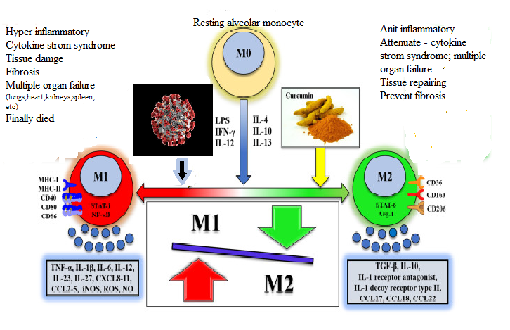
Figure 1: Turmeric shifts macrophage polarization towards M2 phenotype or inhibit the M1 phenotype polarization .Turmeric administration in COVID-19 disease results in a significant increase of macrophages with anti-inflammatory M2 phenotype, paralleled by a decrease of the detrimental M1 phenotype.

1.Zhang D, Guo R, Lei L, Liu H, Wang Y, Wang Y, Dai T, Zhang T, Lai Y, Wang J, Liu Z. COVID-19 infection induces readily detectable morphological and inflammation-related phenotypic changes in peripheral blood monocytes, the severity of which correlate with patient outcome. medRxiv. 2020 Jan 1.
2. Mehta P, McAuley DF, Brown M, Sanchez E, Tattersall RS, Manson JJ; HLH Across Speciality Collaboration, UK. COVID-19: consider cytokine storm syndromes and immunosuppression. Lancet. 2020 Mar 28;395(10229):1033-1034.
3. Wang C, Xie J, Zhao L, Fei X, Zhang H, Tan Y, Nie X, Zhou L, Liu Z, Ren Y, Yuan L. Alveolar macrophage dysfunction and cytokine storm in the pathogenesis of two severe COVID-19 patients. EBioMedicine. 2020 Jul 1;57:102833.
4. Manoharan Y, Haridas V, Vasanthakumar KC, Muthu S, Thavoorullah FF, Shetty P. Curcumin: a Wonder Drug as a Preventive Measure for COVID19 Management. Indian Journal of Clinical Biochemistry. 2020 Jul;35(3):373-5
5. Mohammadi A, Blesso CN, Barreto GE, Banach M, Majeed M, Sahebkar A. Macrophage plasticity, polarization and function in response to curcumin, a diet-derived polyphenol, as an immunomodulatory agent. The Journal of nutritional biochemistry. 2019 Apr 1;66:1-6.

