Preparation of Hybridomas Producing Monoclonal Antibodies against Aflatoxin B1 as a Tool to Control Hepatocellular Carcinoma

Manal M. E. Ahmed
Pharmacology Department, Medical Research Division, National Research Centre, Egypt
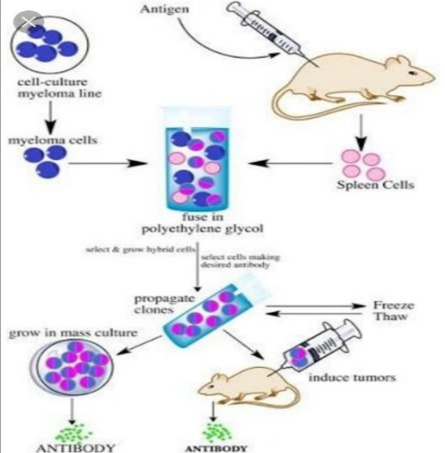

Abstract
Hybridomas that secreted antibodies against aflatoxin B1 for multiple uses were prepared using a unique immunization schedule. Aflatoxin B1-BSA conjugate was used for immunization of Balb/c mice. Spleen cells were harvested from the hyper immunized mice to be fused with myeloma cell line (P3NS1) using polyethylene glycol 3000, 50% concentration as a fusogenic agent. The produced hybridomas were selected using HAT selective medium that was replaced by complete HT medium. From the 10th day after fusion, wells that contain colonies of hybridomas covering 30% or greater of the wells surface were screened for production of monoclonal antibodies against aflatoxin B1 using ELISA. 21 hybridomas were found to be reactive to aflatoxin B1. All were found to belong to IgG2a isotype except one was found to belong to IgM isotype. The prepared monoclonal antibodies and their application to immunoassays represent a useful and rapid quantitative measurement with high affinity and low detection limits in order to purify environmentally occurring levels of this carcinogen specially in areas at high risk for liver cancer.

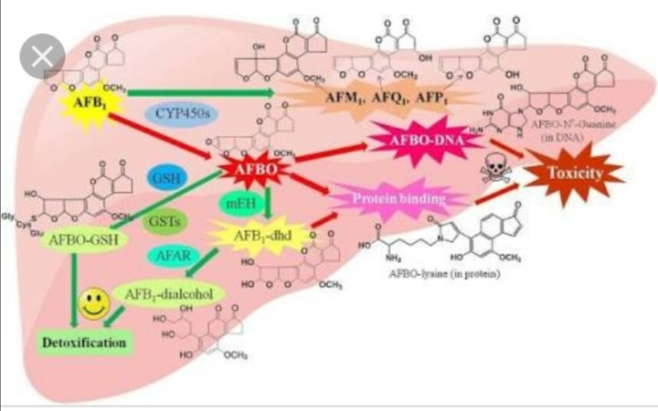
Image

Recent Publications
- Manal ME Ahmed, Tarek Mahran, Jakeen Eljakee (2020) Developement of anti- P. aeruginosa Immunoglobulin Y antibodies as prophylacic therapy for cystic fibrosis patients International Journal of Scientific Research in Biological Sciences 7 (2): 44-50.
- Manal M E Ahmed, Walid Nazmy (2019) Preparation and Evaluation of Novel Anti-Obesity Immunoglobulins for Immunoprophylaxis and Therapy, International Journal of Scientific Research in Biological Sciences 6 (6), 81-88.
- Manal M. E. Ahmed; Rafik Soliman; Jakeen El-jakee; Ahmed EL-sunossi; Haitham Amer; Ibrahim Elsabagh; Rashika El-redii; Hateem Talima; Walid Nazmy (2019) Preparation of hybridomas producing monoclonal antibodies against aflatoxin B1 as a tool to control hepatocellular carcinoma, International Journal of Pharmacology, Phytochemistry and Ethnomedicine,13: 1-12.
- Adham, M. Abdou; Manal, M. E. Ahmed; Yusuke Yamashita; Mujo Kim (2014) Immunoglobulin: A Natural Way to Suppress Helicobacter pylori in Humans, Health, 6 (8): 781-791.
- Mohamed, M.; El-Jakee, J.A; Abo-Alyazeed, H.; Moussa, I.M; Zahran, A.M. and Soliman, R. (2002): Preparation and evaluation of the protective efficacy of Pseudomonas aeruginosa irradiated vaccine in chickens, Vet. Med. J., 50(4): 709 – 719.

Biography
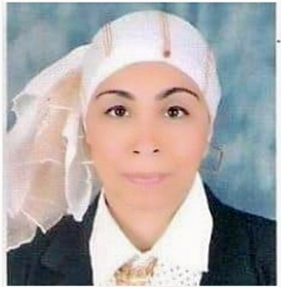
Manal M. E. Ahmed is Immunologist, Researcher, Columnist, Author, Reviewer, Public Speaker, Consultant and Principal Investigator of one of the national challenge projects in Egypt. She studied at Cairo University where she successfully completed B.Sc., M.Sc. and Ph.D. in microbiology and immunology. She also studied Business Administration at Ain Shams University where she successfully completed MBA. Currently, working researcher at the Department of Pharmacology, Medical Research Division, National Research Centre, Egypt. She worked over almost 25 years in the field of preparation of vaccines, immunoglobulin Y, polyclonal antibodies, and monoclonal antibodies as immunological tools for pharmaceutical and diagnostic industries. She has been awarded two patents from the academy of scientific research, Egypt. She published different scientific researches and articles in the scope of her work. She also interested in providing a social awareness for her community through the multimedia activities. She is the principal investigator of one of the national challenge of the projects of her country. She was actively participated in many scientific national and international seminars, workshops, and conferences. Her main interest is the employ of Immunology in innovating novel biological products that have pharmaceutical and diagnostic applications.
Email: Thinktankteam2014@gmail.com

Notes/Comments:

Dears Natural Products, 2020,
Thanks a lot for your kind invitation!

It’s a great pleasure to participate in this valuable event,

Also, I do appreciate if you can accept my waiver request from the registration fees.

Thank you,
Best Regards,
Manal M E Ahmed, Ph. D

