Activity-guided isolation of Bioactive compounds from under explored folklore: Rhus Punjabensis Stewart.
Saira Tabassum¹, Esperanza J. Carcache de Blanco², Nelson Freitas Fernandes², Hidayat Hussain⁴ and Muhammad Zia¹
¹NUTECH School of Applied Science and Humanities (NUSASH), National University of Technology Islamabad Pakistan
² Division of Pharmacy Practice Science and Division of Medicinal Chemistry and Pharmacognosy, College of Pharmacy, The Ohio State University, Columbus, OH, U.S.A.
³ Biological Sciences, Quaid-I-Azam University Islamabad, 45320, Pakistan.
⁴ UoN Chair of Oman’s Medicinal Plants and Marine Natural Products, University of Nizwa, P.O Box 33, Postal Code 616, Birkat Al Mauz, Nizwa, Sultanate of Oman

Abstract
Background: Plant based products have been an important source of several clinically useful bioactive compounds.
Objectives: The present study aims to comprehend activity-directed fractionation and compound purification processes employed to identify the bioactive compounds from the arial part of Rhus punjabensis.
Material and methods: Based on potent bioactivities, the ethyl acetate extract was selected for isolation of pure compounds. Four different compounds were isolated via chromatographic techniques comparing spectral data (NMR, and ESI-MS). This plant wasfirst explored for the isolation of these compounds according to best of our knowledge. Antioxidant activities were evaluated by following colorimetric assays. Brine shrimp lethality, MTT, antileishmania and SRB cytotoxicity against different cancer cell lines were investigated to elucidate plant’s cytotoxic potentials. Chemo- preventive NF-kB studies was made to trace out role of bioactive compounds in anticancer therapies. Antibacterial, antifungal and protein kinase inhibition assay was performed by disc diffusion method.
Rsults: Compound 1 (RPPE-C1) showed substantial antibacterial potential against S. typhimurium and B. bronchiseptica (MIC = 11.11 μg/mL) as well as antileishmanial activity (IC50 = 11.6 μg/mL). Compound 2 (PEEA-C2) demonstrated noteworthy cytotoxic activity against DU-145 and HL-60 human cancer cell lines with an IC50 of 11.2 and 15.2 μg/mL respectively. It also exhibited chemopreventive prospective in terms of inhibition of NF-kB 50% inhibition). (PEEA-C2) most potent compound among all of compounds. All the four compounds isolated, in the present study have been reported for the first time from R. Punjabensis.

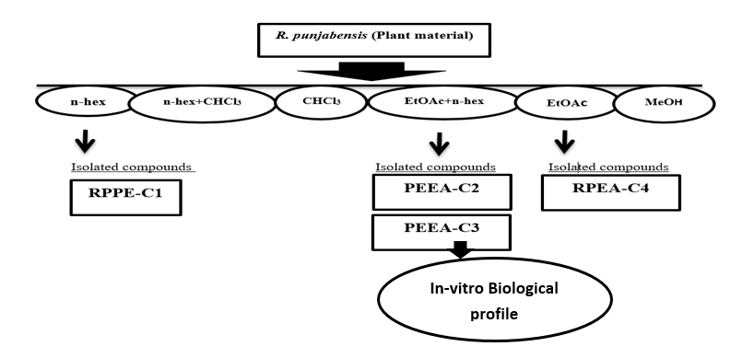
Bibliography

I am completed my Ph. D (2018) from Quaid-I-Azam University of Islamabad, Pakistan. Recently I am working assistant professor at NUTECH National University of Technology. My expertise in evaluation Researcher in the field of drug discovery from natural products, natural (isolated) and synthetic compounds. Practical experience of procedures and techniques of molecular biology, plant taxonomy, Nano-technology microbiology, biochemistry discovery of new compounds with enzymatic, antimicrobial, antioxidant, anticancer and cytotoxic activities. In addition, part of my practical experience includes the isolation of natural compounds by chromatography (HPLC and Column Chromatography techniques.

Presenting author details
Full name: Dr Saira Tabassum
Contact number: 092334-5333967
Recent Publications
Khan, I., Tabassum, S., Ikram, M. and Zia, M., 2018. Antioxidant, cytotoxicity, protein kinase inhibition and antibacterial activities of Fragaria× ananassa leaves. Pakistan Journal of Pharmaceutical Sciences, 31(4).
Naz, S., Tabassum, S., Freitas Fernandes, N., Mujahid, M., Zia, M., & Carcache de Blanco, E. J. (2018). Anticancer and antibacterial potential of Rhus punjabensis and CuO nanoparticles. Natural product research, 1-6.
Zubair, S., Asghar, F., Badshah, A., Lal, B., Hussain, R. A., Tabassum, S., & Tahir, M. N. (2019). New bioactive ferrocene-substituted heteroleptic copper (I) complex: Synthesis, structural elucidation, DNA interaction, and DFT study. Journal of Organometallic Chemistry, 879, 60-68.

Study of Rumex dentatus extracts for phytochemicals, antioxidant, antimicrobial and cytotoxic properties
Ejaz Aziz, Hina Salahuddin, Riffat Batool, Saira Tabassum, Javed Iqbal and Muhammad Tariq
Khan, S. I., Ali Khan, I., Badshah, A., Perveen Malik, F., Tabassum, S., Ullah, I & Khawar Rauf, M. (2018). Mononuclear copper (I) complexes with triphenylphosphine and N, N′-disubstituted thioureas: synthesis, characterization, and biological evaluation. Journal of Coordination Chemistry, 1-23.

