Evaluation of pharmacological activity of Sinularia secondary metabolite, a systematic review
Pardis Mohammadi pour, pharmacy PhD student, school of pharmacy, Isfahan University of Medical science, Isfahan, Iran

Abstract
The order Sinularia is a large, diverse and ecologically important group of marine invertebrates. In this work, we present an overview of the most promising marine bioactive compounds isolated From Sinularia in the first decade of the 21st century, which may have applications in the therapy of human diseases. The present study also discusses future perspectives for the bio prospecting of new marine natural product that produced by this species group of marine invertebrates.
This study was systematic review and reviewed publications were identified through searches in Scopus, science direct, PubMed, Proquest, Ovid and also Wiley by using the search terms “sinularia”, “metabolite” and “pharmacology” .The search was completed through December 2017, and was limited to articles published in English. Relevant articles were identified based upon the expertise and clinical experience of the authors. This review covered 31 species of Sinularia and their secondary metabolites effects. The result categorized in different pharmacological effects including: cytotoxic, antitumor and anticancer, activity against antibiotic-resistant and antibacterial activity, anti-inflammatory, anti-neuroinflammatory, neuroprotective activity, antiviral, antialgeal, and antifouling effects. And inhibitory effect on HIV-1 reverse transcriptase and p56lck tyrosine kinase, HIF-2α Induced Gene Expression, the release of elastase by human neutrophils, the generation of the superoxide anion (that shown in table 1).Studies showed that the most of the species were collected from Taiwan (that shown in figure 1) and most of them had the cytotoxic effect (shown in figure 2.).
Finally, the review speculates sinularia secondary metabolite were potent bioactive compound that had a potential to introduce as lead compound in many diseases especially in cancer and anti-inflammatory and neuro-degenerative diseases.

Image
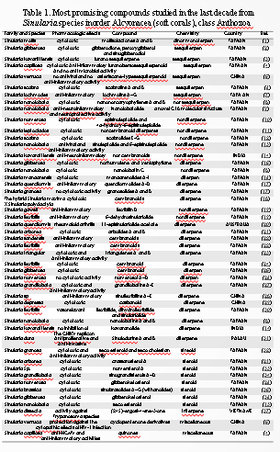
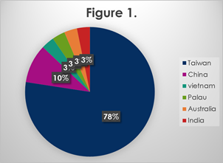
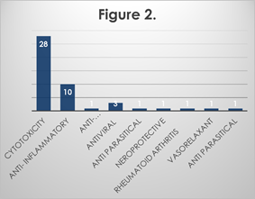
Recent publications (minimum 5)
- Cheng S-Y, Wang S-K, Ou Y-H, Duh C-Y. Mollisolactones A and B, novel dinormonoterpenes from the soft coral Sinularia mollis. Bioorganic & medicinal chemistry letters. 2016;26(3):879-81
- Ahmed AF, Kuo Y-H, Dai C-F, Sheu J-H. Oxygenated Terpenoids from a Formosan Soft Coral Sinularia g ibberosa. Journal of natural products. 2005;68(8):1208-12.
- Cheng S-Y, Huang K-J, Wang S-K, Wen Z-H, Chen P-W, Duh C-Y. Antiviral and anti-inflammatory metabolites from the soft coral Sinularia capillosa. Journal of natural products. 2010;73(4):771-5.
- Yuan W, Cheng S, Fu W, Zhao M, Li X, Cai Y, et al. Structurally Diverse Metabolites from the Soft Coral Sinularia verruca Collected in the South China Sea. Journal of natural products. 2016;79(4):1124-31.


Biography (150 word limit)
Pardis Mohammadi pour received her pharm D. from the Joundi Shapour University of Medical Science and studying PhD from Isfahan University of Medical Science. Where she studying the isolation, structure elucidation and structure– activity relationships of biologically active marine natural products from marine soft coral (Sinularia sp.) under the guidance of Professors Ghannadian.
Email: p.mohamadi90@yahoo.com

Notes/Comments:

