“Synthesis of ZnO/MnO₂ Nanomaterials using Plant Extracts and their Antibacterial and food packaging Applications”
Ishfaq Ahmed^{1*}, Dept. of chemistry, NIT, Srinagar, India
J.A. Banday¹ , Dept. of chemistry, NIT, Srinagar, India
F.A. Mir², Dept. of Physics, BGSBU, Rajouri, India
*Corresponding author. E-mail: ishfaqchoudhary09@gmail.com.

Abstract
Zinc oxide (ZnO) and Manganese dioxide (MnO₂) are commonly used nanomaterials with various applications. When combined and synthesized using a plant-based extract, they formed a nanocomposite with potential applications in antibacterial and food packaging. The plants contain several components and biochemicals which has been used as stabilizing and reducing agents to synthesize nanomaterials. Synthesis of Nanomaterials using plants extract becomes the most extensive research area since last two decades. Nanomaterials have a variety of applications in different fields like medical, cosmetics, catalysts, packing, agriculture and electronics. The ZnO/MnO₂ nanocomposite can be incorporated into coating for various surfaces e.g medical instruments. ZnO is known for its antimicrobial properties, but on combination with MnO₂ enhanced the effectiveness against different bacterial strains. The use of plant extract is preferred because they can be easily available and one can easily control the size of nanoparticle. The plant contains a number of phytochemicals which play role of oxidation and reduction in the synthesis of different nanoparticles and also beneficial for human and animals health. Plants mediated green synthesis of nanomaterials utilized these phytochemicals to produce different nanomaterials. The plant phytochemicals have some special properties inside the plant which attract the attention of researchers to make use of these thin films of ZnO/MnO₂ was Prepared in Polyvinyl alcohol (PVA) and used for food packaging application.it was found that these films can preserve the food items for long time thus increases the shelf life. Moreover, these films help in retaining of moisture and decreases weight loss in addition to retardation of bacterial growth. The characterization and confirmation of nanoparticles traits is done by different instruments such as UV-Vis spectroscopy (UV-Vis), Fourier transform infrared spectroscopy (FT-IR), Scanning electron microscope (SEM), Transmission electron microscopy (TEM), X-ray diffraction (XRD), Atomic force microscopy (AFM) etc.

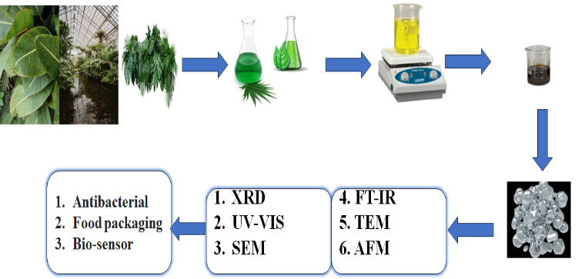
Figure 1 Synthesis of ZnO/Mno2 nanomaterials

References
1. Ahmed, I., Mir, F. A., & Banday, J. A. (2023). Synthesis of Metal and Metal Oxide Nanoparticles using Plant Extracts—Characterization and Applications. BioNanoScience, 1-17.

Photograph

Biography
Ishfaq Ahmed A research scholar at NIT Srinagar in department of chemistry. Research interest in Natural products, Nanobiotechnology, Nanoparticles and Thin Films
Email:ishfaqchoudhary09@gmail.com

