Glycol chitosan amphiphile nanotheranostic system for ultrasound-mediated localized release and biodistribution of doxorubicin

1 Sidra Saeed NILOP Nanomedicine Research Laboratories (NNRL), National Institute of Laser and Optronics College, Pakistan Institute of Engineering and Applied Sciences, Islamabad 46000, Pakistan. 2 Usama Sarwar Department of Biotechnology, Quaid-i-Azam University, Islamabad 46000, Pakistan.
3 Masoom Yasinzai Suleiman Bin Abdullah Aba Alkhail–Centre for Interdisciplinary Research in Basic Science (SA-CIRBS), Faculty of Sciences, International Islamic University, Islamabad 44000, Pakistan.
4 Abida Raza National Center of Industrial Biotechnology, University Institute of Biochemistry and Biotechnology, Pir Mehr Ali Shah Arid Agriculture University, Rawalpindi 46000, Pakistan.

Abstract (300 word limit)
Statement of the Problem: Ultrasound-mediated delivery has garnered attention as a noninvasive modality for localized drug delivery in cancer. Doxorubicin, a chemotherapeutic drug, shows low penetration, nonspecific distribution, and uncontrolled release. Methodology & Theoretical Orientation: We have synthesized a hydrophobic doxorubicin (hDox)-loaded palmitoyl-modified glycol chitosan amphiphile (PmGCA) polymer-based nanotheranostic drug delivery system (hDox-NDS) for ultrasound (US)-mediated release. Findings: PmGCA encapsulates 210 μg/mL hDox in 90 ± 15 nm cationic micelles. The reappearance of the Dox fluorescence peak after 2 MHz US exposure confirms the encapsulated drug release. hDox-NDS display a considerable drug release (~30 to 50%) over 72 h, following the Weibull model. Fluorescence microscopy shows a higher uptake of hDox-NDS (~10%) in rhabdomyosarcoma (RD) cells compared to DoxHCl. Ultrasound exposure significantly (p < 0.001) enhances the anticancer effect of hDox-NDS on RD cells, as shown by its lower IC50 value of 1.7 ± 0.05 μM compared to that of DoxHCl (2.62 ± 1.2 μM). In vivo optical imaging shows significantly lower fluorescence in the heart (~84%) and liver (~59%) compared to DoxHCl, thereby reducing side effects. Conclusion & Significance: This nanotheranostic hDox-NDS has been considered an effective drug delivery system, offering enhanced therapeutic effects in cancer treatment.

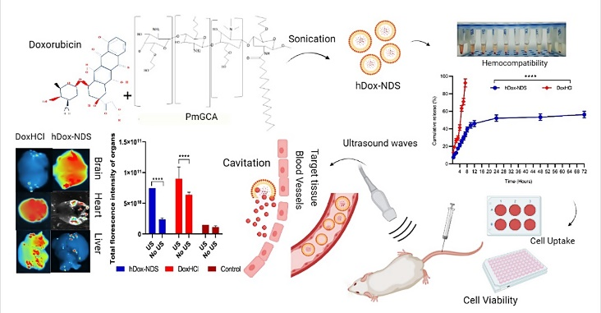
Figure. Graphical abstract of ultrasound-mediated localized release and biodistribution of doxorubicin from glycol chitosan amphiphile nanotheranostic system
Recent Publications (minimum 5)
- Glycol chitosan amphiphile nanotheranostic system for ultrasound-mediated localized release and biodistribution of doxorubicin
- Nanoparticles as a Novel Tool to Inhibit Inflammatory Cytokines in Human Lymphocytes and Macrophages of Coronary Artery Disease
- Therapeutic Potential of Novel Mastoparan-Chitosan Nanoconstruct Against Clinical MDR Acinetobacter Baumannii: In Silico, In vitro, and In vivo Studies.
- Prevalence of endo parasites in the freshwater fishes in river Punjkhora, Khyber Pakhtunkhwa Pakistan.
- Prevalence of Entamoeba histolytica and Giardia lamblia in District Hangu of Khyber Pakhtunkhwa, Pakistan
- Molecular Detection of Cryptosporidium parvum in Different Water Sources of District Peshawar, Pakistan

Photograph

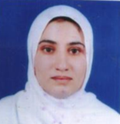
Biography (150 word limit)
Miss Sidra Saeed has expertise in research and data evaluation. She studied biosciences at the Kohat University of Science and Technology and graduated with an M.Phil. in molecular biology in 2012. She then joined the research group NILOP Nanomedicine Research Labs of Dr. Abida Raza. She is also working as a Molecular Biologist in Influenza Virology National Institute of Health Islamabad. She has published research articles in reputed journals.
Email: sidra_saeed2023@outlook.com

Notes/Comments:

