A magnetic SERS probe fabrication & in cell
Yuhuan Liu¹, Tingting Zheng^{2,3}, Huanhuan Feng¹*, Xing Ma¹*

- School of Materials Science and Engineering, Harbin Institute of Technology (Shenzhen), 518055, Shenzhen, China
- Shenzhen Peking University-The Hong Kong University of Science and Technology Medical Centre, Shenzhen 518036, China.
- Peking University Shenzhen Hospital, Shenzhen 518036, China.
Abstract

We have fabricate a magnetic SERS probe for biomedical detection through a handy modified Stöber reaction. The silica reaction is occurred under magnetic field to align the magnetic particles and string them together to form micro rob structure. Its geographical magnetic moment offers a perfect platform for precise movement and locomotion manipulation under magnetic field. We can make it go through a micro scaled Maze easily to reach targeted area via magnetic guiding and driving. Not only it could move as we designed but also it could rotate with demanding angular velocity for some very special application such as cell tissue depletion experiments. Its surface satellite doping silver is just adding SERS (Surface Enhanced Raman Spectrum) as an extra function for its biomedical detection. The detection ability is checked by Crystal Violet in vitro. The full potential of biomedical sensor in vivo will be explored in view. Its multi-functional ability makes it an outstanding candidate for further biomedical application such as micro surgery robot, biomedical sensor and of course targeted drug delivery mediation.

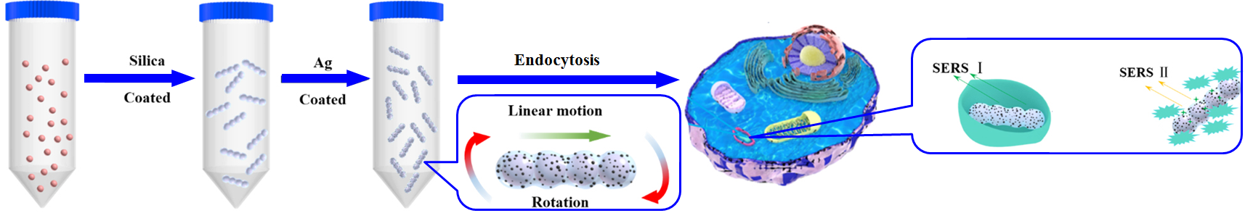
Figure 1 Schema of SERS probe fabrication and experiments in cell

Keywords—SERS probe, mini surgery robot, biomedical sensor

Professional Biography

Huanhuan Feng has completed his PhD at the age of 31 years from Wageningen University and postdoctoral studies in Wageningen University. He is assistant professor of School of Materials Science and Engineering, Harbin Institute of Technology (Shenzhen). He has published more than 20 papers in reputed journals and has been serving as an editor of Open Chemistry, De Gruyter.



Email Id: fenghuanhuan@hit.edu.cn

Acknowledgements:
We acknowledge financial support from Grants: NSFC No. 81871358, STKP No. 2016YFC0104707, SMP No. 201605018, GMRP No. B2018090, JCYJ20170413102735544.

