The Effect of Magnetic Resonance Imaging (MRI) on Some Properties of Acrylic Resin Denture Base Materials
Ahmed I.Al-Khyet , MSC. Prosthodontic Densitry, Assist.Lecturer, Mosul University , Iraq
Ahmed I.Al-Khyet , MSC. Prosthodontic Densitry, Assist.Lecturer, Mosul University , Iraq

Abstract (300 word limit)
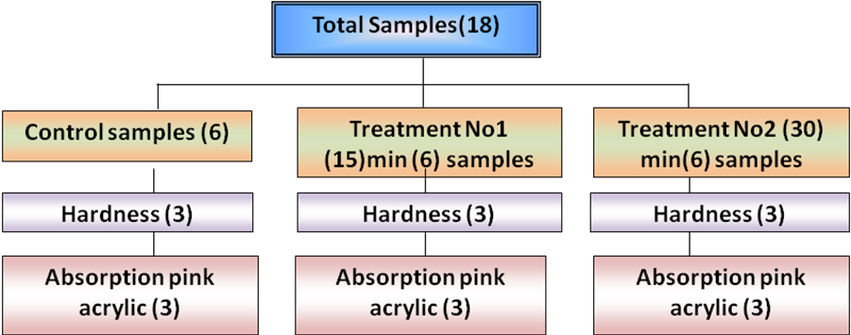
Introduction :magnetic resonance imaging have been used nowadays as one of the accepted tool for diagnosis, estimation, and evaluation of many of human been disease; in dentistry, many of prosthodontics patients and "maxillofacial-prosthesis" patients may fall under the category who might be subjected to routine "MRI" check-up either for follow-up of certain disease or cancer patient for determination the degree of healing or metastasis, thus, there has been growing interest in the research of the possible effect of "MRI" procedure on different component of "dental appliances" wears by those patients and one of these components is "heat cured acrylic resin".
Aims: the aims of this study were to evaluate the effects of "magnetic resonance imaging" on mechanical (tensile strength, hardness) physical (color change) chemical (FTIR, NMR) properties at different periods of time exposure.
Material and methods: total samples of (454) were prepared from acrylic based heat cured denture material, which divided into two main groups "Clear, Pink", each main group was subdivide, into four groups according to exposure to "MRI" control;(5,15 ,30)minute each of the four sub-groups undergo different tests" tensile strength, hardness(Rockwell) test, dimensional accuracy test, color change by spectrophotometery, surface roughness, water sorption, residual monomer release "FTIR" and "NMR". Conclusions: it was concluded that exposure to "MRI" at different periods of time lead to altering of some physical properties at different level of significant with the exception for one to two experiments water sorption and residual monomer which showed less significant than other tests done. Also, FTIR and NMR tests demonstrated a change in vibration of bonds between two, atoms but without rotation of molecule without alter the main chemical structure of material.

Image

Figure (3.1) Experimental design of pilot study
Recent publications (minimum 5)

- Abdul-Razzak S.A. (2010): The effect of temperature, time, and some additives on same physical and mechanical properties of acrylic denture base materials. M. Sc. Thesis ; College of Dentistry , University of Mosul.
- Amor N. and Blűmich(2011): Low-power MRI by frank-sequence excitation.J.Magnet.Resonan Imag .;(211):143-148
- Alfano B., Comerci M., Larobina M., Prinsta A., Hornak P.J., Easter S., Amato U., Qyarantelli M., Brunetti A. (1911): An MRI digital brain phantom for validation of segmentation method. J. Medic. Imag. Analy. ; (15) : 329-339.
- Aljallad H.M., Yan J., Pilaton C.M., McDannold N., Panych P.L.(2011) : Multiresolution (MRI) temperature monitoring in a reduced field of view. J. Magnet. Resonan. Imag .; (29) : 1205-1214.
- Allan M., Feast R., Gledhill M., Hurrell M., Oliverd A., Tremewan R. (2002): Magnetic resonance imaging safety quid line, Magne. Resona. Imag.j.;1: (97)-101.




Biography (150 word limit)
Ahmed I. AL-Khyet Assist lecturer prosthodontic dentistry. Mosul University .iraq have Msc.degree in prosthodontic dentistry ,he published more than 8 researches papers in national and international academic journals, authored 1 book .
He has expertise in Oral-health and dental field .His specific work deal with effects of (MRI) on polymers and dental products ,his Msc.thesis consider the 1st one all over middle east ,and available on more than 10 search –engine on internet.
Email: identist82@gmail.com
amertaga@hotmail.com
Notes/Comments:

