Design and fabrication of Micro-Pressure Sensor via Conducting Nanoparticles
Rui. Tong, Weijia. Wen

¹ Department of Physics (The Hong Kong University of Science and Technology, HK)
² Department of Physics (The Hong Kong University of Science and Technology, HK)

Abstract (not more than 300 words)

Polydimethylsiloxane (PDMS) has played an important role in chip fabrication owing to its properties such as transparency, biocompatibility, and good flexibility. However, PDMS is a non-conducting polymer, on which patterning metallic structures during the fabrication is challenging due to the weak adhesion between metal and PDMS. Hence, the integration of conducting structures into bulk PDMS was a critical issue. Here, we introduce PDMS-based conducting composites synthesized by mixing conductive nano/micro-meter-sized particles with PDMS gel, with which the patterning of the conductive structure can be realized by soft lithographic approach. Experiments show that such composite material can perfectly constructed into PDMS bulk material in all cases, thereby greatly enhancing their potential functionalities.
By employing above conducting composite for the fabrication of electrodes, some applications for the on-chip signal control and monitoring becomes feasible, for example, micro pressure sensor has been designed and fabricated. The micro pressure sensor presented here is a deformable thin conducting membrane attached on the wall of a microfluidic channel and its line resistance can be tunable under the external pressure variations. The testing results show that a good linear relationship between line resistance of sensor and applied pressure can be obtained which is a desired property of pressure sensor.

Keywords—conducting nanoparticles, micro-pressure sensor, PDMS

Professional Biography (100-150 words)

Rui Tong is a PhD candidate in nano science and technology at the Hong Kong University of Science and Technology. Her research focuses on studies and applications of microfluidics and microsystems for molecular detection, and she works with Dr. Weijia Wen. She obtained her Bachelor’s Degree in actuarial science from University of Toronto. As a multidisciplinary explorer, she can efficiently apply previous knowledge to current research.

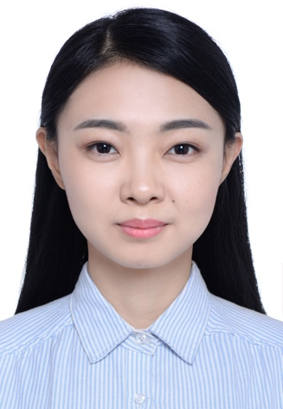
Email Id: rtongaa@connect.ust.hk

Dr. Weijia Wen has completed his PhD from Chinese Academy of Sciences and postdoctoral studies from University of California, Los Angeles. With over years of researches in micro- and nano-materials, advanced functional structural materials, nano-electric (magnetic) rheological fluid, microfluidic controlling, soft material physics and optoelectronic functional structure of the materials, he has published more than 350 papers in reputed journals with over 8000 citation times and has been serving as an editorial board member of repute. He has 15 US invention patents and 9 Chinese invention patents.



Email Id: phwen@ust.hk

Any Comments:

