Structural and dynamic mechanical analysis of composite films produced with Graphene Nanoplatelets/HDPE/LDPE
MSc. Danieli Dallé, MSc., UCS/Ford, BR
MSc. Samuel B. F. Santos, MSc., IEL/Ford., BR
MSc. Bruna F. Bortoli, MSc., Ford Motor Company, BR
Dr. Layne L. O. Gontijo, PhD, IEL/Ford, BR
MSc. Ricardo F. C. Albuquerque, MSc., Ford Motor Company, BR
Dr. Rodrigo Polkowski, PhD, Ford Motor Company, BR

Abstract
Combining several materials with a polymer matrix is an alternative to link up different microstructure characteristics and build unique mechanical properties in polymer-based composites. In this paper, nanocomposites films were fabricated with graphene nanoplatelets (GNP) added to a polymer matrix formed by high-density polyethylene (HDPE) and low-density polyethylene (LDPE), structural and dynamic mechanical performance were evaluated by X-Ray diffraction (XRD) and dynamic mechanical analysis (DMA) analysis. Dried HDPE, LDPE, and GNP were mixed in a co-rotating twin screw extruder with a pellet mill attached, dried again, and then the films were obtained by extrusion in a single-screw blown type film balloon extruder, with temperature zones set at 170, 180, and 190 ºC, under 56 RPM. Samples of HDPE/LDPE and HDPE/LDPE/GNP were obtained in 14:86 and 13:86:1 wt.%, respectively, as well as pure GNP. XRD showed a crystalline orthorhombic structure composed majorly of HDPE and LDPE as majority phases, expressed by 21.5 º (110) and 23.7 º (200) (2θ) peaks. Low patterns were exhibited for GNP with a characteristic peak at 26.4 º (002) corresponding to a c-axial plane, as a second phase, perpendicular to the graphite hexagonal plane, indicating a highly ordered structure with an interlayer distance of 0.33 nm. Regarding the storage modulus at 25 ºC, the HDPE/LDPE/GNP composite exhibited a larger value (1.4.10³ MPa) compared to HDPE/LDPE (1.1.10³ MPa), which can be related to a higher viscoelastic material property and its greater stiffness, promoted by the addition of GNP. The slightest improvement for the tangent delta (from 0.12 to 0.14) indicates the contribution of viscous and elastic composite enhanced by GNP addition. Through single-screw processing of HDPE and LDPE polymer matrix added with 1 wt.% GNP, these results are essential when it comes to polymer processing and developing materials with improved mechanical properties for structural applications.

Image

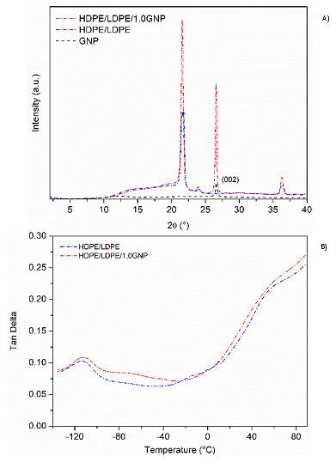
Figure 1: (a) XRD patterns and (b) Tan δ from DMA results
Recent Publications
- Li H, Xie XM (2018) Polyolefin-functionalized graphene oxide and its GO/HDPE nanocomposite with excellent mechanical properties. Chinese Chem. Lett. 29, 161.
- Zhang C, Chen Z, Guo W, Zhu C, Zou Y (2018) Simple fabrication of Chitosan/Graphene nanoplates composite spheres for efficient adsorption of acid dyes from aqueous solution. J. Int. J. Bio. Mac. 112:1048-1054.
- Anu MA, Pillai SS (2022) Structure, thermal, optical and dielectric properties of SnO nanoparticles-filled HDPE polymer. Solid. St. Com., 341.
- Chagas NPS, Aguiar VO, Garcia Filho FC, Figueiredo ABS, Monteiro SN, Huaman NRC, Marques MFV (2022) Ballistic performance of boron carbide nanoparticles reinforced ultra-high molecular weight polyethylene (UHMWPE). J. M. R. & T., 17, 1799-1811.
- García E, Louvier-Hernandez JF, Cervantes-Vallejo FJ, Flores-Martínez M, Hernandez R, Alcaraz-Caracheo LA, Hernandez-Navarro (2021) Mechanical, dynamic and tribological characterization of HDPE/peanut shell composites. Polym. Test., 98.

Biography
MSc. Danieli Dallé has her expertise in the Research & Development of polymeric materials applied for structures and ballistic armor. Her focus is the development of polymeric composites layer structured by polyamide fibers (Aramid), thermoplastic polyethylene (HDPE and LDPE), and nanocharges (graphene, nanoclay, and nanocellulose). She has built her path in materials for structural applications, and now she works as Lightning Engineer at Ford Motor Company.
Email: ddalle@ford.com

Notes/Comments:

