Abstract Template
Thermal conduction characteristics of polymer composites containing graphite
Mujin Jang, Weontae Oh

Division of Advanced Materials Engineering, Dong-Eui University, Korea

Abstract

Metal or metal oxides having excellent ther-mal conductivity and heat dissipation proper-ty is mixed with polymer resin as a binder to make a composite material and is applied to various types of thermal conduc-tive/dissipative functional material compo-nents. Various types of thermal conductive tapes and heat-radiation coating materials prepared with thermally conductive and dis-sipative composite materials are used in re-cent high-tech electronic devices such as smartphone, OLED TV, and LED lighting to prevent the heat accumulation and to perform the key functions that keep the performance of the product stable. As is well known, graphite is the structure in which a hexagonal plane unit of carbon-carbon bonds is lami-nated with a weak Van der Waals attraction, and is very important in various industrial fields because of its excellent electrical and thermal properties. In addition, graphene pre-pared by exfoliating graphite is known as the best material with the highest thermal con-ductivity (~5,000W/mK) on the earth, and many studies in academics and industries are being conducted due to its attractive proper-ties on electrical and mechanical applications. Graphite was ultrasonic-treated in solution to exfoliate the layered stacks, and the structural and thermal properties of the as-treated graphite were analyzed depending on ultra-sonic power and processing time. As-treated graphite was mixed with AlN or alumina powders, and the silicone-based TIM (ther-mal interface material) composites were pre-pared with the mixed fillers. Thermal con-ductivity of TIMs was characterized and compared in terms of inorganic additives (AlN and alumina) in the TIM composites. In addition, the thermal dissipation characteris-tics of the TIM-used LED lighting were inves-tigated.

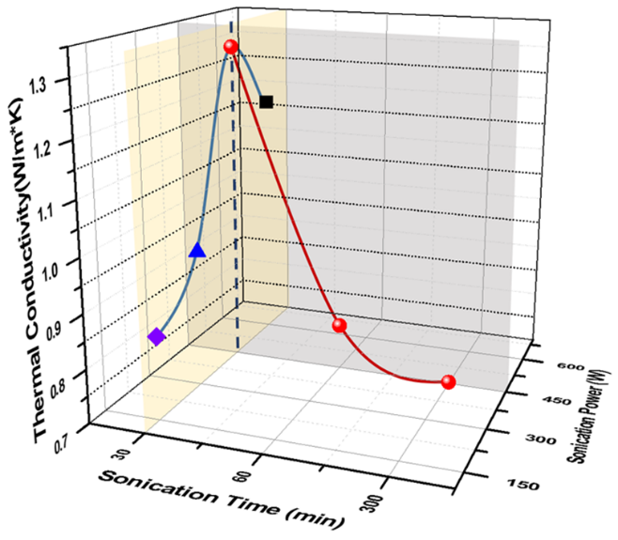

Figure 1. Thermal conductivity of silicone composites (TIM) including sxGr filler (40wt.%). Blue and red lines show the ther-mal conductivity curve measured on the samples which were ultrasonic-treated at the fixed time & the variable power, and at the fixed power & the variable time, respectively.

Keywords— thermal condcutivity, thermal interface material, ultrasonic treatment,

Professional Biography (100-150 words)

W. Oh has completed his PhD at the age of 34 years from POSTECH and postdoctoral studies from Georgia Institute of Technology, School of Chemical and Biomolecular Engineering. He is the professor of division of Advanced Materials Engineering, Dong-Eui University. He has published more than 70 papers in international/domestic journals.

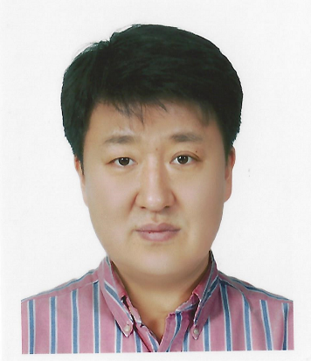
Email Id: wtoh2005@deu.ac.kr

Any Comments:

