Biogenic silver nanoparticles synthesis and their biomedical applications

Irshad Ahamad Msc, Dr. Tasneem Fatma PhD,
Department of Biosciences, Jamia Millia Islamia, New Delhi 110025, India

Abstract

Biogenic silver nanoparticles (AgNPs) are of significant interest due to their vast applications. In order to make non toxic, cost effective AgNPs, several microorganism have been utilized. In the present study emphasis was given to Anabaena variabilis mediated AgNPs synthesis. Optimal conditions for extract preparation were heating of extraction mixture at 100 ºC for 5 minutes, while for AgNPs synthesis optimal condition were 1:9 v/v [cell extract : AgNO3 (1 mM)], pH 7.4, and 30 ºC reaction temperature. The synthesized AgNPs were characterized by UV-Vis spectrophotometer and maximum absorbance peak was obtained at 440 nm. XRD techniques confirmed their crystalline nature. SEM with EDX showed 89.66 % elemental silver by weight which signified the purity of AgNPs. DLS study confirmed the nearly monodispersive nature of AgNPs.TEM observation confirmed 11-15 nm spherical NPs. FTIR analysis of synthesized AgNPs showed the functional moieties responsible for their bioactivity. Anabaena variabilis mediated AgNPs showed good antibacterial and antifungal activities. In combination with standard antibiotic and antifungal agents [AgNPs + Streptomycin, AgNPs + Amphotericin B, AgNPs + Fluconazole] showed significant synergistic effect. The blend of antimicrobial

properties, coupled with their “green” synthesis, make these biogenic nanoparticles predominantly attractive in nanomedicine for future applications.

Image
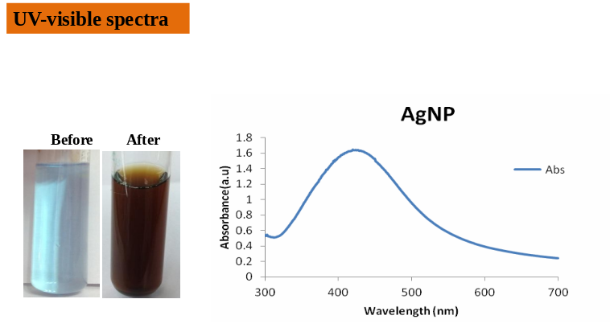

Figure.1 Synthesis of Silver nanoparticles from A. variabilis
Photograph


Biography
I am persuing PhD at Department of Biosciences Jamia Millia Islamia New Delhi under the supervision of Prof. Tasneem Fatma. She was the head of the Department. She has published more than 100 papers in reputed journals and has been serving as an editorial board member of many reputed biological sciences journal.

Email: ahmadirshad784@gmail.com

Notes/Comments:

