Structure analysis of gold nanorods obtained using selected oligomeric surfactants
Joanna Maksim, BS, Department of Macromolecular Physics, Faculty of Physics, Adam Mickiewicz University in Poznan, Poznan, Poland
Karolina Rucińska, BS, Department of Macromolecular Physics, Faculty of Physics, Adam Mickiewicz University in Poznan, Poznan, Poland
Augustyn Moliński, MA, Department of Macromolecular Physics, Faculty of Physics, Adam Mickiewicz University in Poznan, Poznan, Poland NanoBioMedical Centre, Adam Mickiewicz University in Poznan, Poznan, Poland
Agnieszka Boś-Liedke, PhD, Department of Macromolecular Physics, Faculty of Physics, Adam Mickiewicz University in Poznan, Poland
Zuzanna Pietralik, PhD, Department of Macromolecular Physics, Faculty of Physics, Adam Mickiewicz University in Poznan, Poznan, Poland
Barbara Peplińska, PhD, NanoBioMedical Centre, Faculty of Physics, Adam Mickiewicz University in Poznan, Poznan, Poland
Maciej Kozak, Prof, Department of Macromolecular Physics, Faculty of Physics, Adam Mickiewicz University in Poznan, Poznan, Poland, Joint Laboratory for SAXS Studies, Faculty of Physics, Adam Mickiewicz University in Poznan, Poznan, Poland

Abstract
Preparation of nanoparticles characterized by different shapes and sizes allows us to change their properties and application. From the point of view of wide biomedical applications is very important also the ability to modify of these nanostructures with surfactants. It allows attaching macromolecules important for biomedicine and avoiding aggregation of nanostructures. The main aim of this study was to synthesize gold nanorods (GNRs) by modified method based on seeding growth and analyse the morphology of obtained nanostructures. During the stage of growth, it was added five oligomeric Gemini surfactants (denoted as: Cl_C6_C8, Cl_C6_C12, imi Cl_C6_12, Cl_C6_C16, imi Cl_C6_16) and two different amounts of silver nitrate.
The next part of the project covered characterization obtained nanoparticles using the microscopic and spectroscopic techniques, including UV-Vis spectroscopy, transmission electron microscopy (TEM) and atomic force microscopy (AFM). By the use of these methods we were able to achieve the information about the shape and the size of nanorods, which permits to choose the most perspective sample for future biomedical applications.

Image

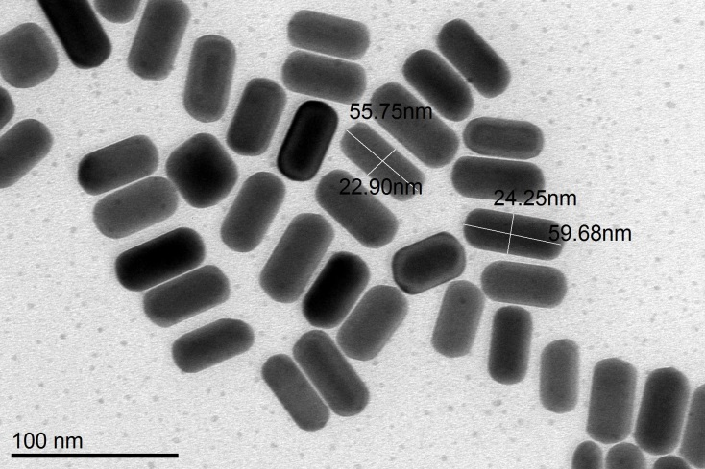
Figure 1 Transmission Electron Microscopy’s image of synthesized nanorods.
.

Photograph

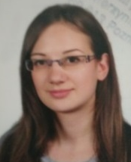Biography
Joanna Maksim is a fourth year medical physics student. She studies at Adam Mickiewicz University in Poznan, at Physics Faculty and is working on her master thesis in the Department of Macromolecular Physics. In this work, she synthesized rod-shaped nanoparticles which have potential biomedical applications. This research project was supported by programme Best of the Best (Najlepsi z Najlepszych) 3.0 from Ministry of Science and Higher Education (Poland).
Email:
asiasp3@gmail.com

