Preliminary studies of the synthesis of gold nanoribbons based on the seed size
Joanna Patalas, BSc, Department of Macromolecular Physics, Faculty of Physics, Adam Mickiewicz University in Poznan, Poznan, Poland
Joanna Maksim, BSc, Department of Macromolecular Physics, Faculty of Physics, Adam Mickiewicz University in Poznan, Poznan, Poland
Karolina Rucińska, BSc, Department of Macromolecular Physics, Faculty of Physics, Adam Mickiewicz University in Poznan, Poznan, Poland
Marika Musielak, BSc, Department of Macromolecular Physics, Faculty of Physics, Adam Mickiewicz University in Poznan, Poznan, Poland
Agnieszka Boś-Liedke, PhD,Department of Macromolecular Physics, Faculty of Physics, Adam Mickiewicz University in Poznan, Poznan, Poland
Augustyn Moliński, MSc, Department of Macromolecular Physics, Faculty of Physics, Adam Mickiewicz University in Poznan, Poznan, Poland, NanoBioMedical Centre, Adam Mickiewicz University in Poznan, Poznan, Poland
Zuzanna Pietralik, PhD, Department of Macromolecular Physics, Faculty of Physics, Adam Mickiewicz University in Poznan, Poznan, Poland
Maciej Kozak, Prof, Department of Macromolecular Physics, Faculty of Physics, Adam Mickiewicz University in Poznan, Poznan, Poland, Joint Laboratory for SAXS Studies, Faculty of Physics, Adam Mickiewicz University in Poznan, Poznan, Poland

Abstract

Nanotechnology and medicine gave birth to the new and promising interdisciplinary research field called nanomedicine. Thanks to the improvements in both of the nanotechnology and nanomedicine we are able to help and improve people’s health on the nanoscale. One way is using biosensors that can signalize the existence of pathogens, alien DNA, viruses etc.

The most important features of the nanomaterial to create a biosensor are their shape and stability. Shapes that are the best fit are elongated and flat nanoparticles such as nanotubes, nanorods, nanowires and nanoribbons. The size of these nanocreations gives an opportunity to later functionalize them with biological and chemical molecules.

Gold nanoribbons are promising metallic support for biosensors in the nanoscale, and thanks to the development of modern technology, we are able to create them using various methods. One of them is using oligomeric and polymeric surfactants – surface active agents, built of hydrophobic and hydrophilic moieties that can wrap around the growing nanoparticles. The properties of surfactants are helping to stabilize the growth of the specific shape of nanoparticle such as nanoribbons.
The conducted study has been focused on creation of metallic nanoribbons especially gold nanoribbons with the use of various surfactants. The gold seeds used in the synthesis of nanoribbons have been tested via UV-Vis. Later, properties of synthesized nanoribbons have been tested with Atomic Force Microscopy and Transmission Electron Microscopy. Relying on those spectroscopy and microscopy techniques we were able characterize created nanoparticles.

Image
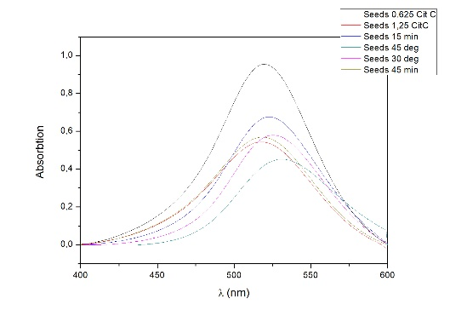
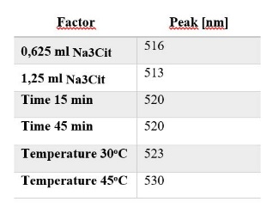

Figure 1 (left). Impact of the temperature, time and concentration of Na₃Cit for the growth of nanoribbons.

Figure 2 (right). Peak value for each factor.

This research project was supported by the programme Best of the Best (Najlepsi z Najlepszych) 3.0 from Ministry of Science and Higher Education (Poland).

Photograph

 Biography
Joanna Patalas is a student of the 4th year of Medical Physics, Department of Macromolecular Physics, Faculty of Physics, University of Adam Mickiewicz. She and 3 other students under coordination of prof Maciej Kozak has been working on a project that improves ways of obtaining specific shape of nanoparticles with the use of oligomeric and polymeric surfactants. Her passion is working for the improvements in new methods of helping people such as nanomedicne and gene therapy.
Email: asiapatalas96@gmail.com

