Liposomes based donepezil nasal in situ gel: Formulation development and in vivo characterization
Shital Butani, Associate Professor, Institute of Pharmacy, Nirma University, Ahmedabad, India
Amarjtsing Rajput, PhD scholar, Institute of Pharmacy and Assistant Professor at Poona College of Pharmacy, Bharati Vidyapeeth Deemed to be University, Pune

Abstract
Donepezil is widely prescribed drug for treatment of Alzheimer disease and is available in market as a tablet or a capsule for oral administration. However, poor bioavailability of donepezil is reported due to the first pass metabolism and resistance offered by BBB. Further donepezil also showed gastrointestinal side effects like nausea and diarrhea. Hence, in present research, donepezil liposomes were prepared and incorporated into in situ gel formulation to deliver it via nasal route for brain targeting. Hydrogenated soybean phosphatidylcholine (HSPC) and cholesterol were used for preparation of liposomes by the ethanol injection method followed by high pressure homogenization to get desired vesicle size. Donepezil being weak base, can form complex with ammonium sulphate and thus can be entrapped inside the liposomes by active loading method. The drug loaded liposomes were evaluated for entrapment efficiency, pH, size and poly dispersibility index. Dowex resin, HLB cartridge, ultracentrifuge and amicon ultrafilter centrifugal methods were evaluated for entrapment efficiency determination. The selected formulation was further tested in animal models for pharmacodynamics using the Morris water maze test and for pharmacokinetic after nasal administration in comparison to marketed product. Ultracentrifuge and amicon filters could effectively separate the free drug from the entrapped drug and hence amicon filters were selected for further testing. The optimized batch showed entrapment efficiency greater than 90%, vesicular size of 100.5 nm and PDI of 0.189. The pharmacodynamic study showed that donepezil liposomal based in situ gel had shorter escape latency time, less distance travelled, more time spent in the target quadrant and more number of annulus crossings in comparison to the marketed tablet. Donepezil concentration in the brain was 3.28 fold higher after intranasal administration of optimized in-situ gel in comparison to oral administration of the marketed tablets.

Image

In vivo evaluation A) Donepezil HCl liposome based gel and B) Marketed oral tablet

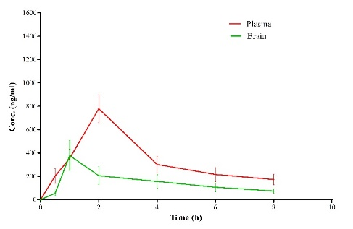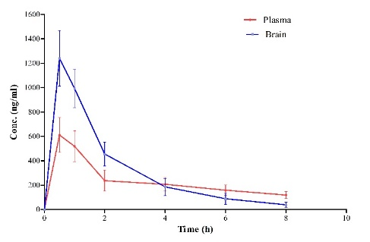
A
B
Recent Publications
- Salimi A, Gobadian H, Sharif Makhmalzadeh B. (2020) Dermal pharmacokinetics of rivastigmine-loaded liposomes: an ex vivo–in vivo correlation study. Journal of Liposome Research.:1-9.
- Rajput AP, Butani SB(2019). Resveratrol anchored nanostructured lipid carrier loaded in situ gel via nasal route: Formulation, optimization and in vivo characterization. Journal of Drug Delivery Science and Technology.:51:214-23.
- Johnsen KB, Moos T. (2016) Revisiting nanoparticle technology for blood–brain barrier transport: Unfolding at the endothelial gate improves the fate of transferrin receptor-targeted liposomes. Journal of Controlled Release.222:32-46.
- Al Asmari AK, Ullah Z, Tariq M, Fatani A. (2016) Preparation, characterization, and in vivo evaluation of intranasally administered liposomal formulation of donepezil. Drug design, development and therapy.10:205-15.
- Kanazawa T, Taki H, Okada H. (2020) Nose-to-brain drug delivery system with ligand/cell-penetrating peptide-modified polymeric nano-micelles for intracerebral gliomas. European Journal of Pharmaceutics and Biopharmaceutics.152:85-94.

Biography Dr Shital Butani has more than 20 years of research and teaching experience. She has completed a Major project entitled "Exploring non-equilibrium atmospheric plasma for effective sterilization including biological safety aspects” as PI and working on “Feasibility Study of Waste Water Treatment using Non Thermal Plasma” as CO-PI granted from the Board of Research in Nuclear Sciences (BRNS), DAE-GOI. She have done project for the development of an oral formulation for a natural product as well as nasal and oral spray for an Indian Industry; Dr Butani has received "Project Excellent" award during her tenure at Zydus Cadila Healthcare Ltd., Ahmedabad. She also received a best paper award from IDMA in January 2015 for one of her publications in the Pharmaceutics category.
Email: shital.butani@nirmauni.ac.in

