Formulation and in vivo bioavailability studies of lipid nanoparticles of anticancer agent
Dr Bhupendra G. Prajapati, PhD, Ganpat University, India
Ms Payal Patel, M.Pharm, Ganpat University, India

Abstract (300 word limit)
Exemestane HCl (EXM) has very low solubility as well as low bioavailability which limits the therapeutic outcome. Following oral administration, EXM is rapidly and extensively absorbed; although animal data suggests that the absolute bioavailability was low (about 5%) due to an extensive first-pass effect. Formulation of solid lipid nanoparticles (SLNs) of EXM is a promising approach to increase the bioavailability. EXM SLNs were prepared by Solvent Injection method. As the optimized parameters, homogenization speed is kept at 10000 rpm, homogenization time set for 30 minutes and sonication time set for 20 minutes. Where as in case of excipients optimization, GMS and Drug were optimized as 300 mg and 120 mg respectively, aqueous phase 50 ml, organic phase (as Acetone:Methamol) (1:1 ) 7 ml and Surfactant amount 1000 mg. For the optimized batch particle size found to be 576 nm. The % entrapment efficiency for optimized batch was found 85.038 ± 2.6. In all cases, % entrapment efficiency was found to be 53.638±3.1 to 85.038 ±2.6. Dissolution study shows effect of different amount of lipid as well as different amount of surfactant in drug release profile. For in vivo bioavailability study the relative bioavailability of Exemestane HCL solid lipid nanoparticles compared with the plain Exemestane HCL drug was 165.75 %, suggesting that a SLNs formulation could improve the oral absorption of Exemestane HCL.

Image
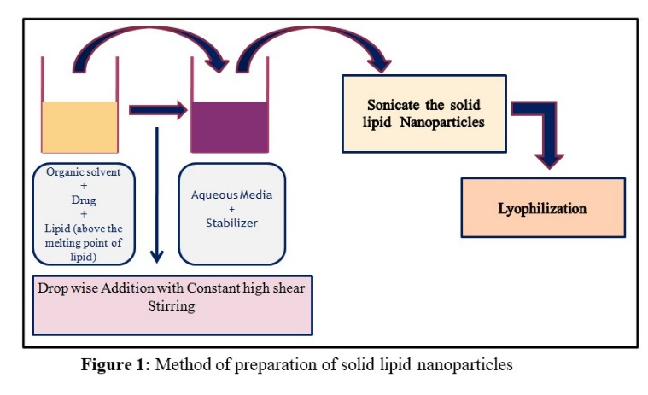
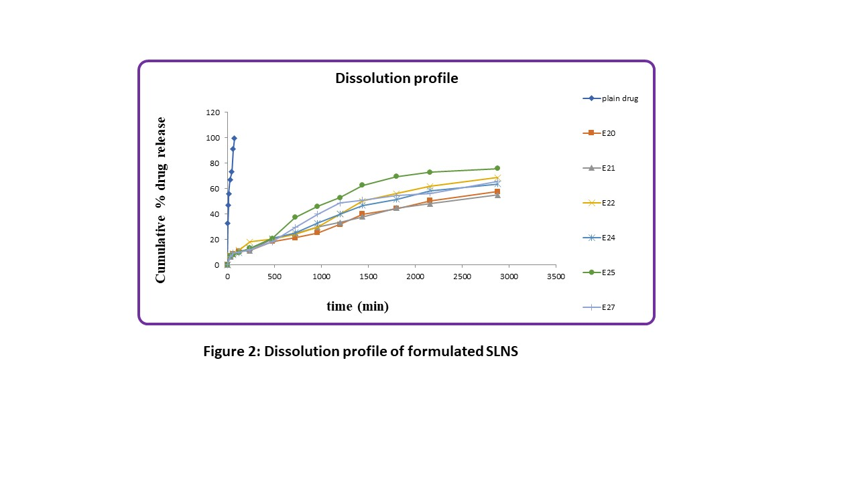
Recent Publications (minimum 5)
1. Bhattacharya, S., Saindane, D., & Prajapati, B. G. (2022). Liposomal Drug Delivery and Its Potential Impact On Cancer Research. Anti-cancer agents in medicinal chemistry, 10.2174/1871520622666220418141640. Advance online publication.
2. Paliwal, H., Parihar, A., & Prajapati, B. G. (2022). Current State-of-the-Art and New Trends in Self-Assembled Nanocarriers as Drug Delivery Systems. Front. Nanotechnol. 4: 836674. doi: 10.3389/fnano.
3. Prajapati, B., Paliwal, H., & Patel, J. (2022). Pharmacokinetics of Nanoparticle Systems for Pulmonary Delivery. In Pharmacokinetics and Pharmacodynamics of Nanoparticulate Drug Delivery Systems (pp. 347-364). Springer, Cham.
4. Prajapati, B. G., Patel, H. P., & Patel, J. K. (2022). Nanoparticle Pharmacokinetic Profiling In Vivo Using Magnetic Resonance Imaging. In Pharmacokinetics and Pharmacodynamics of Nanoparticulate Drug Delivery Systems (pp. 399-416). Springer, Cham.
5. Prajapati, B. G., Jivani, M., & Paliwal, H. (2021). Formulation and optimization of topical nanoemulsion based gel of mometasone furoate using 32 full factorial design. Indian drugs, 58(06), 19.

 Biography
Dr. Bhupendra Prajapati is a Professor in Department of Pharmaceutics, Shree S.K.Patel College of Pharmaceutical Education and Research, Ganpat University, Gujarat, India. He has more than 20 years of academic and research experience, has published more than 100 research and review papers in international and national Journals. Under his editorial two book under process and he authored 20 book chapters in the field of novel drug delivery. He published two Indian patent and three applications under evaluation. He is a reviewer in three high impact journals and is on the editorial board of several scientific journals.
Email: bhupen27@gmail.com

